Press Release

RAFI’s SAFETY TOUCH wins German Innovation Award 2025

The German Design Council has named the SAFETY TOUCH technology platform recently developed by RAFI to be the winner of the German Innovation Award 2025. The award was presented for “Electronic Technologies” in the main category of “Excellence in Business to Business.”

Based on the innovative safety architecture, capacitive touch displays can be equipped with the safety features required for performance level d in accordance with industry standards. The safety concept, which is based on reliable and durable hardware components, redundant controller architecture, and comprehensive diagnostic software, provides significantly greater flexibility than hard-wired safety features.

“We are extremely proud to have received an award for our SAFETY TOUCH technology. With this solution, we enable machine manufacturers and users to better align their operating philosophy with modern touchscreen visualization and capacitive input technology. Thanks to the system architecture in accordance with performance level d, even safety-critical features can be executed using touch commands. This enhances the versatility and efficiency of touch-based machine operation,” says Frank Fleischer, Head of RAFI’s Technology and Innovation Management Team, at the May 13 award ceremony held at the German Museum of Technology in Berlin.

Initiated by the German Bundestag in 1953, the German Innovation Award is presented annually to especially innovative products, technologies, and services that stand out due to their added value for both users and the environment. A jury of senior R&D experts selected this year’s winners from among 460 submissions based on key criteria that included innovation, market readiness, sustainability, technical quality, and potential. The award impressively underscores RAFI’s innovative strength and commitment to developing pioneering technologies for industry.

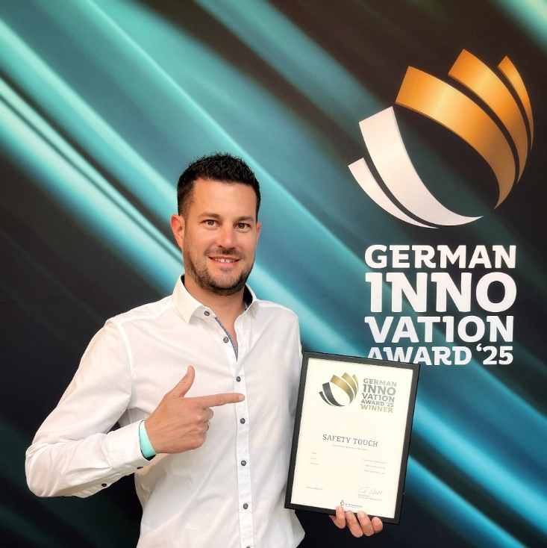
Caption: RAFI’s SAFETY TOUCH technology was honored with the German Innovation Award

Image/s: | fleischer_innoaward_2000.jpg | Characters: | 1,885
File name: | 202505008_pm_innoaward-safetytouch_en.docx | Date: | 05-15-2025
Tags: | RAFI, Safety Touch, SafetyTouch, German Innovation Award, German Design Council, Design Council, Innovation Award 2025, March 13, award ceremony at the Museum of Technology, germandesigncouncil, germaninnovationawards, gia2025

About the RAFI Group
Founded in 1900, RAFI today develops and produces electromechanical components and systems for human-machine interaction. The range of products includes switches and key switches, touchscreens, control systems, and electronic assemblies. RAFI products are used in many industries, including automation, medical technology, machine and plant engineering, road and railway vehicles, household appliances, and telecommunication. The RAFI Group operates internationally at sites in Germany, Europe, China, and the USA. Its headquarters are located in Berg near Ravensburg, Germany.

Contact:  RAFI GmbH & Co. KG  Patrick Müller  Product Marketing Manager  Ravensburger Straße 128–134  88276 Berg, Germany  Phone: 0751 89-1634  Email: patrick.mueller@rafi-group.com  Web: www.rafi-group.com |  | gii die Presse-Agentur GmbH  Christburger Str. 41  10405 Berlin, Germany  Phone: +49 30 53 89 65-0  Email: info@gii.de  Web: www.gii.de

