Press Release

RAFI invests in the future: new factory opened in Bad Waldsee

Berg, May 16, 2025 – Construction of the new RAFI factory in Bad Waldsee started in May 2023, and the facility went into operation in early 2025. Covering a floorspace of 10,000 m², the building now houses new production facilities for synthetic material and machine production, metal processing, a toolshop including tool development, as well as a training and apprentice center. Built to the latest economic and ecological standards, the building is a clear commitment to Upper Swabia as a business location. With this development, RAFI continues to position itself as an attractive employer and driver of innovation in the region.

What began with the symbolic ground-breaking ceremony on May 2, 2023 is now complete with official opening: the construction and commissioning of the new RAFI factory in Bad Waldsee. It is great success for the RAFI Group, which is celebrating its 125th anniversary this year. Dr. Lothar Seybold, CEO of the RAFI Group, summed up this investment in the future with the words: “I’m delighted that we’ve built a state-of-the-art factory in which, on the one hand, our employees have the best possible working conditions and, on the other hand, we can guarantee the best possible quality and delivery reliability for our customers.” He added: “I would like to thank everyone involved for what has been achieved, above all the many helpers within RAFI and the planners and implementers from Planquadrat Gaiser & Partner and Georg Reisch.”

A model factory: climate-friendly and resource-saving

In addition to economic factors such as increasing efficiency and stabilize processes, RAFI placed great emphasis on energy-efficient building infrastructure that meets the EFFH-40 standard. The primary energy source will be a geothermal probe system with 34 probes installed at a depth of 131 meters. Additional energy will be provided by a PV system with a performance of 760 kWp. “Sustainability is firmly integrated into our organizational and management systems and is part of our corporate culture. We consistently pursue ESG objectives. This also applies to our new factory in Bad Waldsee,” said Lothar Arnold, CFO of the RAFI Group. Last year, RAFI was awarded gold status by the EcoVadis rating agency for its commitment to the environment and ethics.

Dr. Lothar Seybold, CEO of the RAFI Group: “With the new building, we are making a sustainable investment in the further growth of the entire RAFI Group.”

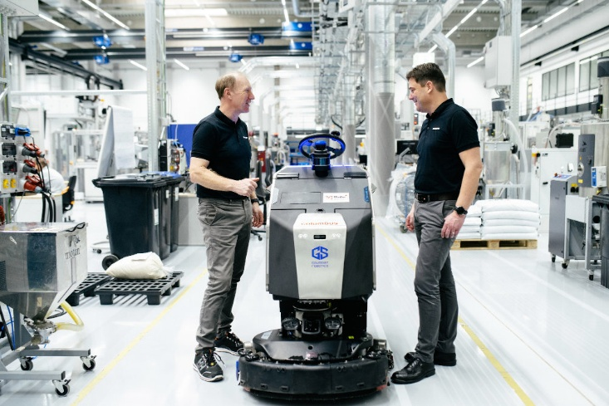
Caption 1: Cleaning robots at work on the shop floor in Bad Waldsee
Source: Luis Barreiro PHOTOGRAPHY

Lothar Arnold, CFO of the RAFI Group: “Our new factory in Bad Waldsee is a clear commitment to Upper Swabia as a business location and secures jobs in the region.”

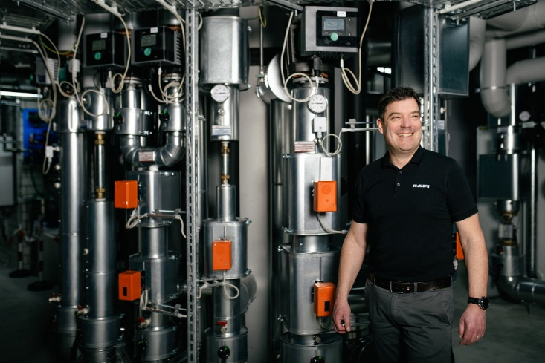
Caption 2: Reason to celebrate: state-of-the-art cooling and heating technology
Source: Luis Barreiro PHOTOGRAPHY

Rethinking production: following the value stream

Almost 130 employees currently work in three shifts at the new RAFI factory. All relevant departments for the operation of modern synthetic material and machine production are located at the site: These include process technology, quality assurance, logistics, maintenance, and the in-house toolshop, including tool design. Components made of synthetic materials in various sizes, combinations, and applications, punched parts, electromechanical buttons and control devices, and components for further processing in customer-specific applications are manufactured in the facility. “By moving component production to a new factory, RAFI has not only created more space for the future, but also given the go-ahead for a more efficient and future-proof orientation of this sub-division within the Group,” said plant manager Sven Nothelfer, summing up the strategic and operational vision.
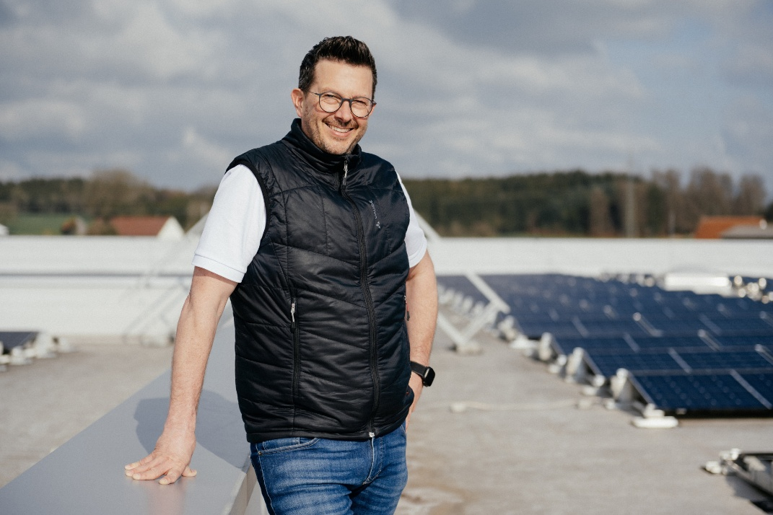
Caption 3: Managing the fortunes of the RAFI factory in Bad Waldsee: Plant Manager Sven Nothelfer
Source: Luis Barreiro PHOTOGRAPHY

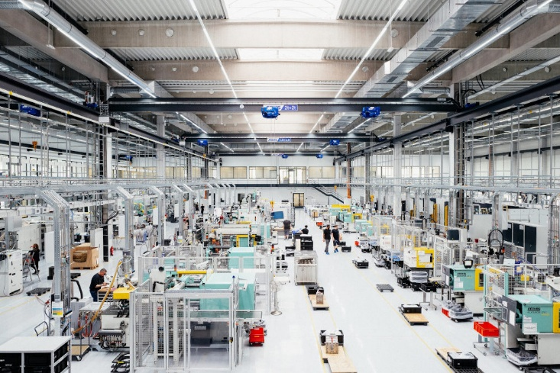
Caption 4: RAFI invests in the future: new factory opened in Bad Waldsee
Source: Luis Barreiro PHOTOGRAPHY

Lifelong learning: training and apprentice center

Bruno Felder, Head of the metalworking training workshop in Bad Waldsee, sees the teaching concept as follows: “The aim was to design an attractive and future-oriented metalworking training workshop. And we’ve succeeded. In our ultra-modern environment, we train and will continue to train apprentices in the professions of industrial and tool mechanics, synthetic material and rubber technologists, as well as machine and plant operators.” Up to 16 apprentices, students, and interns can currently be trained on the premises. The apprentices learn the basics of metalworking, such as milling and turning, as well as skills in areas such as production technologies, product design, and electronics.

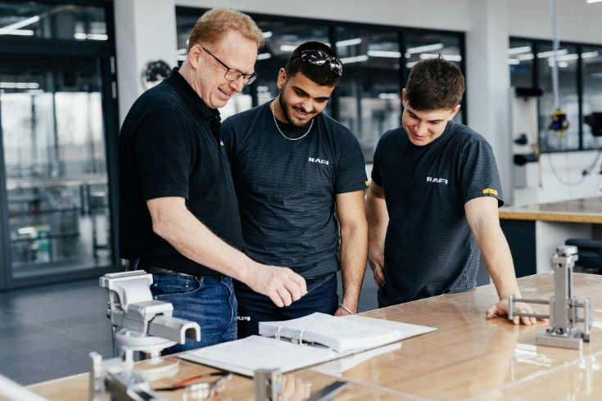
Caption 5: Head of training Bruno Felder with trainees in the new training workshop at the RAFI factory in Bad Waldsee
Source: Luis Barreiro PHOTOGRAPHY

New this year is the RAFI Academy, which was inaugurated at the RAFI site in Überlingen in January 2025. With immediate effect, specialist conferences and training courses for up to 40 people as well as workshops and lectures can also be held in Bad Waldsee on a total area of 240 m². “The aim of the RAFI Academy is to promote the transfer of know-how between the RAFI locations and to build up overarching skills in the areas of personnel development, specialist training, and management development. We also want to offer our cooperation partners a platform for exchange,” said Jana Brielmayer, who is also responsible for the RAFI Academy in the RAFI Group’s Human Resources department.

RAFI factory Bad Waldsee: Key data at a glance
- Address: Felix-Wankel-Straße 8, 88339 Bad Waldsee
- Start of construction/groundbreaking: May 2, 2023
- Official opening: May 16, 2025
- Building area: 28,242 m²
- Production and logistics space: 10,000 m²
- Synthetic material and machine production, metal processing, toolshop
- Training workshop and training and apprentice center
- Energy efficiency according to EFFH 40 standard
- Heat pumps, geothermal probes, PV system
- Calculated savings potential according to KFW application for QNG and LCA certification: 920,869.00 kWh/year primary energy savings, 756,254.00 kWh/year final energy savings and 236,363.00 kWh/year CO2 savings.

Modernization of the RAFI site in Berg completed
Sustainability and future viability are not only important in Bad Waldsee. The RAFI Group also launched various measures to modernize the building infrastructure at its main plant in Berg at the beginning of 2022. The three-year construction measures for refurbishment and energy modernization have now been completed. Energy savings of up to 45 percent can be achieved in future thanks to the physical improvements of the building. There is also an effective boost in CO₂ emission saving: around 340 tonnes per year can be saved thanks to measures such as facade insulation.
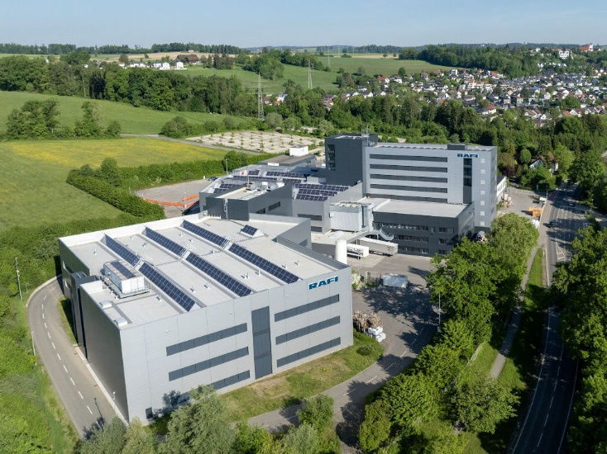

Caption 6: The refurbishment and energy modernization of the Berger RAFI factory has been completed
Source: Luis Barreiro PHOTOGRAPHY

Image/s: | seybold_werkhalle_2000.jpg  werkhalle_badwaldsee_2000.jpg | Characters: | 7.750
File name: | 202505_pm_rafi_werkeröffnung_en.docx | Date: | 05-18-2025
Tags: | RAFI, Bad Waldsee, RAFI factory opening

About the RAFI group
Founded in 1900, RAFI today develops and produces electromechanical components and systems for human-machine interaction. The range of products includes key switches, switches, touchscreens, control systems, and electronic assemblies. RAFI products are employed in many industries including automation, medical technology, machine and plant engineering, road and railway vehicles, household appliances, and telecommunication. The RAFI Group operates internationally at sites in Germany, Europe, China, and the USA. Its headquarters are in Berg near Ravensburg.

Contact:  RAFI GmbH & Co. KG  Fred Nemitz  Head of Corporate Marketing  Ravensburger Straße 128-134  88276 Berg  Germany  Phone: +49 160 92048569  Email: fred.nemitz@rafi-group.com  Web: www.rafi-group.com |  | gii die Presse-Agentur GmbH  Christburger Str. 41  10405 Berlin, Germany  Phone: +49 30 53 89 65-0  Email: info@gii.de  Web: www.gii.de

