Press Release

DC motors with multiple adaptations for copper rolling mill

Menzel Elektromotoren has manufactured two identical DC motors for a copper rolling mill. The motors replace an older tandem motor setup. The manufacturer had to replicate the mechanical and electrical properties of the existing motors in detail. Numerous adjustments were necessary to achieve a drop-in solution: special shaft ends, shorter lamination design, maintaining the total length of the motors and special commutator and winding designs. In addition, new foot holes were applied to fit the drilling pattern in the customer’s plant. The MEBGVA-type motors have a shaft height of 400 mm, a rated output of 250 kW and a rated voltage of 220 V DC at a base speed of 455 rpm. The speed in the field-weakening range is 1216 rpm. The DC motors feature construction type IM 1002, protection class IP54 and cooling type IC 37. Menzel manufactures DC motors in various designs and for a wide range of applications from 20 kW to 2 MW.
More information is available at https://www.menzel-motors.com/dc-motors/

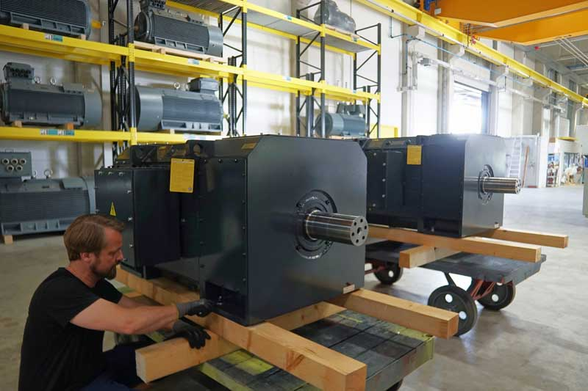
Caption: Two identical DC motors on the way to driving a rolling mill

Image/s: | dc-motors_metalworks | Characters: | 933
File name: | 202506010_pm_dc_motors_rolling_mill_en | Date: | 06-24-2025
Tags: | DC motors, roller motors, copper rolling mill, special design
About Menzel Elektromotoren
Menzel Elektromotoren GmbH has been manufacturing and distributing electric motors since 1927. The German family-run company based in Hennigsdorf near Berlin specializes in the delivery of large electric motors, including special models, within the shortest time possible. The product range comprises high and low voltage motors, DC motors, transformers, and frequency inverters. Services include motor production up to and beyond 25 MW and short-term adaptation of stock motors to application-specific requirements. In order to ensure short delivery times, Menzel maintains a large inventory with over 20,000 motors up to 15 MW. Qualified engineering, experienced staff, and state-of-the-art production and testing facilities help the manufacturer provide excellent reliability. Menzel operates subsidiaries in Sweden, the UK, France and Italy and cooperates with numerous partners worldwide.
Contact:  Menzel Elektromotoren GmbH  Anja Leipold  Corporate Communications  Am Alten Walzwerk 2  16761 Hennigsdorf  Germany  Phone: +49 30 349 922-0  Email: info@menzel-motors.com  Internet: www.menzel-motors.com |  | gii die Presse-Agentur GmbH  Christburger Str. 41  10405 Berlin  Germany  Phone: +49 30 538 965-0  Email: info@gii.de  Internet: www.gii.de

