Press Release

MID-certified energy meters with radio interface

Gossen Metrawatt expands its portfolio of MID-certified ENERGYMID energy meters, adding models with a radio interface based on the LoRaWAN standard. The radio protocol features a long range and bidirectional communication, using secure AES encryption. The new ENERGYMID LPWAN energy meters are powered from the measuring voltage; users do not need to exchange batteries. Radio transmission creates significant cost savings as it requires no communication channels or time-consuming cabling. This enables easy integration into IoT structures and makes ENERGYMID LPWAN energy meters a perfect fit for decentralized, billable energy data acquisition at locations without wired communication, mobile meter stations such as construction site power supplies or small distribution boards and for integration into existing LoRaWAN networks. The new generation with radio function comes in several types, including versions for 4-wire networks, 400 V with 5(80) A direct connection or 1/5(6) A transformer connection. The devices record up to 33 measured variables in addition to the active power, such as reactive and apparent power, neutral conductor current, power factor, frequency, as well as power fed to the grid. They also monitor the network quality via THD current and voltage measurements. Like all ENERGYMID meters, the new series is highly compact, measuring only four standard width units, and can be mounted on 35-mm DIN top-hat rails in any position. Their high-contrast three-line LCD display with LED background illumination ensures excellent readability of measurement values. It simplifies connection parameter monitoring and warns of installation errors by changing colors. The devices are tamper-proof, featuring configuration disabling and sealed covers.

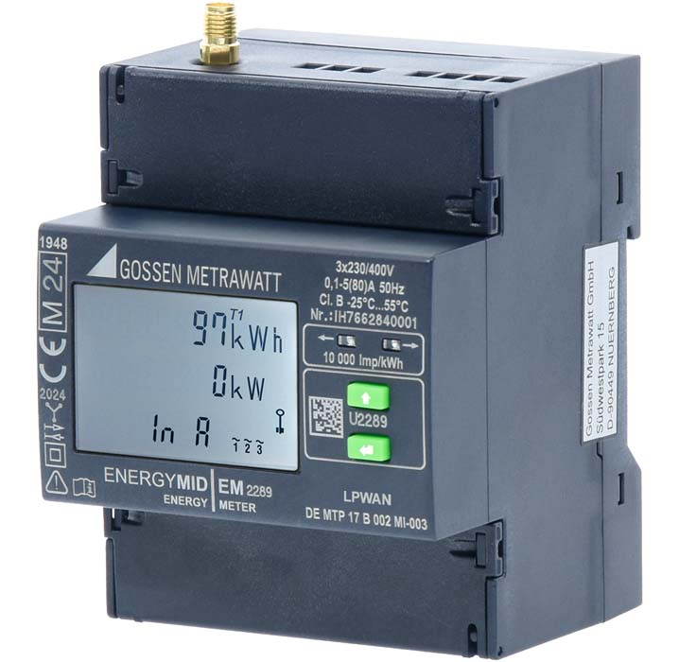
Caption: The new ENERGYMID LPWAN energy meters with a LoRaWAN interface reliably record and transmit the import and export of active power over long ranges via radio

Image/s: | energymid_lpwan_2000.jpg |  | Characters: | 1768
File name: | 202506017_pm_energymid_lpwan_energy_meter_en |  | Date: | 06-25-2025
Tags: | energy meter, energy meters, ENERGYMID LPWAN, MID-certified, radio interface, LoRaWAN, encryption, IoT, energy data acquisition
About Gossen Metrawatt
Gossen Metrawatt, one of the world’s leading suppliers of measurement systems, develops and distributes a wide range of high-quality measuring and test devices for electrical trade, various industries and the public sector.
The Gossen Metrawatt brand has been synonymous with safety and quality “Made in Germany” for decades. Its product range includes measurement and test technology for the electrical safety of plants, devices and machines as well as for the e-mobility and medical technology industries. Additional key areas of interest are power quality, battery testing technology, multimeters, calibrators, power supply technology and energy management systems. For a truly comprehensive electrical safety portfolio, Gossen Metrawatt also offers a continuously growing range of digital services and cloud services and supports its customers with a versatile training program and a wide range of after-sales services.
Gossen Metrawatt is part of the GMC Instruments Group, which also includes other specialized manufacturers for measurement and testing technology – notably, Camille Bauer Metrawatt, Dranetz, Prosys, Seaward and Rigel and Kurth Electronic. The Camille Bauer and Rigel brands add to the portfolio various transducers, display instruments and detection systems for heavy-current engineering as well as special measuring, testing and functional testing devices for the medical sector. The GMC-I Group runs its own DAkkS-certified calibration center that performs DAkkS, ISO and factory calibrations for virtually all electrical measured quantities. The GMC-I Group has development and production sites in Germany, Switzerland, England and the USA and a worldwide sales network of its own companies as well as sales partners.
Contact:  Gossen Metrawatt GmbH  Christian Widder  Head of Marketing Communication  Suedwestpark 15  90449 Nuremberg  Germany  Phone: +49 . 911 . 8602-572  Email: christian.widder@gossenmetrawatt.com  Internet: www.gossenmetrawatt.com |  | gii die Presse-Agentur GmbH  Christburger Str. 41  10405 Berlin  Germany  Tel.: +49 . 30 . 538 9650  Email: info@gii.de  Internet: www.gii.de

