Press Release

Gas explosion proof extruder motor in size 1000

Replacing an explosion-proof size 1000 motor at short notice is an ambitious task. For the German family-run company Menzel Elektromotoren, it was a chance to prove once again its extensive expertise in the design, manufacture and certification of explosion-proof motors. A plastics producer had to replace an existing extruder motor with ignition protection type Ex d (flameproof encapsulation) very urgently. Menzel and the client found that a motor with the ignition protection type Ex ec (increased safety) would satisfy the current hazardous zone requirements. The motor manufacturer selected a suitable three-phase squirrel-cage motor from its extensive stock, individually adapting it for the drive task and the installation site. The project hinged on upgrading the motor for zone 2 hazardous areas with potentially explosive gas atmospheres and getting it the necessary ATEX certification. Menzel’s officially certified in-house experts labeled the motor II 3G Ex ec IIC T4 Gc. The new motor with a lower shaft height at 630 mm was brought up to the center height of the old motor by means of a welded base. Since the new motor has four winding systems instead of the two of the old one, Menzel also made electrical modifications for operation on the existing frequency converter.

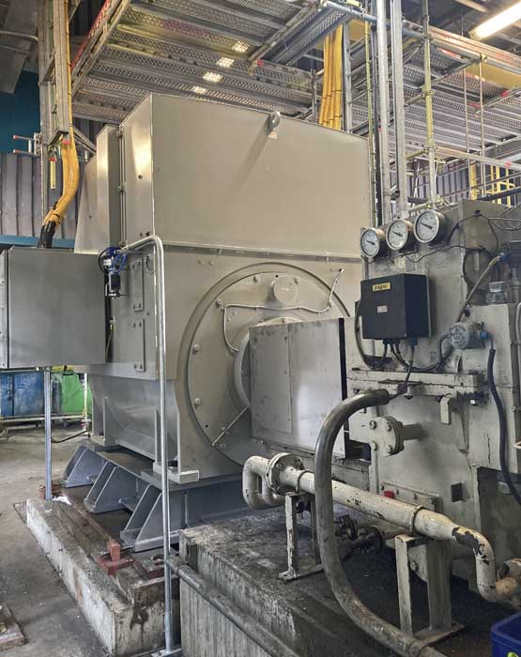
Caption: Fasttrack customization and certification for hazardous areas – the extruder motor is now already in use and the customer is satisfied

The project exposes the existing supply gap for explosion-proof motors in large sizes: the few existing suppliers can only offer building a motor from scratch – with the corresponding months-long delivery times. Menzel stands out from the competition with its large stock inventory and ability to configure and adapt stock electric motors in-house for hazardous areas and certify them according to the latest ATEX directives. In this instance, only two weeks passed from order placement to installation at the customer’s site. The customer came to Berlin for testing and acceptance and praised Menzel’s flexibility.
More about motors with ignition protection type Ex ec (increased safety) for zone 2 or 22 hazardous areas with gas or dust atmospheres: https://www.menzel-motors.com/ex-na/

Image/s: | extruder_motor_ex_ec_1000_mm | Characters: | 1904
File name: | 202507002_pm_extruder_motor_ex_ec_en | Date: | 07-22-2025
Tags: | gas explosion proof, ATEX, Ex ec, increased safety, extruder motor, squirrel-cage motor, frequency converter, customization
About Menzel Elektromotoren
Menzel Elektromotoren GmbH has been manufacturing and distributing electric motors since 1927. The German family-run company based in Hennigsdorf near Berlin specializes in the delivery of large electric motors, including special models, within the shortest time possible. The product range comprises high and low voltage motors, DC motors, transformers, and frequency inverters. Services include motor production up to and beyond 25 MW and short-term adaptation of stock motors to application-specific requirements. In order to ensure short delivery times, Menzel maintains a large inventory with over 20,000 motors up to 15 MW. Qualified engineering, experienced staff, and state-of-the-art production and testing facilities help the manufacturer provide excellent reliability. Menzel operates subsidiaries in Sweden, the UK, France and Italy and cooperates with numerous partners worldwide.
Contact:  Menzel Elektromotoren GmbH  Anja Leipold  Corporate Communications  Am Alten Walzwerk 2  16761 Hennigsdorf  Germany  Phone: +49 30 349 922-0  Email: info@menzel-motors.com  Internet: www.menzel-motors.com |  | gii die Presse-Agentur GmbH  Christburger Str. 41  10405 Berlin  Germany  Phone: +49 30 538 965-0  Email: info@gii.de  Internet: www.gii.de

