Press Release

Floor-level rail system for efficient warehouse logistics

LOSYCO designs and builds efficient heavy-duty transport solutions based on its modular, floor-level LOXrail system. Applications include production logistics, machine feeding, material flow and warehouse logistics. Now, the German intra-logistics experts have installed a system with 180 meters track length for the window and door manufacturer HÖNING. They established connections from the goods receipt area to the material warehouse and to the new machining center in two construction phases, each with two tracks along and four across. Eight crossing points enable flexible navigation of the plant. LOSYCO also built 20 customer-specific transport trolleys featuring AllRounder wheelsets for an easy change of direction directly on the rail. “Initially, we had planned to set up an automated high-bay warehouse for material storage and feeding,” says Höning production manager Ronny Paulsen. “However, it turned out that the associated fire protection requirements would cause disproportionately high costs. In our search for alternatives, we came across LOXrail. The concept and offer designed by LOSYCO convinced us both functionally and as an economic proposition.” The trolleys run on the new, floor-flush rails with 25-mm stainless-steel shafts. Designed for a maximum payload of five tons, each trolley can transport several material containers. The loads are secured by special brackets. To securely stop the trolleys at the loading and unloading points, locking bolts at the ends of both side arms are lowered into corresponding floor bushings. “The transport system has significantly improved material logistics and order picking for us,” says Ronny Paulsen. “The low friction makes the LOXrail system easy to handle and very ergonomic. We can move loads along and across with just one person. And we can cross the tracks laid in the hall floor on foot or with industrial trucks without a problem.”

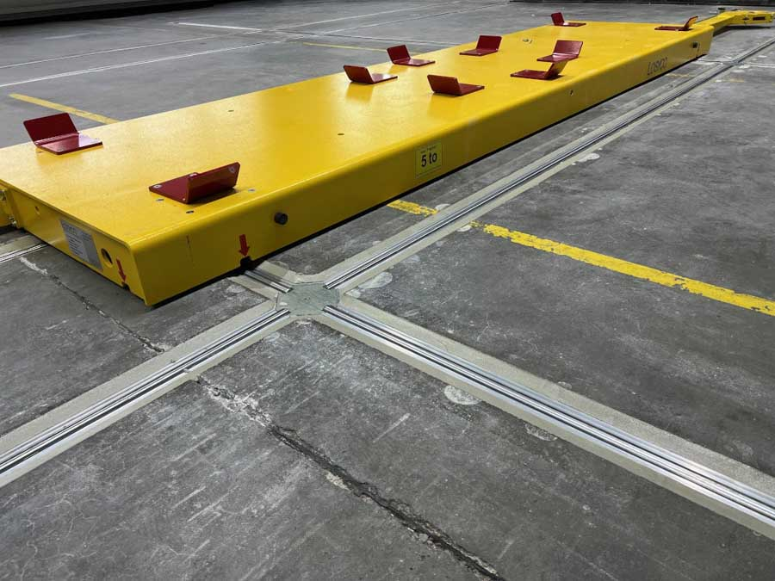
Caption 1: The LOXrail system enables crossing lines and trolley travel around corners

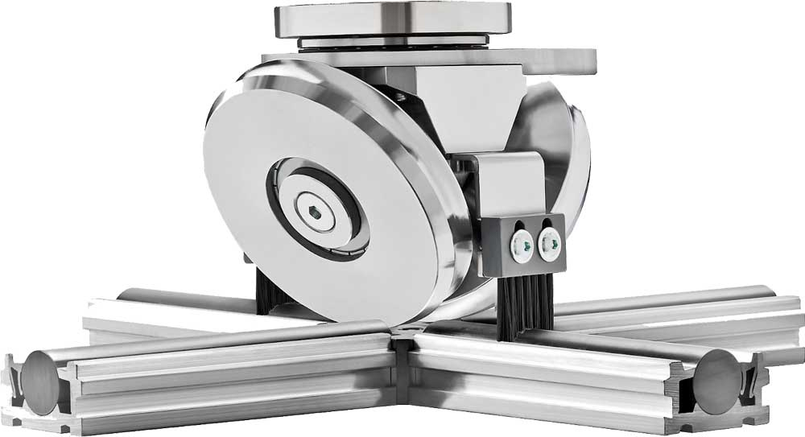
Caption 2: LOSYCO has developed AllRounder wheelsets for an easy change of direction directly on the LOXrail without additional shunting elements

Image/s: | fahrwagen_nah_1000.jpg  allrounder-radsatz_schiene_2000.jpg | Characters: | 1912
File name: | 202507012_pm_warehouse_logistics_en | Date: | 07-01-2025
Tags: | intra-logistics, floor-level rail system, warehouse logistics, machine feeding, heavy-duty transport
About Losyco
LOSYCO designs, builds, and installs intra-logistics systems for the manufacturing industry. The company based in Bielefeld, Germany, was founded by experienced engineers in 2016. LOSYCO’s core product is the LOXrail® floor rail system for easy transport and precise positioning of loads weighing several tons. LOXrail transport platforms can be operated manually or with auxiliary drives. LOSYCO also supplies handling equipment such as chain and roller conveyors, material management and storage systems, as well as sound-proof cabins and machine covers. LOSYCO supports customers wishing to transform their production processes to lean manufacturing and continuous flow production. LOSYCO is a member of the DRECKSHAGE Family.
Contact:  LOSYCO GmbH  Tim Schneider  Walter-Werning-Str. 7  33699 Bielefeld  Germany  Tel.: +49 . 521 . 945 643-0  Email: info@losyco.com  Internet: www.losyco.com |  | gii die Presse-Agentur GmbH  Christburger Str. 41  10405 Berlin  Germany  Tel.: +49 . 30 . 538 965-0  Email: info@gii.de  Internet: www.gii.de

