Biesse at the K 2025 trade fair
#EmbraceTheEvolution

The letter “K” has become a symbol for the fascinating world of plastics. The leading international trade fair K, which premiered over 70 years ago, is a global magnet and meeting place for the plastics and rubber industry. The next show is in Düsseldorf, Germany, from 8 to 15 October 2025 – and Biesse will be there, presenting new technologies to a live audience.

K, the leading international trade fair for the plastics and rubber industry with over 3000 exhibitors from more than 60 countries attracts large numbers of experts from production, processing and related industries such as mechanical engineering, electronics, medical technology, automotive, packaging and construction from all over the world. Every three years, the industry event with a long tradition offers a forum for discussion and networking.

A new era
Biesse presents the new Explora Multi Pro M S. to set new standards in terms of performance and repeatability, redefining the machining of high-precision technical components for the automotive, aerospace and plastics processing industries.

The Explora Multi Pro M S is designed to meet the most demanding applications, ensuring exceptional accuracy and repeatability. By integrating Siemens' next-generation components, such as high-performance motors, drives, and the SINUMERIK ONE numerical control system, the machine delivers top-tier results in every production cycle. It is equipped for exact machining of various materials, featuring a precise head, an automatic tool changer and a large tool magazine. Manufacturers who work with complex geometries and high-performance materials will particularly appreciate this solution.

New naming concept, proven quality

The renewed Biesse Machinery portfolio guarantees significant improvements in the functionality and performance of machines for all materials. It includes an innovative range of services and assistance, along with a new human-machine interaction. The new Human Machine Interface, clear and highly intuitive, has a unified design for all materials, improving the user experience and simplifying production processes.
The manufacturer has introduced a new, logically structured naming concept across all material areas, based on the particular machine’s processing tasks and application segments.

Experience diversity
The new Explora Multi Pro M S will be running at full speed at K 2025, strikingly demonstrating its capabilities. Visitors to the booth will gain insights into the huge range of products, which comprises machining centres, waterjet cutting systems and cutting and thermoforming machines for processing plastics, composites, light metal alloys and thermoformed materials. The Biesse team is looking forward to welcoming visitors in Hall 3, at Booth B17.

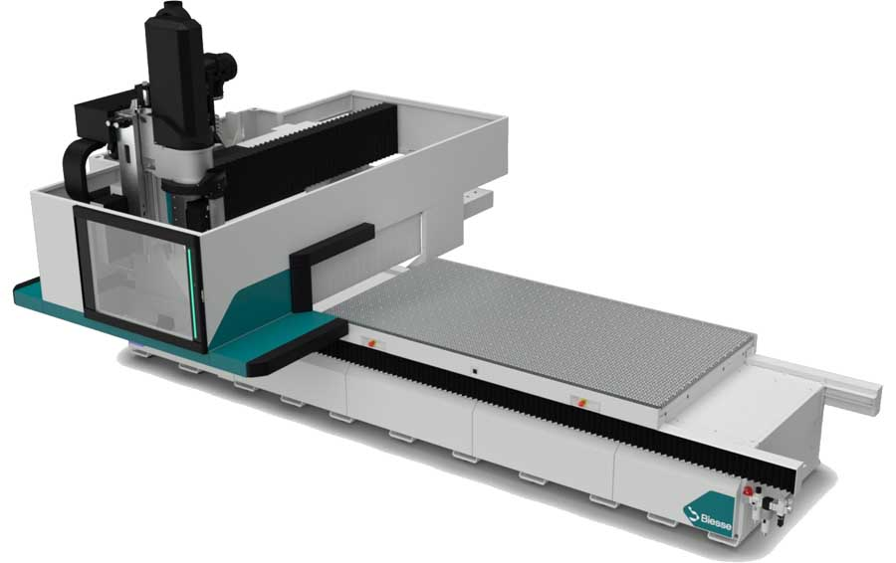
Image 1: Biesse has completely redesigned the Explora Multi Pro M S for demanding tasks

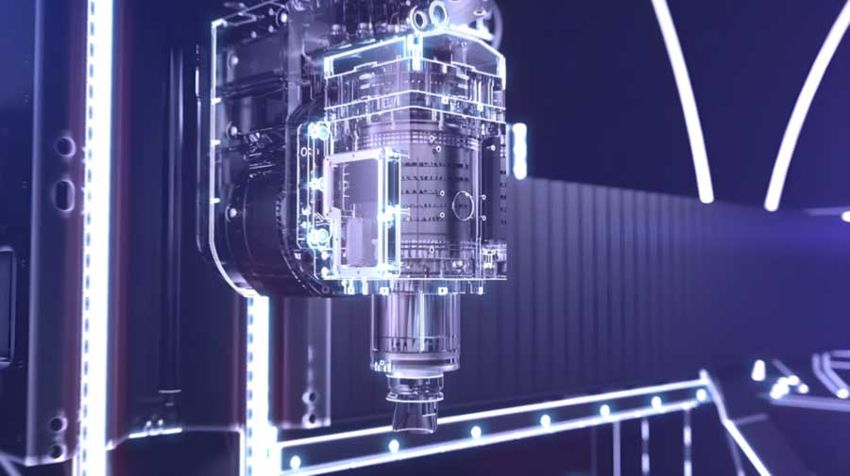
Image 2: The Explora Multi Pro M S features with the industrial SINUMERIK ONE NC, a high-precision head, automatic tool changer and a large tool magazine

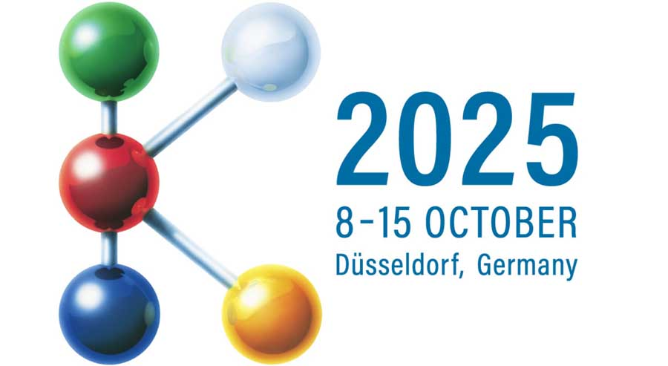
Image 3: Biesse at K 2025 – Hall 3, Booth B17

Image/s: | ExploraMultiProMS  Explora_Multi_detail  K-Logo | Characters: | 3531
File name: | 202508006_kt_k_2025_trade_fair_en | Date: | 09-23-2025

Biesse - We manufacture lines, machinery and components for making products, enhancing the potential of the wide range of materials processed by our customers. We simplify the production processes of customers working in the furniture, construction, automotive and aerospace sectors, courtesy of the skill of the people who work in our production sites around the world. Founded in Italy in 1969 and now listed on the Italian Stock Exchange, we are driven by our international calling, which is manifested through a global network of showrooms, where customers can enjoy a multi-material experience.

