Press Release

Permanently flexible cable design for dynamic applications

SAB Bröckskes presents SABdynamic 900 and 910, a new generation of CSA and UL/cUL approved cables – made in Germany for worldwide use. The special cable manufacturer thus extends its range by permanently flexible control and data cables, which are equally suitable for drag chains and robot-compatible torsion applications. Both cable variants can withstand over 10 million bending cycles and over 10 million torsion cycles up to ±180°/m or 5 million up to ±360°/m. An added advantage of the new generation is the reduced cable capacitance. The SABdynamic 900 and 910 data variants achieve very high signal integrity, due to the reduced material thickness of the SABIX-based insulating sleeve. Therefore, they ensure interference-free and loss-free data transmission for real-time applications even with cable lengths over 20 m. The new SABdynamic 900 and 910 cable series, each manufactured in control and data versions, are designed for voltages up to 350 V and 600 V respectively and can withstand temperatures between -40 °C and 90 °C. In addition, they have an excellent TMPU-tested oil resistance according to EN 50363-10-2 and VDE 0207-363-10-2 as well as good chemical resistance to acids, alkalis, solvents and hydraulic fluids.

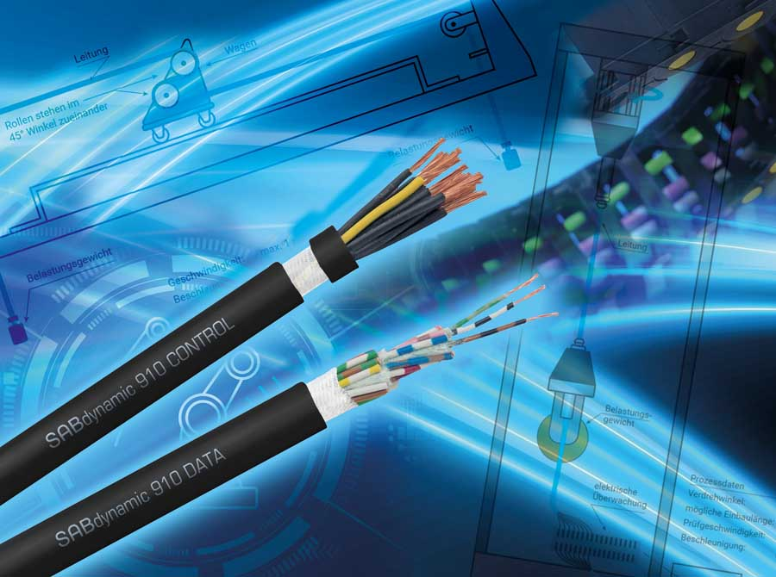
Caption: Highly flexible cables for dynamic applications: cables for applications with particularly high alternating bending loads, e.g. in drag chains and robotic systems

They are UV-resistant according to HD 605, ozone-proof according to DIN EN 50396, saltwater-resistant according to UL 1309 as well as RoHS-compliant and LABS-non-critical. In addition, both versions are PFAS-free, which offers users operational safety even in the event of a PFAS ban. Thanks to the halogen-free material mix with a flame-retardant, self-extinguishing PUR jacket, both product series meet the approval criteria for the North American market. SAB Bröckskes supplies S900 Data by default in the format 12 x 0.14 mm² as a multi-core unshielded cable as well as in four multi-pair shielded variants. The S910 Data version is available in three standard versions. SAB Bröckskes offers standard control cables as two multi-core unshielded and two multi-core shielded options. On request, the manufacturer develops and produces bespoke solutions with customer-specific dimensions, different sheath colors and individual cable designs.

Image/s: | SAB_dynamic_2000.jpg | Characters: | 2180
File name: | 202508012_pm_sabdynamic_900-910_en | Date: | 09-23-2025
Tags: | special cable, flexible cable, bending, control and data cables, dynamic applications, drag chains, robotic systems, CSA and UL/cUL approved
About SAB Bröckskes
Founded in Viersen, Germany, in 1947 by Peter Bröckskes as a one-man operation for electrical system design, SAB Bröckskes GmbH & Co. KG has grown into one of the world’s leading special cable manufacturers, now employing a staff of more than 550 who generate a turnover of over €134 million euros in over 100 countries. The portfolio includes cables and wires manufactured from a wide variety of materials as well as cable assembly and measurement solutions. All products are developed and manufactured exclusively at the Viersen headquarters. The company supplies various industries from industrial automation and communication technology to manufacturers of construction and agricultural machinery, railway and shipping technology and medical technology. SAB Bröckskes has a global presence with international subsidiaries and sales offices.
Contact:  SAB BRÖCKSKES GmbH & Co. KG  Sacir Adrovic  Grefrather Str. 204–212b  41749 Viersen  Germany  Phone: +49 2162 898-146  Email: s.adrovic@sab-cable.com  Internet: www.sab-cable.com |  | gii die Presse-Agentur GmbH  Christburger Str. 41  10405 Berlin  Germany  Phone: +49 30 538 965-0  Email: info@gii.de  Internet: www.gii.de

