Press Release

Requirements engineering for sustainable sensor cables

SAB Bröckskes designs special sensor cables for environmental monitoring, offering individual requirements engineering with regard to environmental compatibility, ruggedness, weight, insulation and sheath materials. Sensor-based biomarker tracking is gaining importance in environmental monitoring and ranges from long-term air and water quality monitoring to sample evaluation of farm surface water and real-time water level monitoring. The reliability and longevity of the sensor systems are crucial in all monitoring tasks. Wired connections have proven to be a robust and reliable solution. High transmission capacities and data rates can be achieved via USB 3.0 and Gigabit Ethernet, depending on the sensor and measurement task. However, the ecological footprint has a negative impact if critical raw materials are combined or in case of less sustainable manufacturing processes. ‘For this reason, we attach great importance to sustainability in production and material selection,’ says Marc Gerlatzek, Business Development for the Medical Technology and Assembly Division at SAB Bröckskes. ‘For example, the jacket material in our SABorganic series consists of around 45 percent ecological, environmentally friendly raw materials. As a result, we reduce our CO2 footprint by an average of 25 percent compared to comparable fossil products. We source the materials from short, regional supply chains.’ Sustainable, resource-saving production processes are just as relevant for the life cycle assessment. SAB Bröckskes now generates around a quarter of its electricity needs from renewable sources from its own photovoltaics systems.

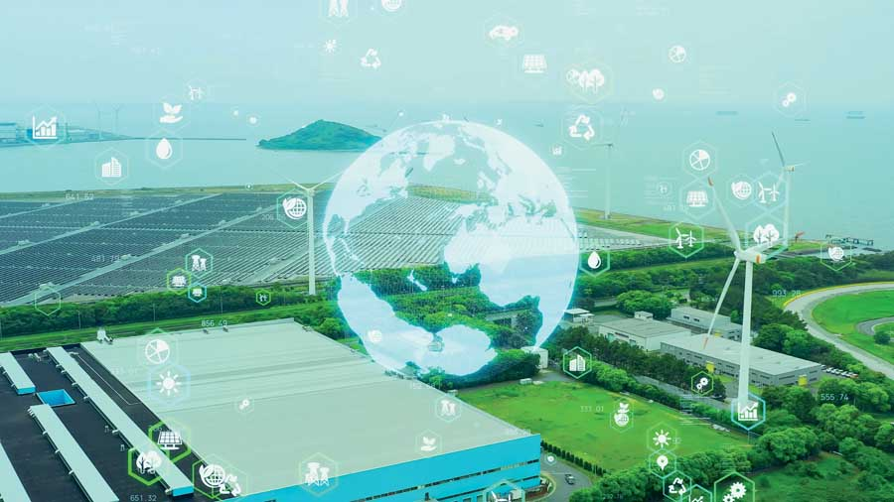
Caption 1: Requirements engineering for environmental monitoring

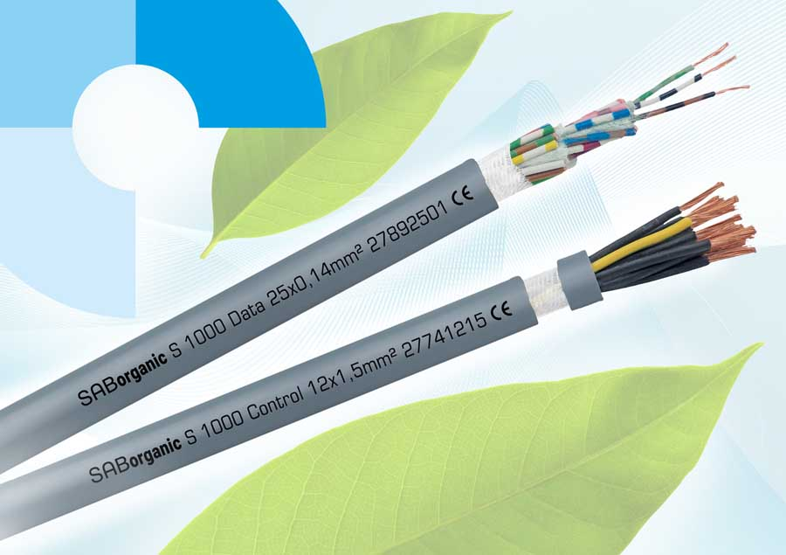
Caption 2: The ecologically sustainable SABorganic data and control cables from SAB Bröckskes in a CO2-reduced outer jacket

Image/s: | umweltmonitoring_rgb_2000.jpg  sab_organic_2024_2000.jpg | Characters: | 1638
File name: | 202508013_pm_environmental_monitoring_en | Date: | 09-03-2025
Tags: | special sensor cables, environmental monitoring, requirements engineering, environmental compatibility
About SAB Bröckskes
Founded in Viersen, Germany, in 1947 by Peter Bröckskes as a one-man operation for electrical system design, SAB Bröckskes GmbH & Co. KG has grown into one of the world’s leading special cable manufacturers, now employing a staff of more than 550 who generate a turnover of over €134 million euros in over 100 countries. The portfolio includes cables and wires manufactured from a wide variety of materials as well as cable assembly and measurement solutions. All products are developed and manufactured exclusively at the Viersen headquarters. The company supplies various industries from industrial automation and communication technology to manufacturers of construction and agricultural machinery, railway and shipping technology and medical technology. SAB Bröckskes has a global presence with international subsidiaries and sales offices.
Contact:  SAB BRÖCKSKES GmbH & Co. KG  Sacir Adrovic  Grefrather Str. 204–212b  41749 Viersen  Germany  Phone: +49 2162 898-146  Email: s.adrovic@sab-cable.com  Internet: www.sab-cable.com |  | gii die Presse-Agentur GmbH  Christburger Str. 41  10405 Berlin  Germany  Phone: +49 30 538 965-0  Email: info@gii.de  Internet: www.gii.de

