Press Release

Connection cables optimized for NVH testing

Special cable manufacturer SAB Bröckskes develops and produces sensor cables ‘Made in Germany’ optimized for NVH testing in a wide variety of designs.

A trouble-free connection between sensor and measuring system is essential in NVH (noise, vibration, harshness) measurement technology, in vibration analyses or in the electric vehicle sector. As one of the leading cable manufacturers, SAB Bröckskes offers a broad portfolio of connecting cables for accelerometers that ensure superior signal quality and long-lasting performance. The special cable supplier’s NVH cables ensure precise data transmission even under demanding conditions.

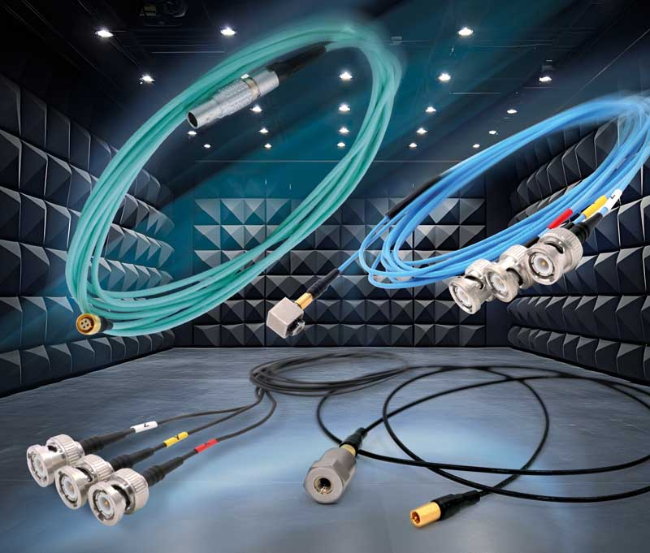
Caption: SAB Bröckskes has a broad portfolio of sensor cables for NVH testing

The range includes sensor cables for triaxial and uniaxial sensors that are compatible with IEPE or charge-based systems. The manufacturer supplies special low-noise coaxial cables for particularly sensitive charging applications, which operate with low interference voltage and reliably protect the measuring chain from electrostatic interference. The cables are optimally adapted to the specific requirements by using different sheath materials in order to provide the right cable variant for every installation situation, whether a robust IEPE sensor cable or a flexibly assembled special solution. While TPFK jackets are ideal for high temperatures and confined spaces, PUR jackets are ideal for mechanical stress and silicone for highly flexible applications with narrow bending radii. In addition to proven standard designs, SAB Bröckskes designs customized cable solutions such as specific connector configurations (e.g. for PAK II from Müller-BBM); HV-compatible variants for touch-safe applications; or special solutions like coaxial cable drums and multiple cables for NVH test benches. In addition, the manufacturer supports customers with comprehensive services, including very small production runs, delivery of individual cable lengths, customer-specific labeling and personal advice online or on site.

https://www.sab-cable.com/cables-wires-harnessing-temperature-measurement/measurement-solutions/connection-cables-for-nvh-testing.html

Image/s: | SAB_nvh-kabel_2500.jpg | Characters: | 1952
File name: | 202508014_pm_nvh_testing_en | Date: | 10-14-2025
Tags: | NVH testing, vibration analyses, electric vehicle sector, IEPE sensor cable, low-noise coaxial cables, triaxial, uniaxial
About SAB Bröckskes
Founded in Viersen, Germany, in 1947 by Peter Bröckskes as a one-man operation for electrical system design, SAB Bröckskes GmbH & Co. KG has grown into one of the world’s leading special cable manufacturers, now employing a staff of more than 550 who generate a turnover of over €134 million euros in over 100 countries. The portfolio includes cables and wires manufactured from a wide variety of materials as well as cable assembly and measurement solutions. All products are developed and manufactured exclusively at the Viersen headquarters. The company supplies various industries from industrial automation and communication technology to manufacturers of construction and agricultural machinery, railway and shipping technology and medical technology. SAB Bröckskes has a global presence with international subsidiaries and sales offices.
Contact:  SAB BRÖCKSKES GmbH & Co. KG  Sacir Adrovic  Grefrather Str. 204–212b  41749 Viersen  Germany  Phone: +49 2162 898-146  Email: s.adrovic@sab-cable.com  Internet: www.sab-cable.com |  | gii die Presse-Agentur GmbH  Christburger Str. 41  10405 Berlin  Germany  Phone: +49 30 538 965-0  Email: info@gii.de  Internet: www.gii.de

