Press Release

Pump motor for Red Cross in Syria

Menzel Elektromotoren has manufactured a pump motor for the Red Cross in Syria. The vertical motor will help stabilize the water supply in communities destroyed in the civil war. The pump station operator required a straightforward drop-in replacement for an old V1-type motor, matching the existing mechanical interfaces without any constructional changes. This called for various complex features. The large vertical motor with a shaft height of 800 mm has the unusual cooling type IC 511 (tube cooling), with a smooth round welded steel housing in protection class IP54. Menzel built a special flange and fitted the slip ring motor with a short-circuiting and brush-lifting device, which lifts the carbon brushes after the motor start, thus reducing brush wear as well as the effort needed for regularly cleaning the slip ring chamber. The customer requested Menzel to fit the brush-lifting device on the drive side. The motor manufacturer also implemented this uncommon design expertly and within a manageable budget, including various additional works such as fabricating extension rings. Moreover, the family business manufactured a customized motor shaft and terminal boxes. Before shipping, Menzel thoroughly tested the pump motor, making use of the latest addition to its test field, a 3-MW right-angle gearbox that allows load tests in a vertical position. An independent test technician appointed by the customer supervised the load test. The bespoke motor is rated for 1150 kW, 6300 V, 14841 Nm and 740 rpm.
More about the motor cooling type IC 511 (tube cooling): https://www.menzel-motors.com/slip-ring-motor/ic511/

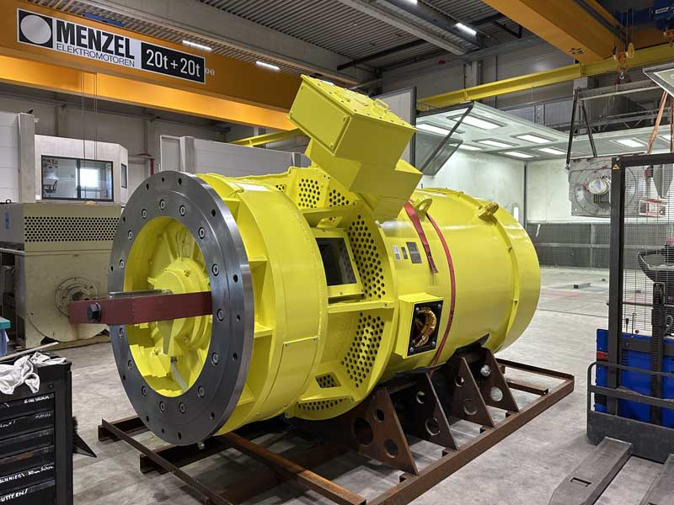
Caption: The family business Menzel expertly implements even unusual features such as special cooling types and customized designs for brush lifting

Image/s: | pump_motor_red_cross_syria |  | Characters: | 1519
File name: | 202509011_pm_pump_motor_red_cross_syria_en |  | Date: | 10-16-2025
Tags: | pump motor, vertical motor, slip ring motor, customized, drop-in replacement, cooling type IC 511, tube cooling, brush-lifting, load test
About Menzel Elektromotoren
Menzel Elektromotoren GmbH has been manufacturing and distributing electric motors since 1927. The German family-run company based in Hennigsdorf near Berlin specializes in the delivery of large electric motors, including special models, within the shortest time possible. The product range comprises high and low voltage motors, DC motors, transformers, and frequency inverters. Services include motor production up to and beyond 25 MW and short-term adaptation of stock motors to application-specific requirements. In order to ensure short delivery times, Menzel maintains a large inventory with over 20,000 motors up to 15 MW. Qualified engineering, experienced staff, and state-of-the-art production and testing facilities help the manufacturer provide excellent reliability. Menzel operates subsidiaries in Sweden, the UK, France and Italy and cooperates with numerous partners worldwide.
Contact:  Menzel Elektromotoren GmbH  Anja Leipold  Corporate Communications  Am Alten Walzwerk 2  16761 Hennigsdorf  Germany  Phone: +49 30 349 922-0  Email: info@menzel-motors.com  Internet: www.menzel-motors.com |  | gii die Presse-Agentur GmbH  Christburger Str. 41  10405 Berlin  Germany  Phone: +49 30 538 965-0  Email: info@gii.de  Internet: www.gii.de

