Press Release

RAFI at Agritechnica 2025:
Pioneering solutions for agricultural technology

RAFI will be showcasing groundbreaking technologies and products for agricultural machinery operation at Agritechnica in Hanover from November 9 to 15; 2025. One of the main attractions at the booth (Hall 17, Stand B29) is the innovative Safety Touch technology platform, designed for the series production of industrial touchscreen control systems of performance level d for safety-critical applications. The safety concept, which is based on reliable and durable hardware components, redundant sensor architecture, and comprehensive diagnostic software, provides significantly greater flexibility than hard-wired safety features. Another highlight of the exhibition is the multifunctional UNI-TOUCH system, which RAFI developed for the latest UNIMOG generation from Mercedes-Benz. This system features a touchscreen, center console, and detachable joystick. The control system’s functions and button assignments can be flexibly adapted to a wide range of applications and attachments. One of the exhibited products is a recently developed steering joystick. The ergonomic, fully electronic steering stick can be customized as required in terms of steering force, steering angle, neutral position, and park position. TrueMotion technology and direct force feedback ensure an authentic driving experience. Another new feature is the Flex Knob, which uses wear-free Hall-effect sensors. The smart Flexcoder can be configured via software with individually programmable detent positions. For force feedback, the actuator can be coupled to a defined torque, enabling a realistic actuation feel in applications such as hydraulic systems. The HMI specialist will also be concentrating on advancing technology for autonomous agricultural machinery through its AUTONOMY KIT.

“We think big, even if transformations are often implemented in baby steps. We encourage you to check out our live HMI innovations, featuring SAFETY TOUCH and the AUTONOMY KIT. These are tools that take efficiency, safety, and autonomous processes in agricultural technology to the next level, ensuring your products and vehicles are prepared for the future,” explains Ladun Bakar, Head of Team Sales of Agriculture & Commercial Vehicles at RAFI.

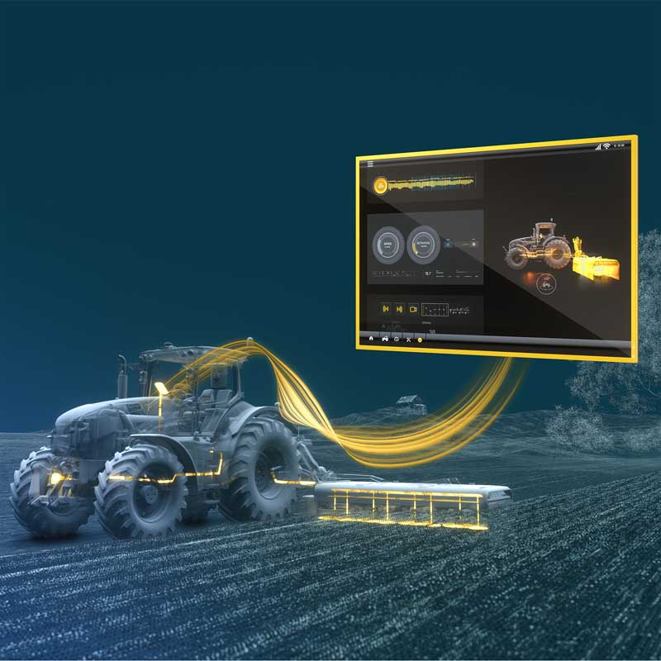
Caption: An exhibition highlight from RAFI at Agritechnica: The safety touchscreen in performance level d developed according to industry standards

Image source: RAFI GmbH & Co

Image/s: | rafi_safety_touch_2000px.jpg | Characters: | 2213
File name: | 202510005_pm_agritechnica_en.docx | Date: | 10-01-2025
Tags: | RAFI, Agritechnica 2025, agricultural technology, touchscreen, control systems, safety, performance level d, Safety Touch, joystick

About the RAFI Group
Founded in 1900, RAFI today develops and produces electromechanical components and systems for human-machine interaction. The range of products includes switches and key switches, touchscreens, control systems, and electronic assemblies. RAFI products are employed in many industries including automation, medical technology, machine and plant engineering, road and railway vehicles, household appliances, and telecommunication. The RAFI Group operates internationally with over 2,000 employees at sites in Germany, Europe, China, and the USA. The headquarters of the RAFI group of companies is located in Berg near Ravensburg.

Contact:  RAFI GmbH & Co. KG  Fred Nemitz  Head of Test Center Marketing & Communications  Ravensburger Straße 128–134  88276 Berg, Germany  Phone: 0160 92048569  Email: fred.nemitz@rafi-group.com  Web: www.rafi-group.com |  | gii die Presse-Agentur GmbH  Christburger Str. 41  10405 Berlin  Phone: +49 30 53 89 65-0  Email: info@gii.de  Web: www.gii.de

