Press Release

New products from GMC-Instruments at SPS 2025 tradeshow:
System solutions for energy data acquisition and management and PQ monitoring

Representing the entire GMC-Instruments Group, GOSSEN METRAWATT will showcase professional system solutions for comprehensive energy management from data acquisition and monitoring to analysis at the SPS tradeshow in Nuremberg, Germany, from 25 to 27 November 2025. Exhibits in hall 7A, at booth 420 will feature the latest product innovations from all GMC-Instruments brands. GOSSEN METRAWATT has announced the trade fair premiere of the new METRACAL CM handheld calibrator with intuitive operation, test routines and dual display mode for simultaneous calibration and measurement. The measurement technology specialist has also added a new MID-certified ENERGYMID energy meter featuring a radio interface in the LoRaWAN® standard. Radio communication simplifies integration into IoT structures and enables decentralized, billable energy data acquisition at locations without wired data transmission.

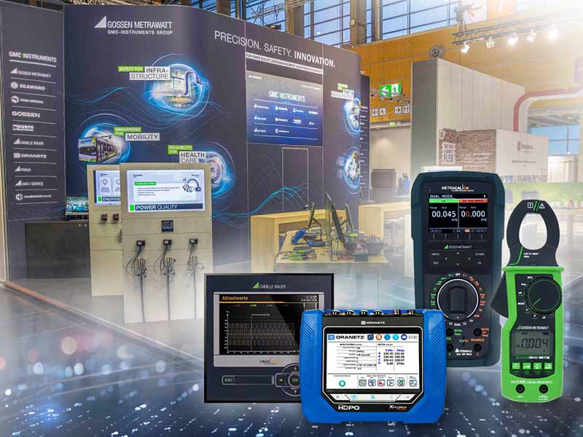
Caption: The brands of GMC-Instruments Group will present integrated solutions for electrical safety, power quality and energy management at the 2025 SPS tradeshow in Nuremberg, Germany

(Image: GMC-Instruments)

Tradeshow highlights will also include power quality analyzers from the DRANETZ brand. CAMILLE BAUER will present PME radio modules, which allow users to extend the range of functions of the multifunctional indicators and network analyzers from the SINEAX AM, DM5000, CENTRAX CU or LINAX PQ series, thereby transforming them into full-fledged energy centers for highly exact measurements of low-voltage systems. These can record up to 100 currents, divided between the PME sensors for 3 or 4 conductors each, without any additional wiring effort and secured by AES encryption. The British sister company SEAWARD has developed a new test device for photovoltaic systems up to 1500 V DC and 25 A. The Seaward PV:1525 portable photovoltaics tester combines output analyses, electrical safety tests and intuitive operation in a compact system. Dynamic surge protection dampens the inrush current and prevents damage from strong power surges. The trade fair appearance will also include a wide range of tried-and-tested measurement and testing technology, professional solutions for renewable energies, telecommunications testers and an overview of the extensive range of services offered by the group of companies. GMC-I experts are looking forward to engaging conversations and professional exchange at the tradeshow booth.

Image/s: | banner_messe25_1000.jpg | Characters: | 2222
File name: | 202510015_pm_sps_preview_en | Date: | 10-23-2025
Tags: | energy management, data acquisition, electrical safety, power quality, PQ monitoring, calibration, measurement, energy meter, photovoltaics tester
About Gossen Metrawatt
Gossen Metrawatt, one of the world’s leading suppliers of measurement systems, develops and distributes a wide range of high-quality measuring and test devices for the electrical trade, various industries and the public sector.
The Gossen Metrawatt brand has been synonymous with safety and quality “Made in Germany” for decades. Its product range includes measurement and test technology for the electrical safety of plants, devices and machines as well as for the electric vehicle sector and the medical technology industry. Additional key areas of interest are power quality, battery testing technology, multimeters, calibrators, power supply technology and energy management systems. For a truly comprehensive electrical safety portfolio, Gossen Metrawatt also offers a continuously growing range of digital services and cloud services and supports its customers with a versatile training program and a wide range of after-sales services.
Gossen Metrawatt is part of the GMC-Instruments Group along with further specialized manufacturers for measurement and testing technology: Camille Bauer Metrawatt, Dranetz, Prosys, Seaward, Rigel and Kurth Electronic. The Camille Bauer and Rigel brands add to the portfolio various transducers, display instruments and detection systems for heavy-current engineering as well as special measuring, testing and functional testing devices for the medical sector. The GMC-I Group runs its own DAkkS-certified calibration center that performs DAkkS, ISO and factory calibrations for virtually all electrical measured quantities. The GMC-I Group has development and production sites in Germany, Switzerland, England and the USA and a worldwide sales network of its own companies as well as sales partners.
Contact:  Gossen Metrawatt GmbH  Christian Widder  Head of Marketing Communication  Suedwestpark 15  90449 Nuremberg  Germany  Phone: +49 . 911 . 8602-572  Email: christian.widder@gossenmetrawatt.com  Internet: www.gossenmetrawatt.com |  | gii die Presse-Agentur GmbH  Christburger Str. 41  10405 Berlin  Germany  Phone: +49 . 30 . 538 9650  Email: info@gii.de  Internet: www.gii.de

