Press Release

Economic tailor-made pump motors for London water supply

Menzel Great Britain has completed its biggest project to date, providing 10 seven-ton electric motors to the UK water utility company Thames Water, which serves 16 million customers across London and the Thames Valley. This strategic motor replacement is crucial to extend the lifespan of a key water treatment plant by 10 years and secure the water supply to the Greater London area. Menzel won the contract for its economic, well-thought-out concept. The high-lift pump station at the Coppermills Water Treatment Works had experienced repeated failures, mainly due to the age of the existing equipment. As Thames Water is planning to build a new station in about 10 years, the utility company put out a tender for an economic drive solution to ensure reliable operation of the existing pumps in the interim. Other OEMs suggested costly variable-frequency drives (VFDs), which would have required major building reconstruction to accommodate control systems and transformers. Menzel proposed slip ring motors that are compatible with the existing installation and use the electric infrastructure and starting equipment already in place. The state-of-the-art motors are superior to the original motors with nearly 5 % increased eﬃciency, greater ease of maintenance and an expected lifespan of at least 25 years. The motor engineers worked closely with the project team of Thames Water’s contractor MWH Treatment. Their design also takes account of anticipated future extreme outdoor summer temperatures. The project came in under budget and was completed on schedule. Compared to the proposed VFDs, Menzel’s concept saved Thames Water hundreds of thousands of pounds, took much less time and is more environmentally friendly.

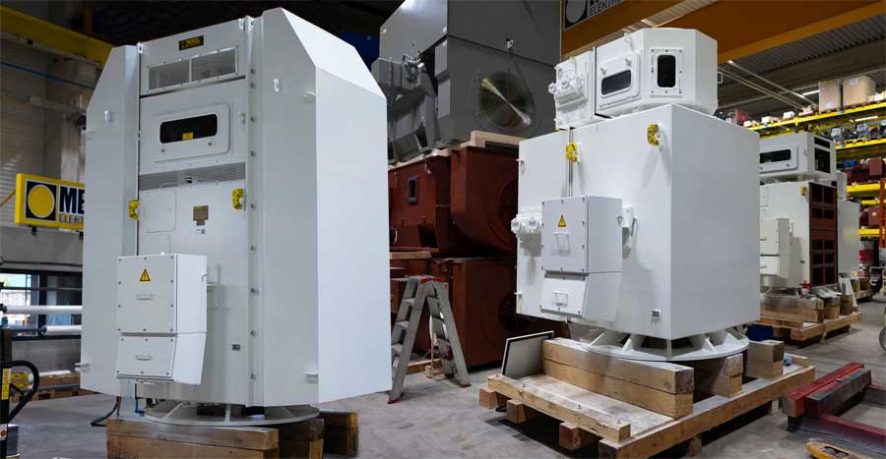
Caption: Menzel Elektromotoren is uniquely qualified in customizing large slip ring motors and always considers the customer and the application needs in its designs. The company established a British subsidiary in 2009.

The German manufacturer Menzel Elektromotoren has great expertise in building and customizing large-scale slip ring motors. These particular 10 slip ring motors utilized the existing pump pedestals, ensuring minimal site work and disruption. Menzel even tailored the terminal boxes to match the existing installation to make the cabling as easy and cost-efficient as possible. Menzel’s modular motor families accommodate various mounting types, cooling types and accessories. The 10 new motors have a shaft height of 500 mm and are designed for vertical mounting on the pumps. Six of the motors feature the cooling type IC 81W (air-to-water heat exchanger) and four IC 611 (air-to-air heat exchanger). They provide IP55 ingress protection, operate at 3300 V and, between the different models, provide outputs of 746 kW or 343 kW and rated torques of 12075 Nm or 5551 Nm.
This project earned Menzel a place in the finals for the 2025 AEMT Awards of the Association of Electrical and Mechanical Trades.

More information: https://www.menzel-motors.com/reference/ten-3300-kv-replacement-motors/

Image/s: | mebssw500_v1_pump_motors_coppermills |  | Characters: | 2726
File name: | 202511001_pm_pump_motors_thames_water_en |  | Date: | 11-21-2025
Tags: | Menzel Great Britain, Thames Water, water utility, water treatment, pump motors, slip ring motors, tailor-made
About Menzel Elektromotoren
Menzel Elektromotoren GmbH has been manufacturing and distributing electric motors since 1927. The German family-run company based in Hennigsdorf near Berlin specializes in the delivery of large electric motors, including special models, within the shortest time possible. The product range comprises high and low voltage motors, DC motors, transformers, and frequency inverters. Services include motor production up to and beyond 25 MW and short-term adaptation of stock motors to application-specific requirements. In order to ensure short delivery times, Menzel maintains a large inventory with over 20,000 motors up to 15 MW. Qualified engineering, experienced staff, and state-of-the-art production and testing facilities help the manufacturer provide excellent reliability. Menzel operates subsidiaries in Sweden, the UK, France and Italy and cooperates with numerous partners worldwide.
Contact:  Menzel Elektromotoren GmbH  Anja Leipold  Corporate Communications  Am Alten Walzwerk 2  16761 Hennigsdorf  Germany  Phone: +49 30 349 922-0  Email: info@menzel-motors.com  Internet: www.menzel-motors.com |  | gii die Presse-Agentur GmbH  Christburger Str. 41  10405 Berlin  Germany  Phone: +49 30 538 965-0  Email: info@gii.de  Internet: www.gii.de

