Press Release

Compact photovoltaics tester with dynamic surge protection

Seaward, part of the GMC-Instruments Group, presents a new portable tester for photovoltaic systems up to 1500 VDC and 25 A. The Seaward PV:1525 photovoltaics tester combines output analyses, electrical safety tests and intuitive operation in a compact handheld system. Functions include measurement of ground continuity, insulation resistance, no-load voltage and short-circuit current. Dynamic surge protection reduces the inrush current caused by short-circuiting PV modules during testing, ensuring it remains at a safe level. This prevents equipment damage from high power surges and ensures reliable performance and durability of the tester even under very demanding testing conditions.

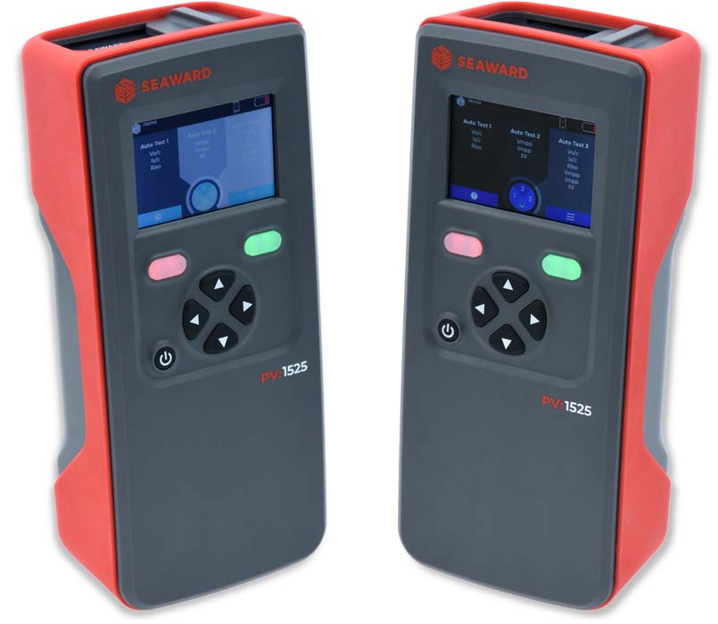
Caption 1: The new compact Seaward PV:1525 photovoltaics tester with dynamic surge protection and Bluetooth interface

Image: GMC-Instruments

Precise diagnostic tools enable rapid troubleshooting – for example, in the event of power loss, wiring problems or the degradation of modules. In this way, technicians can efficiently evaluate and optimize PV system performance. This makes the tester ideal for PV installers as well as operation and maintenance teams in commercial and industrial settings. Test results can be supplemented with site-specific information to simplify data management and traceability. Featuring a Bluetooth interface, the tester fits seamlessly into modern maintenance and installation processes. Users can transmit measurement results wirelessly, check them with a mobile app and install software updates via Bluetooth. In addition, the PV:1500 clamp meter included in the scope of delivery can directly record measured values and reliably transmit them to the tester via Bluetooth. Additional precise current measurements are integrated into the testing process to expand the analysis and documentation of performance.

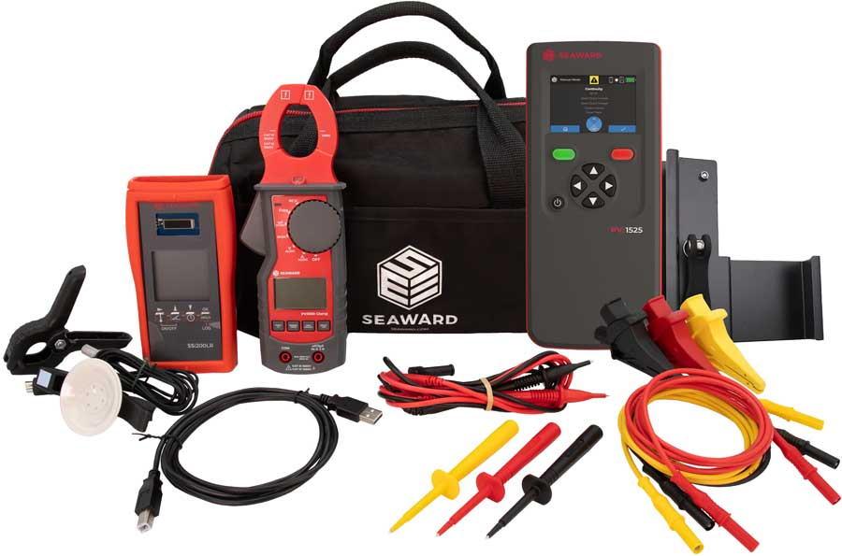
Caption 2: GMC-Instruments supplies the Seaward PV:1525 photovoltaics tester with a wide range of accessories

Image: GMC-Instruments

Mark Burton, Head of Engineering at Seaward, says: “The PV:1525 tester is our response to the rapid advances in solar technology. As solar panels become more powerful, testing technology must keep pace. We have developed a PV tester that is tailored to the everyday challenges of installers and maintenance technicians. This gives them a powerful, reliable tool for operating PV systems safely and efficiently.”

Image/s: | pv-152_doppelsicht_2000.jpg  seaward-pv-1525-kit_2000.jpg | Characters: | 2106
File name: | 202511022_pm_seaward_pv1525_tester_en | Date: | 11-06-2025
Tags: | photovoltaics tester, photovoltaic systems, solar technology, output analyses, electrical safety tests, ground continuity, insulation resistance, no-load voltage, short-circuit current, Bluetooth
About Gossen Metrawatt
Gossen Metrawatt, one of the world’s leading suppliers of measurement systems, develops and distributes a wide range of high-quality measuring and test devices for the electrical trade, various industries and the public sector.
The Gossen Metrawatt brand has been synonymous with safety and quality “Made in Germany” for decades. Its product range includes measurement and test technology for the electrical safety of plants, devices and machines as well as for the electric vehicle sector and the medical technology industry. Additional key areas of interest are power quality, battery testing technology, multimeters, calibrators, power supply technology and energy management systems. For a truly comprehensive electrical safety portfolio, Gossen Metrawatt also offers a continuously growing range of digital services and cloud services and supports its customers with a versatile training program and a wide range of after-sales services.
Gossen Metrawatt is part of the GMC-Instruments Group along with further specialized manufacturers for measurement and testing technology: Camille Bauer Metrawatt, Dranetz, Prosys, Seaward, Rigel and Kurth Electronic. The Camille Bauer and Rigel brands add to the portfolio various transducers, display instruments and detection systems for heavy-current engineering as well as special measuring, testing and functional testing devices for the medical sector. The GMC-I Group runs its own DAkkS-certified calibration center that performs DAkkS, ISO and factory calibrations for virtually all electrical measured quantities. The GMC-I Group has development and production sites in Germany, Switzerland, England and the USA and a worldwide sales network of its own companies as well as sales partners.
Contact:  Gossen Metrawatt GmbH  Christian Widder  Head of Marketing Communication  Suedwestpark 15  90449 Nuremberg  Germany  Phone: +49 . 911 . 8602-572  Email: christian.widder@gossenmetrawatt.com  Internet: www.gossenmetrawatt.com |  | gii die Presse-Agentur GmbH  Christburger Str. 41  10405 Berlin  Germany  Phone: +49 . 30 . 538 9650  Email: info@gii.de  Internet: www.gii.de

