Press Release

Next-generation process calibrators from GOSSEN METRAWATT:
Two-in-one multimeter and calibrator

GOSSEN METRAWATT presents a new generation of multifunctional process calibrators for field use. The METRACAL CM series combines a calibrator and precise multimeter in a compact handheld device. Users can simultaneously simulate galvanically isolated sensor signals and measure output signals up to 30 VDC without time-consuming switching. The device measures and displays electrical quantities such as VDC, mA, mA-Loop, Ω, TC, RTD in °C/°F, Hz and CPM with a basic accuracy of up to 0.015. It features a Bluetooth interface for data transfer and also enables communication via a USB module. Compared to the previous model, METRACAL CM offers a significantly expanded range of functions with fundamentally improved user guidance.

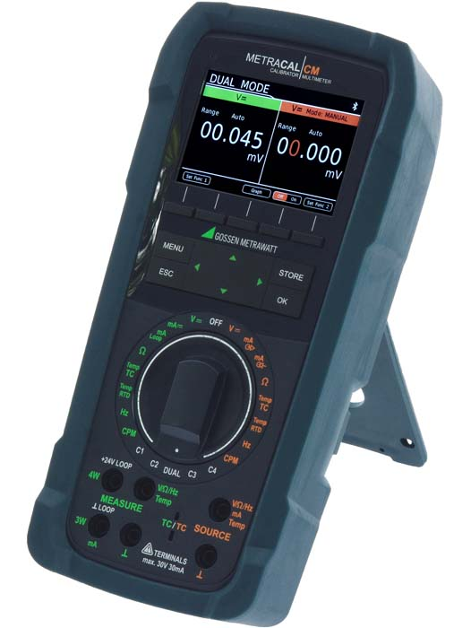
Caption: The METRACAL CM next-generation multifunction process calibrator combines calibrator and precise multimeter in a compact handheld device

Image: GMC-Instruments

The new dual display mode shows input and output signals at the same time on a modern TFT color display, significantly accelerating balancing and troubleshooting. The graphic menu structure with context-sensitive help screens makes operation easier, even for less experienced users. A flexible signal generator provides freely configurable calibration signals in manual, interval, ramp or table modes. Four direct accesses allow users to instantly recall frequently used tests and save valuable time in the field. The flexibly expandable software architecture is particularly forward-looking: users can activate additional functions at any time in the field, for example, HART communication, a graphical history review or an extended sequence function for complex calibration processes. The modular power supply with a quick-change battery or optional power module ensures continuous operation. The integrated data logger with a real-time clock automatically documents series of measurements, enabling traceable, auditable test protocols – a significant advantage in view of compliance requirements in the process industry, infrastructure and laboratories. Since METRACAL CM also enables precise temperature measurements due to internal balancing via separate temperature-compensated TC connections, and since it supports numerous temperature sensors, it is also ideal for measurement, calibration and revision work in chemical processes, energy systems, development laboratories and for service providers. GOSSEN METRAWATT supplies the new multifunctional process calibrators with a DAkkS calibration certificate and a 36-month warranty.

Image/s: | metracal_cm_2000.jpg | Characters: | 2367
File name: | 202511025_pm_metracal_cm_calibrator_en | Date: | 11-13-2025
Tags: | process calibrators, multimeter, calibrator, handheld, Bluetooth, HART communication, process industry, infrastructure, laboratories, temperature measurements
About Gossen Metrawatt
Gossen Metrawatt, one of the world’s leading suppliers of measurement systems, develops and distributes a wide range of high-quality measuring and test devices for the electrical trade, various industries and the public sector.
The Gossen Metrawatt brand has been synonymous with safety and quality “Made in Germany” for decades. Its product range includes measurement and test technology for the electrical safety of plants, devices and machines as well as for the electric vehicle sector and the medical technology industry. Additional key areas of interest are power quality, battery testing technology, multimeters, calibrators, power supply technology and energy management systems. For a truly comprehensive electrical safety portfolio, Gossen Metrawatt also offers a continuously growing range of digital services and cloud services and supports its customers with a versatile training program and a wide range of after-sales services.
Gossen Metrawatt is part of the GMC-Instruments Group along with further specialized manufacturers for measurement and testing technology: Camille Bauer Metrawatt, Dranetz, Prosys, Seaward, Rigel and Kurth Electronic. The Camille Bauer and Rigel brands add to the portfolio various transducers, display instruments and detection systems for heavy-current engineering as well as special measuring, testing and functional testing devices for the medical sector. The GMC-I Group runs its own DAkkS-certified calibration center that performs DAkkS, ISO and factory calibrations for virtually all electrical measured quantities. The GMC-I Group has development and production sites in Germany, Switzerland, England and the USA and a worldwide sales network of its own companies as well as sales partners.
Contact:  Gossen Metrawatt GmbH  Christian Widder  Head of Marketing Communication  Suedwestpark 15  90449 Nuremberg  Germany  Phone: +49 . 911 . 8602-572  Email: christian.widder@gossenmetrawatt.com  Internet: www.gossenmetrawatt.com |  | gii die Presse-Agentur GmbH  Christburger Str. 41  10405 Berlin  Germany  Phone: +49 . 30 . 538 9650  Email: info@gii.de  Internet: www.gii.de

