Press Release

Innovative cabling concept for maximum flexibility: Modular cable entries with split frame

Conta-Clip continuously expands and improves its cable management solutions and now presents the inverted modular cable entry system KDSI-SR-G for simple and service-friendly assembly from the outside to the inside. Users can feed cables with and without connectors into control cabinets, enclosures and machines and significantly speed up assembly. The design also enables easy changes to the installation at any time.

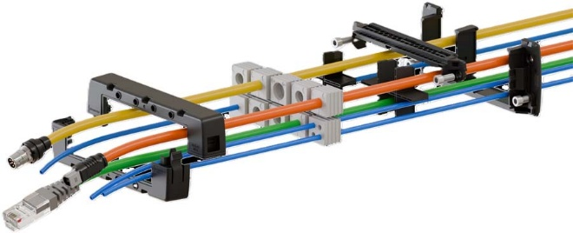
Caption: The modular KDSI-SR-G cable entry from Conta-Clip enables time-saving and highly flexible cabling

The screwless, horizontally latching frame halves made of glass-fiber reinforced polyamide PA 6.6 feature dovetail profiles and thus do not have to be screwed but simply lock in place. Their double, overlapping integrated and captive TPE gasket ensures tight sealing according to protection type IP66. The black cable entry fits in standard cut-outs for 4, 10, 16 and 24-pin heavy-duty connectors. Furthermore, the 8/16 frame has a fixed partition and can be equipped with two 4-piece inlays.

KDSI-SR-G fits cables with all connector sizes and allows the greatest possible variability in the order of assembly. It can either be attached directly to the housing with screws, partially assembled or pre-assembled externally for later mounting – which makes the versatile and time-saving system particularly interesting for cable assemblers as the customer-specific application decides which frame and assembly methods are used. The cable entry offers maximum flexibility with optimized warehousing by using the proven modular KDS system for accessories such as inlays and sealing elements.
More information: https://conta-clip.com/en/products/cable-management/cable-entries-for-cables-with-and-without-plugs/kdsi-sr-g/

Conta-Clip at the SPS tradeshow
Nuremberg, Germany, 25 – 27 November 2025
Hall 10, Booth 122

Image/s: | kdsi-sr-g | Characters: | 1505
File name: | 202511026_pm_kdsi-sr-g_cable_entry_en | Date: | 11-13-2025
Tags: | cable entry, cable entries, modular, cabling, cable management, KDSI-SR-G
About CONTA-CLIP
CONTA-CLIP is one of Europe’s leading manufacturers of electrical and electronic connection elements and cable management solutions. Based in Hövelhof, Germany, the medium-sized, family-run company has been producing electric and electronic connection systems for the process and automation industries since 1978. CONTA-CLIP supplies all industry sectors, focusing on railroad industries, shipbuilding, building automation, conveyor technology, machine and plant engineering and construction, instrumentation and control technology, control panel manufacturing, transformer manufacturing, and environmental technology. The company consists of many specialized branches: CONTA-CONNECT for electric connection technology, CONTA-CABLE for cable management systems, CONTA-ELECTRONICS for electronics and CONTA-CON for PCB edge connectors. Additionally, CONTA-CLIP provides services such as customizing housings and mounting rails, labeling and supplying user-specific electronic components.
Contact:  CONTA-CLIP  Verbindungstechnik GmbH  Christian Quade  Otto-Hahn-Str. 7  33161 Hövelhof  Germany  Phone: +49 . 5257 . 9833 - 172  Email: christian.quade@conta-clip.de  Internet: www.conta-clip.com |  | gii die Presse-Agentur GmbH  Christburger Str. 41  10405 Berlin  Germany  Phone: +49 . 30 . 538 965 - 0  Email: info@gii.de  Internet: www.gii.de

