Press Release

Cutting-edge label printer for clear and easy electrical marking

The compact TTPCardMAX thermal transfer printer fulfills all labeling needs for electrical installations – a clever label printing solution from the Conta-Label range of Conta-Clip, one of the leading manufacturers of electrical connection technology. The versatile printer provides outstanding print quality with high resolution. With 12 new card types especially for Conta-Clip terminal blocks added to the existing catalog of markers, the printing system meets all requirements for marking in the electrical sector.

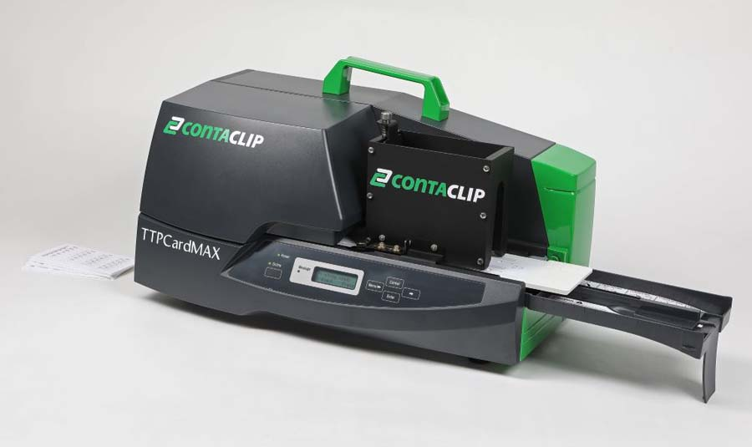
Caption: The TTPCardMAX label printer creates clear and sharp markings for electrical installations

The efficient printer employs proven thermal transfer technology to quickly and reliably create sharp and durable markings on labels and signs made of various materials, such as PVC, vinyl, polyester, ABS and polycarbonate. TTPCardMAX thus ensures long-lasting marking of terminal blocks, cables and wires, input and output devices, external control panels, switching modules and many other components. The ContaPrintMAX printing software, which is tailored to the marker cards, with templates for all materials, enables simple and intuitive operation. The printer has a manual feed and an automatic one for high-speed processing of up to 5,500 markers per hour.

Low-maintenance, trouble-proof and easy to operate, the system requires little attention. The print and feed sections are easily accessible for exchanging the color ribbon cartridge. A special cassette for automatically cleaning the materials to be printed increases the print quality. The ContaPrintMAX software for Windows operating systems allows users to edit and print the required markings for single, multiple or series labels with ease. The software enables simple and fast preparation of print data and has been specially developed for professional cable and wire labeling for machines, systems and control cabinets.

Product page: https://conta-clip.com/en/product-finder/details/ttpcardmax/no-33000-0/

Image/s: | TTPCardMAX | Characters: | 1805
File name: | 202511027_pm_ttpcardmax_label_printer_en | Date: | 12-02-2025
Tags: | label printer, electrical marking, terminal blocks, cable and wire labeling, TTPCardMAX
About CONTA-CLIP
CONTA-CLIP is one of Europe’s leading manufacturers of electrical and electronic connection elements and cable management solutions. Based in Hövelhof, Germany, the medium-sized, family-run company has been producing electric and electronic connection systems for the process and automation industries since 1978. CONTA-CLIP supplies all industry sectors, focusing on railroad industries, shipbuilding, building automation, conveyor technology, machine and plant engineering and construction, instrumentation and control technology, control panel manufacturing, transformer manufacturing, and environmental technology. The company consists of many specialized branches: CONTA-CONNECT for electric connection technology, CONTA-CABLE for cable management systems, CONTA-ELECTRONICS for electronics and CONTA-CON for PCB edge connectors. Additionally, CONTA-CLIP provides services such as customizing housings and mounting rails, labeling and supplying user-specific electronic components.
Contact:  CONTA-CLIP  Verbindungstechnik GmbH  Christian Quade  Otto-Hahn-Str. 7  33161 Hövelhof  Germany  Phone: +49 . 5257 . 9833 - 172  Email: christian.quade@conta-clip.de  Internet: www.conta-clip.com |  | gii die Presse-Agentur GmbH  Christburger Str. 41  10405 Berlin  Germany  Phone: +49 . 30 . 538 965 - 0  Email: info@gii.de  Internet: www.gii.de

