Press Release

Hygienic, blue – and up to IP66: FDA-compliant round cable entries

Conta-Clip continuously expands its KES cable entry range and places a particular emphasis on products for the food industry made of certified, hygienic material. The latest addition, the round FDA KES-R-FDA M variants in characteristic blue enable quick and space-saving feed-through of up to 68 conductors into control cabinets or machine housings.

The cable entries, which consist of a robust polyamide frame with injected elastomer, have integrated locking hooks for easy installation. They are first locked into housing openings from the outside and then fixed from the inside with lock nuts. After piercing the outer membrane at a marked insertion point, users simply push cables, wires or hoses through. Tapered TPE sleeves at the back of the cable entry ensure tight sealing according to protection class IP66.

The elastomer of the new KES-R-FDA M variant is FDA-compliant and meets the hygiene requirements of food approvals 1935/2004/EC and (EU) 10/2011. Featuring smooth surfaces and rounded corners, the products are suitable for use in the food and pharmaceutical industries.

Conta-Clip currently offers the FDA-compliant cable entries KES-R-FDA M in 15 round variants for different numbers of conductors with different diameters.

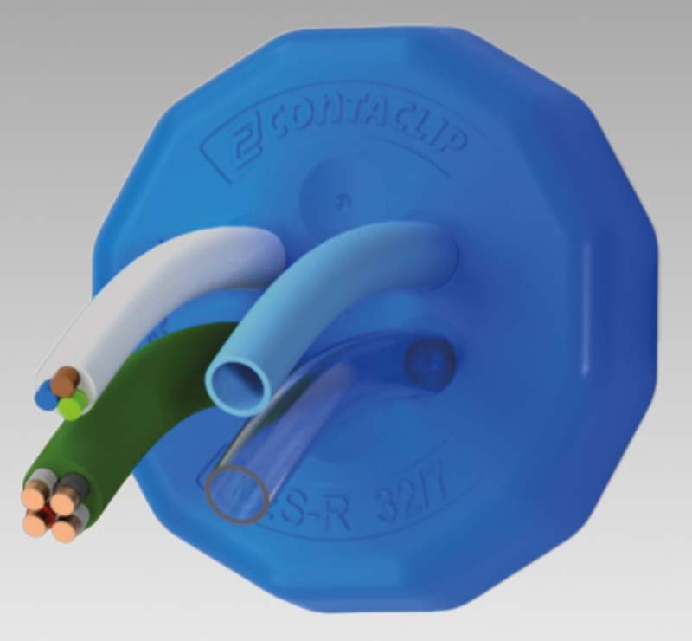
Caption: The FDA-compliant cable entries for hygienic installations ensure tight sealing and easy feed-through of up to 68 conductors of varied sizes

Image/s: | KES-R-FDA_M | Characters: | 1240
File name: | 202511029_pm_fda-compliant_cable_entries_en | Date: | 02-03-2026
Tags: | cable entry, cable entries, FDA-compliant, hygienic, food industry, pharmaceutical
About CONTA-CLIP
CONTA-CLIP is one of Europe’s leading manufacturers of electrical and electronic connection elements and cable management solutions. Based in Hövelhof, Germany, the medium-sized, family-run company has been producing electric and electronic connection systems for the process and automation industries since 1978. CONTA-CLIP supplies all industry sectors, focusing on railroad industries, shipbuilding, building automation, conveyor technology, machine and plant engineering and construction, instrumentation and control technology, control panel manufacturing, transformer manufacturing, and environmental technology. The company consists of many specialized branches: CONTA-CONNECT for electric connection technology, CONTA-CABLE for cable management systems, CONTA-ELECTRONICS for electronics and CONTA-CON for PCB edge connectors. Additionally, CONTA-CLIP provides services such as customizing housings and mounting rails, labeling and supplying user-specific electronic components.
Contact:  CONTA-CLIP  Verbindungstechnik GmbH  Christian Quade  Otto-Hahn-Str. 7  33161 Hövelhof  Germany  Phone: +49 . 5257 . 9833 - 172  Email: christian.quade@conta-clip.de  Internet: www.conta-clip.com |  | gii die Presse-Agentur GmbH  Christburger Str. 41  10405 Berlin  Germany  Phone: +49 . 30 . 538 965 - 0  Email: info@gii.de  Internet: www.gii.de

