Press Release

Avoid incorrect wiring:
New PPVK potential distribution terminals

The new PPVK push-in potential distribution terminals from Conta-Clip are the right solution to avoid incorrect wiring for the power supply in control cabinets – especially with large numbers of cables. They enable structured and clear power distribution in AC and DC control circuits. Thanks to the compact design of the terminals and the reduced wiring effort, users can establish the energy supply for equipment installed in control cabinets easily, efficiently and with a small footprint.

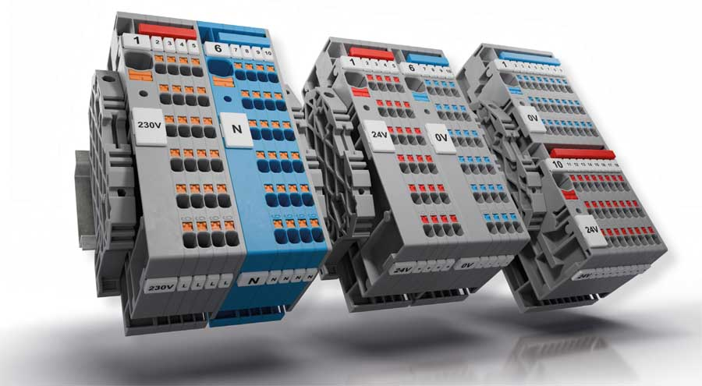
Caption: Lots of potential against incorrect wiring: PPVK by Conta-Clip

The distribution terminals with extensive marking options combine several advantages. Conductors can be inserted without tools and with low mating resistance. There are cross-connection options for feed-in terminals and potential distribution terminals on both sides, allowing the permissible total current to be optimally distributed in both distribution directions; this supports a uniform current load and reduces local overloads. A built-in, insulated pusher is used to disconnect conductors. Depending on the application, users can choose between alternating or block grouping.

The 6-mm² feed-in terminals are dimensioned for a rated current of 41 A and the 1.5-mm² distribution terminals for a rated current of 16 A. All insulating materials used in the series are free of pollutants and also comply with flammability class “V-0 self-extinguishing” according to UL 94. Pre-assembled potential distribution blocks including matching accessories are also available to help reduce the number of variants as well as warehousing and procurement costs. Even after commissioning, the PPVK potential distribution blocks can be expanded in modular fashion. Additional distribution terminals can be flexibly retrofitted via the second cross-connection channel and integrated into the existing potential distribution.

Advantage PPVK
- Tool-free push-in wire connection
- Low mating resistance
- Built-in insulated pusher for disconnecting the wire
- Cross-connection option in both directions doubles the total current
- Test pick-off at any potential
- Extensive marking options

Features
- Push-in connection system
- Feed-in terminals 6 mm², rated current 41 A
- Distribution terminals 1.5 mm², rated current 16 A
- Pluggable cross-connection system PQI
- Material: PA 6.6 UL 94 V-0

Image/s: | PPVK_Verteilerklemmen |  | Characters: | 2257
File name: | 202511034_pm_ppvk_potential_distribution_terminals_en |  | Date: | 11-24-2025
Tags: | potential distribution terminals, power supply, power distribution, control cabinets
About CONTA-CLIP
CONTA-CLIP is one of Europe’s leading manufacturers of electrical and electronic connection elements and cable management solutions. Based in Hövelhof, Germany, the medium-sized, family-run company has been producing electric and electronic connection systems for the process and automation industries since 1978. CONTA-CLIP supplies all industry sectors, focusing on railroad industries, shipbuilding, building automation, conveyor technology, machine and plant engineering and construction, instrumentation and control technology, control panel manufacturing, transformer manufacturing, and environmental technology. The company consists of many specialized branches: CONTA-CONNECT for electric connection technology, CONTA-CABLE for cable management systems, CONTA-ELECTRONICS for electronics and CONTA-CON for PCB edge connectors. Additionally, CONTA-CLIP provides services such as customizing housings and mounting rails, labeling and supplying user-specific electronic components.
Contact:  CONTA-CLIP  Verbindungstechnik GmbH  Christian Quade  Otto-Hahn-Str. 7  33161 Hövelhof  Germany  Phone: +49 . 5257 . 9833 - 172  Email: christian.quade@conta-clip.de  Internet: www.conta-clip.com |  | gii die Presse-Agentur GmbH  Christburger Str. 41  10405 Berlin  Germany  Phone: +49 . 30 . 538 965 - 0  Email: info@gii.de  Internet: www.gii.de

