Press Release

Airflow sensor with IO-Link and Smart Sensor Profile

EGE-Elektronik presents a new airflow sensor with an IO-Link interface and Smart Sensor Profile for easy integration into modern networked industrial plants. The compact, responsive sensor measures the flow velocity in the range of 0.5 to 15 m/s and temperatures from -20 to 70 °C of gaseous non-explosive media. Five colored LEDs at the cable outlet signal the flow and sensor statuses. For further processing, the PNP switching output is available in SIO mode – and the process data in IO-Link operation. The sensor stores min/max values and additionally offers comprehensive programming functions such as hysteresis (limit monitoring), switch-on/switch-off delay and sensor location in the plant via flashing LEDs. The IO-Link interface allows for easy remote setup and monitoring.

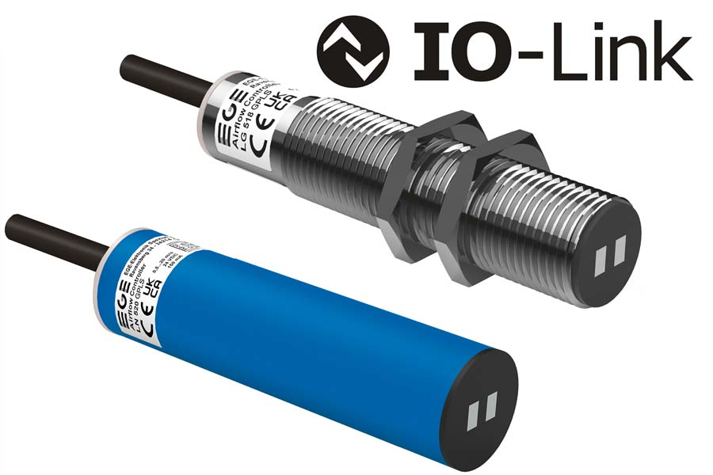
Caption: The IO-Link airflow sensor provides standardized measured values according to the Smart Sensor Profile, thus facilitating integration in large process plants

The IO-Link Smart Sensor Profile ensures the standardized, manufacturer-independent description of sensor parameters and measured values, thus making it easier for users to integrate systems and program PLCs. The new airflow sensor is available in two designs: LG 518 GPLS with an M18x1 threaded sleeve and LN 520 GPLS with a 20-mm plain sleeve. The nuts or a flange required for installation are included in the scope of delivery. The installation takes place directly in the wall of the duct. If the airflow is sufficiently strong near the edge, the measuring surface can be flush with the inner wall of the duct. The sensor is IP67 rated.

More information: https://www.ege-elektronik.com/products/flow-sensors/air-flow-sensors-with-integrated-amplifier/ln-lg-500/

EGE at the SPS tradeshow
Nuremberg, Germany, 25–27 November 2025
Hall 7A, Booth 111

Image/s: | ln_520__lg_518_gpls_airflow_sensors_io-link | Characters: | 1425
File name: | 202511037_pm_airflow_sensor_io-link_en | Date: | 11-20-2025
Tags: | airflow sensor, IO-Link, Smart Sensor Profile, flow velocity, temperatures
About EGE
EGE-Elektronik Spezial-Sensoren GmbH has been developing and manufacturing special purpose sensors for automation applications since 1976. The company serves leading international producers from a wide range of industries. Its product portfolio includes flow controllers, infrared, opto and ultrasonic sensors, capacitive proximity switches, light barriers and inductive proximity switches. EGE also provides sensors for highly sensitive applications, e.g. hazardous areas. The development department's highly qualified staff cooperates closely with all customers, ensuring continuous product updates and enhancement. A total of 130 employees, including 20 engineers and technicians, generate gross sales of approx. 19.5 million Euros worldwide.
Contact:  EGE-Elektronik Spezial-Sensoren GmbH  Sven-Eric Hiss  Ravensberg 34  24214 Gettorf  Germany  Phone: +49 4346 4158-0  Email: info@ege-elektronik.com  Internet: www.ege-elektronik.com |  | gii die Presse-Agentur GmbH  Christburger Str. 41  10405 Berlin  Germany  Phone: +49 30 538 965-0  Email: info@gii.de  Internet: www.gii.de

