Press Release

Hygienic Ultrasonic Sensors for Demanding Production Environments

With the P53 series, PiL Sensoren GmbH offers robust ultrasonic sensors for applications with stringent hygienic requirements. The fully encapsulated stainless-steel housing (1.4404) features a gap-free design and a polished surface finish (< 0.8 µm), meeting the requirements of EHEDG and FDA.
Thanks to protection class IP69 and ECOLAB certification, the sensors are resistant to acidic and alkaline cleaning agents and can be cleaned efficiently using CIP (Cleaning in Place) processes. The P53 sensors operate without contact and accurately detect solid, liquid, and pasty media.
Their fully encapsulated stainless-steel housing provides reliable protection against steam, dust, and moisture, making the series particularly suitable for use in harsh industrial environments. Available with housing diameters of Ø18 mm and Ø30 mm, the series covers measuring ranges from 150 to 1500 mm and is designed for ambient temperatures of up to 70 °C.
Analog or switching outputs, along with integrated temperature compensation, make these sensors ideal for a wide range of applications, including filling and packaging systems, coagulators, and pharmaceutical production lines.

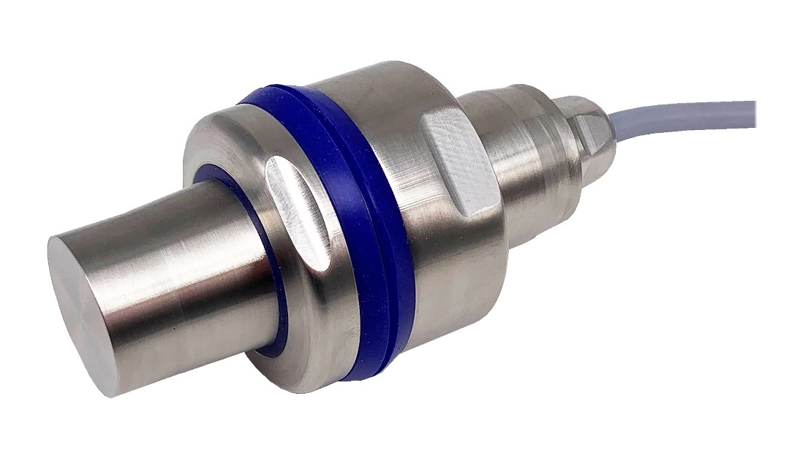
Caption: P53 ultrasonic sensor with mounting bracket by PiL Sensoren for applications with stringent hygienic requirements.

Image/s: | P53_D30_mit Halterung_2000.jpg | Characters: | 1,169
File name: | 202512_pm_p53_en.docx | Date: | 02-03-2026
Tags | PiL, ultrasonic sensor, P53 sensor, EHEDG, FDA, ECOLAB, ultrasonic distance sensor
About PIL
PiL Sensoren GmbH, with its headquarters in Erlensee near Frankfurt/Main is a pioneer of ultrasonic technology and has been developing, producing, and selling standard and customized sensor solutions for industrial applications since 1990. Together with Inelta Sensorsystem GmbH & Co. KG (Taufkirchen near Munich) and VYPRO s.r.o. (Trenčín, Slovakia), PiL offers a wide range of products for measuring displacement and position as well as force, pressure, and inclination. The range of products we offer includes force sensors, sensor signal amplifiers, pressure switches, capacitive sensors, and ultrasonic sensors. Our portfolio is nicely rounded off with cable and connector assembly services.
Most of the group of companies’ customers are in industrial automation, mechanical engineering, hydraulics, medical technology as well as the aerospace industry. We especially focus on industry and customer-specific sensor solutions and are constantly expanding this focus with interdisciplinary know-how.
Contact:

PIL Sensoren GmbH
Zweigstelle Süd

Esther Koller
Ludwig-Bölkow-Allee 22
82024 Taufkirchen
Germany
Phone: +49 89 / 45 22 45-0
Fax: +49 89 / 45 22 45-744
Email: esther.koller@inelta.de

Email: marketing@pil.de
Internet: www.pil.de

