Press release

Autonomy Kit for autonomously operating machines

The market for autonomous machines and vehicles is developing dynamically. With the AUTONOMY KIT, RAFI offers a scalable system solution for industrial applications. RAFI is thus positioning itself as an enabler in the field of autonomy and supports machine manufacturers in the structured further development of existing systems into partially or fully autonomous platforms.

Many manufacturers have products that are powerful but not autonomous. This is exactly where RAFI comes in. Existing machines and systems are specifically autonomized. Individual automation competencies, for example in specific control or charging processes, can be expanded into a holistic autonomous integral system. Even finished, previously non-autonomous products can be converted into an autonomous process by integrating suitable hardware and software solutions.

A central focus is on industrialization and support. RAFI combines production technologies, in-depth production know-how and software expertise to create an integrated solution approach. The aim is to develop robust solutions based on existing concepts that are suitable for series production.

RAFI's expertise in the area of autonomy includes hardware development, software architecture and system integration as well as the industrialization of series solutions. RAFI covers the entire value chain from electronics production to assembly and testing technologies to synthetic material and metal processing. This makes it possible to implement all process steps from development to industrial series production in close coordination with the customer.

Trade fair information: RAFI will present the AUTONOMY KIT and other innovations from March 24 to 26, 2026, at XPONENTIAL in Düsseldorf in Hall 1/A43.

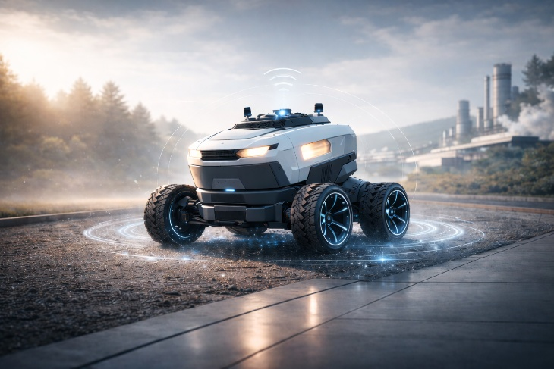

Caption: With the scalable Autonomy Kit from RAFI, mechanical systems can be transformed into semi- or fully autonomous machines.

Image Source: RAFI

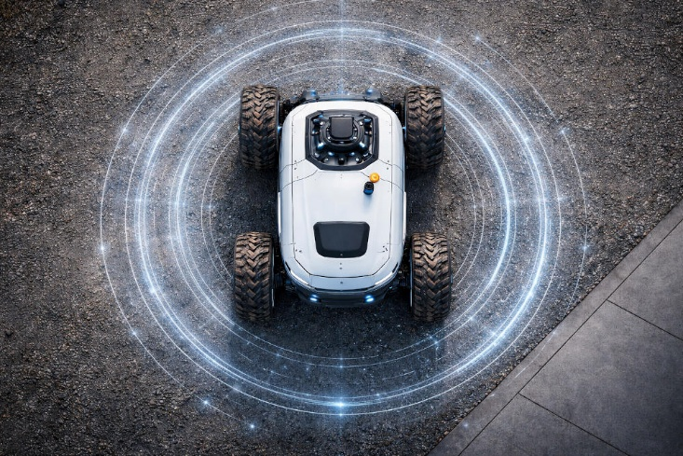

Caption: In the field of "Autonomy," RAFI can implement all process steps from development to industrial series production in-house.

Image Source: RAFI

Image/s: | RAFI_Autonomy_Kit_2000.jpg  RAFI_Autonomy_Kit_2_2000.jpg | Characters: | 1,599
File name: | 20260126-1_pm_autonomy-kit_en.docx | Date: | 03-10-2026
Tags: | RAFI, Human Machine Interface specialist, autonomy kit, autonomous agricultural machinery, agribusiness, logistics, construction, autonomous platforms, electronics manufacturing, robotic assembly

About the RAFI Group
Founded in 1900, the company develops and produces electromechanical components and systems for human-machine interaction. These include key switches, switches, touchscreens and operating systems as well as electronic assemblies. RAFI products are used in automation and medical technology, in mechanical and plant engineering, in road and railway vehicles, in household appliances and in telecommunications. The RAFI Group operates worldwide with over 2,000 employees at locations in Germany, Europe, China and the USA. The headquarters of the RAFI group of companies is located in Berg near Ravensburg.

Contact:  RAFI GmbH & Co. KG  Patrick Müller  Product Marketing Manager  Ravensburger Str. 128–134  88276 Berg, Germany  Tel: 0751 89-1634  E-mail: patrick.mueller@rafi-group.com  Internet: www.rafi-group.com |  | gii die Presse-Agentur GmbH  Christburger Str. 41  10405 Berlin  Tel: 030 53 89 65-0  E-mail: info@gii.de  Internet: www.gii.de

