Press Release

Load testing of supersized vertical motors

Menzel Elektromotoren now also performs load tests on motors in a vertical installation position. The family business has expanded its in-house test field to include a right-angle gearbox with various flange options for vertical motors of different sizes. This enables thorough testing of vertical motors for pumps, compressors and other industrial applications under realistic load conditions. Menzel tests motors and generators from its own production and also offers its state-of-the-art test facilities for manufacturer-independent external tests. The plant in Hennigsdorf near Berlin has two large test stands. Indoor cranes with a hook height of 7.52 meters shift large drive units up to 80 tons. The range of services includes all common routine, type and system tests in accordance with international standards for test voltages from 3 to 13.8 kV. Machines up to 1800 kW and 2300 kVA can be load tested. In addition, Menzel offers a heat run test with the equivalent load method according to IEC60034-29 for higher electrical performances. The test field engineers and certified technicians carry out all measurements and inspections according to EN 60034, with full documentation. The team also has extensive expertise in testing requirements of international acceptance organizations.
Detailed information about Menzel’s testing services and facilities: https://www.menzel-motors.com/motor-test-field/

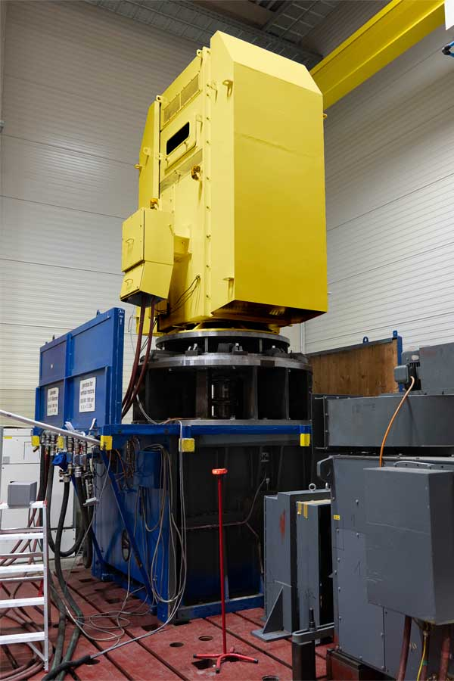
Caption: Menzel Elektromotoren now also performs load tests on large industrial motors in a vertical installation position

Image/s: | vertical_motor_test_h12068 | Characters: | 1294
File name: | 202601804_pm_vertical_motor_load_tests_en | Date: | 01-13-2026
Tags: | load testing, load tests, vertical motors, large industrial motors, type and system tests, heating test
About Menzel Elektromotoren
Menzel Elektromotoren GmbH has been manufacturing and distributing electric motors since 1927. The German family-run company based in Hennigsdorf near Berlin specializes in the delivery of large electric motors, including special models, within the shortest time possible. The product range comprises high and low voltage motors, DC motors, transformers, and frequency inverters. Services include motor production up to and beyond 25 MW and short-term adaptation of stock motors to application-specific requirements. In order to ensure short delivery times, Menzel maintains a large inventory with over 20,000 motors up to 15 MW. Qualified engineering, experienced staff, and state-of-the-art production and testing facilities help the manufacturer provide excellent reliability. Menzel operates subsidiaries in Sweden, the UK, France and Italy and cooperates with numerous partners worldwide.
Contact:  Menzel Elektromotoren GmbH  Anja Leipold  Corporate Communications  Am Alten Walzwerk 2  16761 Hennigsdorf  Germany  Phone: +49 30 349 922-0  Email: info@menzel-motors.com  Internet: www.menzel-motors.com |  | gii die Presse-Agentur GmbH  Christburger Str. 41  10405 Berlin  Germany  Phone: +49 30 538 965-0  Email: info@gii.de  Internet: www.gii.de

