Press Release

embedded world 2026: RAFI puts its focus on E²MS, robotics, and Safety Touch

From 10 to 12 March 2026, RAFI will showcase its product and solution expertise at embedded world in Nuremberg, covering everything from PCBs through to complete system integration and device assembly, all from a single source. At its trade fair appearance in Hall 3, Booth 330, the HMI specialist will focus on the four thematic areas of E²MS production, robotics, command-and-control devices, and Safety Touch operation.

As an experienced partner for Electronic Engineering and Manufacturing Services (E²MS), RAFI supports its customers throughout the development and production of electronics, from the initial concept to series production. With its new Autonomy Kit, the manufacturer has developed a scalable platform technology for automating machines for the agricultural industry, logistics, and construction. The synergy of modular hardware and smart software supports machine manufacturers in transforming mechanical systems into semi-autonomous or fully autonomous solutions.

A third area of focus is the broad range of command and control devices, from micro-switches and the diverse RAFIX and RAMO push-button series to encoders and joysticks. A highlight is the key switches of the RAFIX 22 FS+ series, which combine flat construction with aesthetic design and can be customized as required.

For use in safety-critical applications, RAFI makes specially secured joystick variants built on its JOYSCAPE platform. The manufacturer has also developed Safety Touch, a new technology platform for the series-ready manufacture of touchscreen systems at Performance Level d.

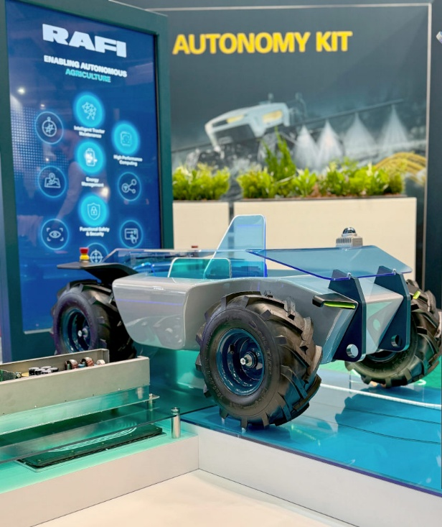
Caption: At the trade fair, RAFI will present an overview of the new Autonomy Kit and demonstrate how pairing hardware expertise with software intelligence can enhance efficiency, flexibility, and productivity.

Source: RAFI

Image/s: | autonomy_kit_2000.jpg | Characters: | 1,581
File name: | 202602011_pm_embedded-world_en.docx | Date: | 02-10-2026
Tags: | embedded world, RAFI, E²MS, robotics, Safety Touch, HMI specialist, E²MS manufacturing, command-and-control devices, Safety Touch operation, Electronic Engineering and Manufacturing Services, electronics, autonomy kit, automation, autonomous systems, micro-switches, push-button series, RAFIX, RAMO, joysticks, RAFIX 22 FS+, JOYSCAPE platform, joystick versions, touchscreen systems, performance level d, system integration

About the RAFI Group
Founded in 1900, RAFI today develops and produces electromechanical components and systems for human-machine interaction. The range of products includes switches and key switches, touchscreens, control systems, and electronic assemblies. RAFI products are employed in many industries, including automation, medical technology, machine and plant engineering, road and railway vehicles, household appliances, and telecommunication. The RAFI Group operates internationally with over 2,000 employees at sites in Germany, Europe, China, and the USA. The headquarters of the RAFI Group are located in Berg near Ravensburg.

Contact:  RAFI GmbH & Co. KG  Fred Nemitz  Communication  Ravensburger Straße 128–134  88276 Berg, Germany  Email: fred.nemitz@rafi-group.com  Web: www.rafi-group.com |  | gii die Presse-Agentur GmbH  Christburger Str. 41  10405 Berlin  Phone: +49 30 53 89 65-0  Email: info@gii.de  Web: www.gii.de

