Press Release

Trade fair premiere from SAB at IT-Trans
New high-performance data cables for rail vehicles

SAB Bröckskes will premiere newly developed high-performance data cables for railway technology at the IT-Trans trade fair in Karlsruhe, Germany, 3–5 March 2026, at booth #1-G60. The three new SABIX R flex Data IQ cables extend the manufacturer’s range of permanently flexible rail cables according to EN 45545-2. The cable design combines high transmission performance for modern infotainment, display and communication systems with a comprehensive safety concept. Depending on type, the cables support DVI Dual-Link, HDMI, DVI, DisplayPort and USB 3.0 / USB 3.2 Gen 1x1. The series fulfils the fire protection requirements R15 (EL1A) and R16 (EL1B) according to EN 45545-2 for hazard levels HL1 and HL2 and flame resistance according to UN/ECE R118 for international use. In the event of a fire, smoke development, emission of toxic gases and consequential damage to electrical components are reduced due to cables’ safety features, i.e., halogen-free design, low corrosivity, low toxicity, attested smoke density. SABIX R flex Data IQ cables are flame retardant and self-extinguishing according to IEC 60332-1-2, bundle fire tested according to IEC 60332-3-25 and oil and fuel resistant according to EN 50264-1. The cables, which are made of RoHS-compliant, PFAS-free materials, are approved for temperature ranges from -50 °C/-40 °C to 90 °C (DIN VDE) or 75 °C (UL/CSA). The minimum bending radius is 4 x d in fixed installations and 12 x d for flexible applications. The high flexibility facilitates installation in confined spaces, supports the standardization of modern interfaces and thus contributes to efficient development and maintenance processes.

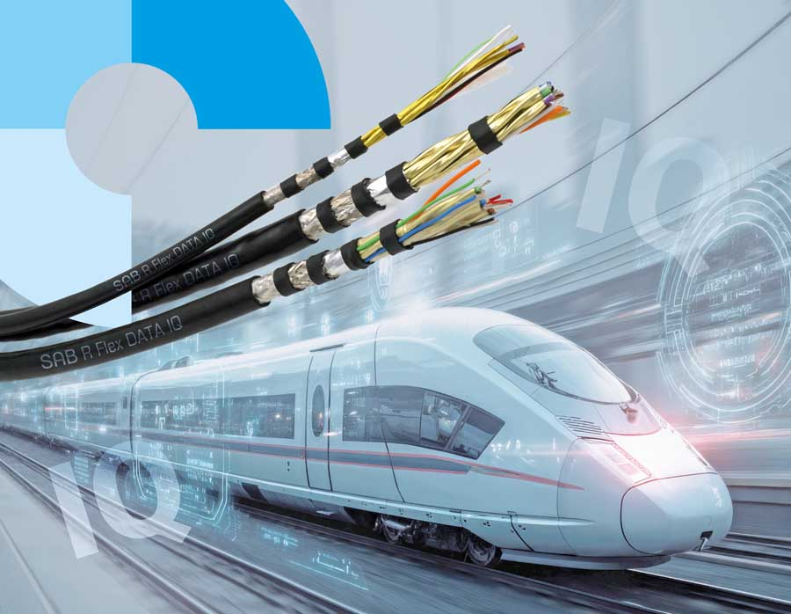
Caption 1: Designed for modern data and multimedia interfaces, SABIX R flex Data IQ cables meet all fire protection requirements for use in rail vehicles

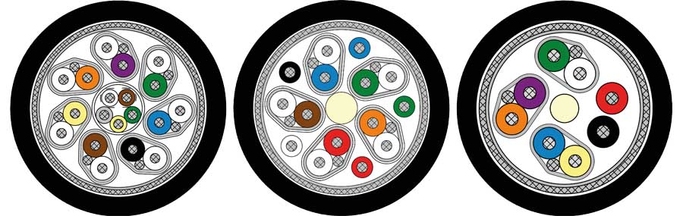
Caption 2: The high-performance data cables are available in three types for DVI Dual-Link, HDMI, DVI, DisplayPort and USB 3.0 / USB 3.2 Gen 1x1

Image/s: | sabix_r_flex_iq_bahn_2000.jpg  sabix-varianten_2000.jpg | Characters: | 1664
File name: | 202602026_pm_data_cable_it-trans_en | Date: | 02-12-2026
Tags: | IT-Trans, rail vehicles, railway technology, data cables, DIN VDE, UL/CSA, EN 45545-2, halogen-free, RoHS-compliant, PFAS-free, low toxicity, flame retardant, self-extinguishing, bundle fire tested, oil and fuel resistant
About SAB Bröckskes
Founded in Viersen, Germany, in 1947 by Peter Bröckskes as a one-man operation for electrical system design, SAB Bröckskes GmbH & Co. KG has grown into one of the world’s leading special cable manufacturers, now employing a staff of more than 550 who generate a turnover of over €134 million euros in over 100 countries. The portfolio includes cables and wires manufactured from a wide variety of materials as well as cable assembly and measurement solutions. All products are developed and manufactured exclusively at the Viersen headquarters. The company supplies various industries from industrial automation and communication technology to manufacturers of construction and agricultural machinery, railway and shipping technology and medical technology. SAB Bröckskes has a global presence with international subsidiaries and sales offices.
Contact:  SAB BRÖCKSKES GmbH & Co. KG  Sacir Adrovic  Grefrather Str. 204–212b  41749 Viersen  Germany  Phone: +49 2162 898-146  Email: s.adrovic@sab-cable.com  Internet: www.sab-cable.com |  | gii die Presse-Agentur GmbH  Christburger Str. 41  10405 Berlin  Germany  Phone: +49 30 538 965-0  Email: info@gii.de  Internet: www.gii.de

