Press Release

RAFI Steering Stick:
Intelligent steering joystick with adaptive force feedback

With the Steering Stick, RAFI presents an innovative joystick solution for precise and ergonomic vehicle control. The steering joystick combines modern drive technology with fully programmable haptics, opening up new possibilities for the intuitive operation of mobile work machines.

At its core is software-controlled force feedback that dynamically adjusts steering behavior based on the situation. Steering force, steering angle, and zero and park positions can be flexibly configured and precisely tailored to the specific application. Users thus benefit from customizable control characteristics and a significantly improved operating experience.

TrueMotion technology, in combination with direct torque adjustment, ensures particularly realistic and precise feedback. Joystick movements are translated into steering movements synchronously and without delay. At the same time, the selected position remains stable, enabling safe and controlled maneuvering even in demanding situations.

By eliminating mechanical components such as springs or damping elements, the Steering Stick operates wear-free and enables freely configurable haptic feedback. The contactless Hall sensor technology ensures reliable and long-lasting signal detection.

The compact and slim design expands integration options in the driver’s cockpit and supports an ergonomic seating position with an optimal field of view. This makes the Steering Stick particularly suitable for industrial trucks as well as mobile agricultural and construction machinery. Furthermore, it can be used as an ergonomic supplement to traditional steering systems.

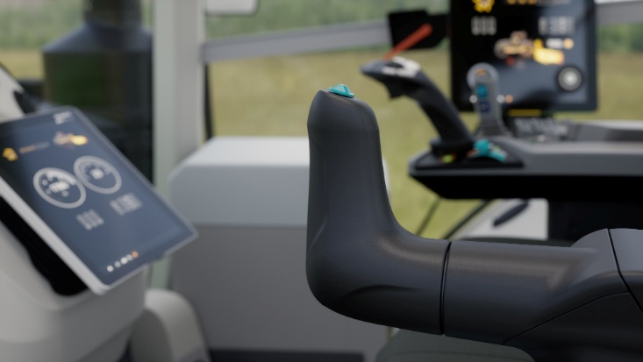

Caption 1: The new Steering Stick from RAFI provides authentic, individually customizable control characteristics with software-controlled force feedback.

Image source: RAFI

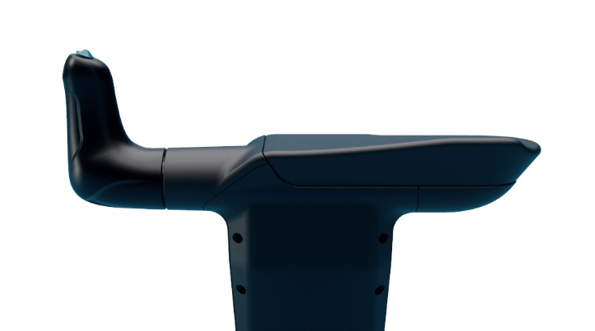

Caption 2: The compact, slim design expands integration possibilities in the cabin and supports an ergonomic seating position with an optimal field of view.

Image source: RAFI

Image/s: | steeringstick-traktor_2000.jpg  Steering_Stick_Profil_2000.jpg | Characters: | 1,614
File name: | 202604018_PM2_lenkjoystick_en.docx | Date: | 05-19-2026
Tags: | RAFI, Steering Stick, steering joystick, force feedback, joystick solution, vehicle control, drive technology, programmable haptics, mobile work machines, steering behavior, steering force, steering angle, zero position, park position, TrueMotion technology, direct force feedback, safe maneuvering, controlled maneuvering, haptic feedback, Hall sensor technology, driver cockpit, industrial trucks, agricultural machinery, construction machinery, steer-by-wire

About the RAFI Group
Founded in 1900, RAFI today develops and produces electromechanical components and systems for human-machine interaction. The range of products includes key switches, switches, touchscreens, control systems, and electronic assemblies. RAFI products are employed in many industries including automation, medical technology, machine and plant engineering, road and railway vehicles, household appliances, and telecommunication. The RAFI Group operates internationally with more than 2,000 employees at sites in Germany, Europe, China, and the USA. Its headquarters are in Berg, Germany.

Contact:  RAFI GmbH & Co. KG  Patrick Müller  Product Marketing Manager  Ravensburger Straße 128-134  88276 Berg  Tel.: 0751 89-1634  E-Mail: patrick.mueller@rafi-group.com  Internet: www.rafi-group.com |  | gii die Presse-Agentur GmbH  Christburger Str. 41  10405 Berlin, Germany  Phone: +49 30 53 89 65-0  Email: info@gii.de  Web: www.gii.de

