Press Release

Ergonomics study on steering systems for agricultural machinery
Scientific research confirms the advantages of joystick steering

The traditional steering wheel in agricultural machinery is facing serious competition. An ergonomics study completed in early 2026 by Furtwangen University in collaboration with HMI specialist RAFI now provides scientific proof that using a joystick to steer agricultural machinery can significantly reduce physical strain.

RAFI has extensive experience in the development and design of custom control levers. On the basis of its own technology platform, the company manufactures a wide range of variants, from Tiny to Rough, with a variety of guide mechanisms, control functions, and durability features. While joysticks were previously developed primarily as right-hand controls for operating attachments, RAFI is now focusing on steering joysticks for direct vehicle control.

This trend is scientifically supported by research initiated by RAFI at Furtwangen University. The study compared the strain levels of steering wheel and joystick steering using objective measurements of muscle activity via electromyography, as well as subjective evaluations by 21 participants from the agricultural sector.

The results are clear: a steering joystick positioned to the left of the driver’s seat allows mobile machinery to be operated with significantly less effort and fatigue than a steering wheel. Short, precise hand movements with the forearm resting comfortably on the armrest eliminate strenuous steering actions and frequent wheel turning, which place considerable strain on the shoulders and neck. Only the forearm muscles exhibit slightly higher activity with the joystick.

The subjective assessments of the 21 participants, aged 19 to 56, confirm the objective findings: in the categories “physical demands” and “effort,” the steering wheel was rated as significantly more strenuous. Moreover, despite its novelty, the joystick achieved higher satisfaction ratings than the long-established steering wheel, indicating strong usability and intuitive operation. The combination of significantly reduced physical workload and high user satisfaction makes joystick steering a promising alternative for the future of agricultural technology.

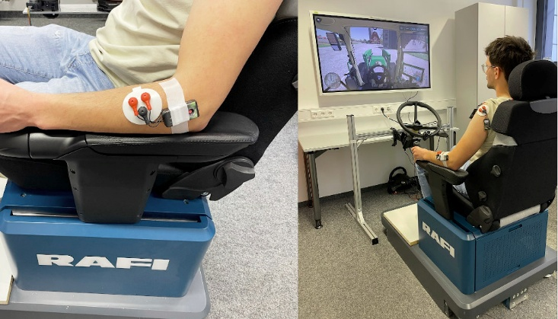

Caption 1: The RAFI simulator uses electromyography to measure muscular strain during steering wheel and joystick steering.

Source: RAFI

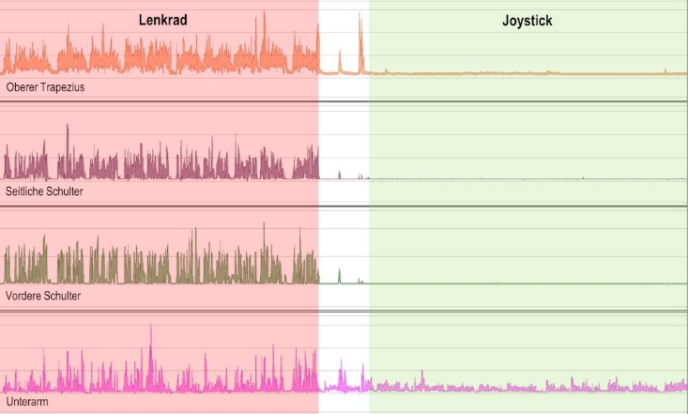

Caption 2: The EMG amplitudes demonstrate the ergonomic advantages of joystick steering over the steering wheel.

Source: RAFI

Image/s: | versuchsaufbau-steuerergonomie_2000.jpg  emg_belastungskurven_2000.jpg | Characters: | 2,358
File name: | 20260428-2_PM2_studie-steeringstick.docx | Date: | 04-28-2026
Tags: | RAFI, HMI specialist, joystick steering, ergonomics, ergonomics study, scientific study, agricultural machinery, Furtwangen University, Florentine Bisinger, electromyography, steering joystick, Human Machine Interface, agricultural engineering, driver’s cab, operating concept

About the RAFI Group
Founded in 1900, RAFI today develops and produces electromechanical components and systems for human-machine interaction. The range of products includes switches and key switches, touchscreens, control systems, and electronic assemblies. RAFI products are employed in many industries, including automation, medical technology, machine and plant engineering, road and railway vehicles, household appliances, and telecommunication. The RAFI Group operates internationally with over 2,000 employees at sites in Germany, Europe, China, and the USA. The headquarters of the RAFI Group are located in Berg near Ravensburg.

Contact:  RAFI GmbH & Co. KG  Fred Nemitz  Corporate Communications  Ravensburger Straße 128-134  88276 Berg  Email: fred.nemitz@rafi-group.com  Web: www.rafi-group.com |  | gii die Presse-Agentur GmbH  Christburger Str. 41  10405 Berlin  Tel.: 030 53 89 65-0  E-Mail: info@gii.de  Internet: www.gii.de

