Press Release

RAFI Standard Keypads and Encoders for robust Off-Highway Applications

RAFI is expanding its HMI portfolio of standardized keypads and encoders for off-highway vehicles. The new control units are specifically designed for rugged use in construction machinery, agricultural vehicles, mining vehicles, forestry machinery, and other off-highway applications. They support modern vehicle architectures and enable safe, intuitive, and durable operation directly within the driver's environment.

The product family includes keypads with silicone keys and rotary push encoders for precise input, menu navigation, and function control. Depending on the model, solutions with 16 or 20 keys, integrated encoder keypads, and compact encoder variants are available. This allows for the implementation of both simple direct functions and more complex operating concepts with high functional density. Typical installation locations include armrests, control consoles, side panels, steering columns, and cockpit trim.

Designed for use in challenging environmental conditions, the standard keypads and encoders are specified for a temperature range of -40 °C to +85 °C. The products feature CAN-FD interfaces with J1939 and UDS, a power supply ranging from 6 to 48 volts, and an IP 69 protection rating when installed. The variants are also designed for safety-critical applications in accordance with ISO 25119 AGPL d, ISO 13849 PL d, and ISO 19014 MPL d. Security features such as Secure Boot and Secure Update support current requirements for cybersecurity and CRA compliance.

RGB status LEDs, along with function and backlighting, provide clear visual feedback on operating states, active functions, and switching states. This makes the controls particularly suitable for applications where frequently used functions must be reliably accessible and tactile blind operation is required during the work process. The products’ customizability allows them to be adapted to different machine classes, operating concepts, and customer-specific requirements.

Live at the iVT Expo in Cologne

RAFI will present its new standard keypads and encoders at the iVT Expo in Cologne at its booth in Hall 1, 5130. The trade fair will take place on June 10 and 11, 2026, at the Cologne Exhibition Center and focuses on components, systems, and technologies for industrial off-highway vehicles. Visitors will have the opportunity to experience the new control elements firsthand and discuss HMI solutions for construction machinery, agricultural machinery, mining vehicles, and other mobile work machines with RAFI.

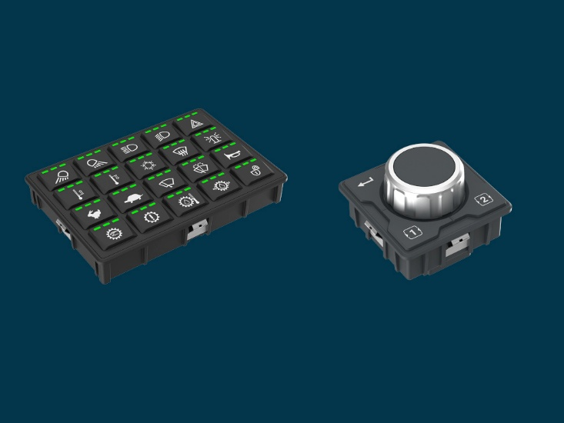

Caption: RAFI expands its HMI portfolio with keypads featuring 16 or 20 keys, integrated encoder keypads, and compact encoder variants.

Image Source: RAFI

Image/s: | keypad_encoder_2000.jpg | Characters: | 2,508
File name: | 20260528_pm_keypads-encoder_EN.docx | Date: | 06-02-2026
Tags: | RAFI, Rafi, iVT Expo, trade fair Cologne, standardized keypads, encoders, rotary push encoders, construction machinery, agricultural vehicles, mining vehicles, forestry machinery, off-highway applications, ISO 25119 AGPL d, ISO 13849 PL d, ISO 19014 MPL

About the RAFI Group

Founded in 1900, RAFI today develops and produces electromechanical components and systems for human-machine interaction. The range of products includes key switches, switches, touchscreens, control systems, and electronic assemblies. RAFI products are employed in many industries including automation, medical technology, machine and plant engineering, road and railway vehicles, household appliances, and telecommunication. The RAFI Group operates internationally with more than 2,000 employees at sites in Germany, Europe, China, and the USA. Its headquarters are in Berg, Germany.

Contact:  RAFI GmbH & Co. KG  Patrick Müller  Product Marketing Manager  Ravensburger Straße 128-134  88276 Berg  Tel.: +49 751 89-1634  E-Mail: patrick.mueller@rafi-group.com  Internet: www.rafi-group.com |  | gii die Presse-Agentur GmbH  Christburger Str. 41  10405 Berlin, Germany  Phone: +49 30 538 965-0  Email: info@gii.de  Web: www.gii.de

