Press Release

Shredder motor powers through blockages

Menzel Elektromotoren designs and manufactures motors for various high-performance shredding applications from the timber industry to the recycling sector. The company builds both squirrel-cage and slip ring motors for these demanding tasks, which involve powerful, irregular vibrations and shocks, and also offers load tests and a maintenance service.

Recently, the electric motor manufacturer replaced a slip ring motor that had failed due to overload. A shredder designed for mixed scrap metal had to process entire car bodies. As a result, exceptionally strong vibrations were transmitted to the motor, disrupting the contact between the carbon brushes and slip rings and causing sparks, brush fire and severe damage to the slip rings.

Menzel, a medium-sized company from the outskirts of Berlin with a large inventory of stock motors, had a suitable unit at hand and quickly equipped it for the application. The slip ring motor is particularly well suited to shredding applications because it delivers the full starting torque from standstill. In the event of blockages or when starting up, the shredder does not necessarily have to be emptied first. In many cases, the motor starts the loaded shredder and powers through blockages.

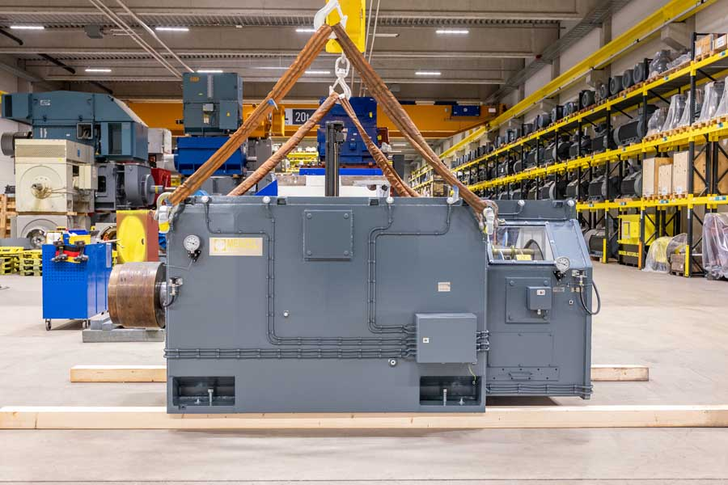
Caption: Menzel Elektromotoren quickly adapted a stock slip ring motor for a metal shredder, adding vibration damping and reinforced brush contact for reliable operation

Menzel selected abrasion-resistant brushes, fitted springs with high contact pressure in the brush holders and installed more brushes to ensure a sufficiently large contact area for current transfer even if a brush momentarily lifts off. This was complemented by a range of measures for vibration damping and absorption as well as motor monitoring. A spherical roller bearing on the drive side absorbs impacts, compensates for slight shaft misalignment and, with good maintenance, achieves a long service life in shredding applications.

The motor manufacturer supported the definition of new best-practice guidelines, working in close collaboration with the machine builder and the scrapyard manager. For instance, in future, car bodies will be cut in half before being thrown into the shredder, especially electric vehicle bodies, whose underbodies are reinforced around the drive battery, making them extremely hard to shred. Menzel also conducted an operational vibration analysis, installed temperature and vibration sensors to continuously monitor the bearings and helped establish an effective maintenance plan. Plant availability has improved significantly since then.

More reference projects: https://www.menzel-motors.com/crusher-drive/

Image/s: | h13233_slip_ring_motor_at_menzel | Characters: | 2409
File name: | 20260602_pm_shredder_motor_scrap_cars_en | Date: | 06-02-2026
Tags: | shredder motor, slip ring motor, metal shredder, recycling, vibration analysis
About Menzel Elektromotoren
Menzel Elektromotoren GmbH has been manufacturing and distributing electric motors since 1927. The German family-run company based in Hennigsdorf near Berlin specializes in the delivery of large electric motors, including special models, within the shortest time possible. The product range comprises high and low voltage motors, DC motors, transformers, and frequency inverters. Services include motor production up to and beyond 25 MW and short-term adaptation of stock motors to application-specific requirements. In order to ensure short delivery times, Menzel maintains a large inventory with over 20,000 motors up to 15 MW. Qualified engineering, experienced staff, and state-of-the-art production and testing facilities help the manufacturer provide excellent reliability. Menzel operates subsidiaries in Sweden, the UK, France and Italy and cooperates with numerous partners worldwide.
Contact:  Menzel Elektromotoren GmbH  Anja Leipold  Corporate Communications  Am Alten Walzwerk 2  16761 Hennigsdorf  Germany  Phone: +49 30 349 922-0  Email: info@menzel-motors.com  Internet: www.menzel-motors.com |  | gii die Presse-Agentur GmbH  Christburger Str. 41  10405 Berlin  Germany  Phone: +49 30 538 965-0  Email: info@gii.de  Internet: www.gii.de

