Reliable and fast: Electric spindles with IPM technology

In the automotive industry in particular, robust and reliable electric spindles for horizontal machining centres are in high demand. Introducing the ES60 series, HSD Mechatronics offers a precise and low-maintenance solution for demanding milling, drilling and tapping operations. The spindles process light metal alloys just as efficiently as cast iron and steel.

HSD Mechatronics has expanded its product portfolio, adding the high-performance ES60 electric spindle series for horizontal machining centres. The robust spindles in this series deliver lasting productivity gains in metalworking. They effortlessly mill, drill and tap materials including light metal alloys, steel and cast iron. All types are characterised by high reliability and low maintenance requirements. The ES60 series employs synchronous motor technology with internal permanent magnets (IPM), which simplifies the overall design and reduces installation costs since it requires no additional cabinet choke.

Users benefit from a compact solution with a minimal footprint and reduced cooling requirements in the control cabinet. The ES60 electric spindles reduce the rotational inertia of the rotating system through their sophisticated engineering, enabling extremely short acceleration times. A representative model in the series, the ES6000, reaches maximum speeds of up to 12,000 rpm and accelerates from zero to rated speed in 0.5 seconds. It delivers a continuous output of 37.5 kW and a torque of up to 143 Nm and has an HSK-A80 tool holder.

Featuring such dynamic characteristics, the ES60 series supports millions of tool changes and thereby increases availability and cost-effectiveness in series production. Liquid-based cooling and reliable oil lubrication of the bearings ensure stable thermal conditions and a long service life even under demanding conditions. Optional features include through-spindle coolant supply, a chip detection system and an integrated encoder solution to further enhance process monitoring.

The sophisticated combination of high performance, modular extras and rugged design makes the ES60 series a key component for OEMs and machine builders who rely on short cycle times and maximum utilisation of their machining centres.

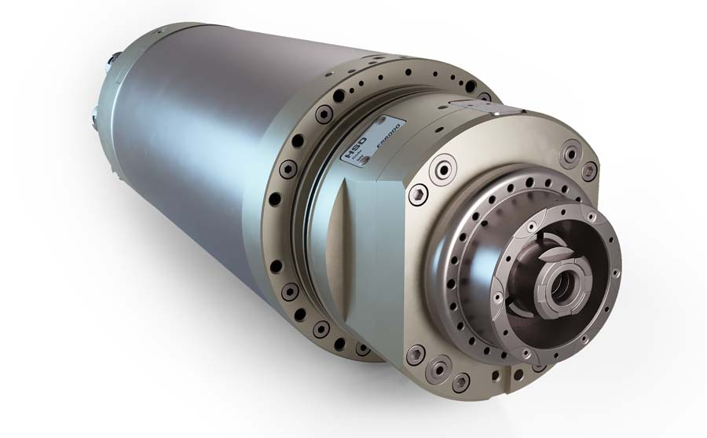
Caption 1: The ES60 series from HSD Mechatronics offers precise and low-maintenance solutions for demanding milling, drilling and tapping

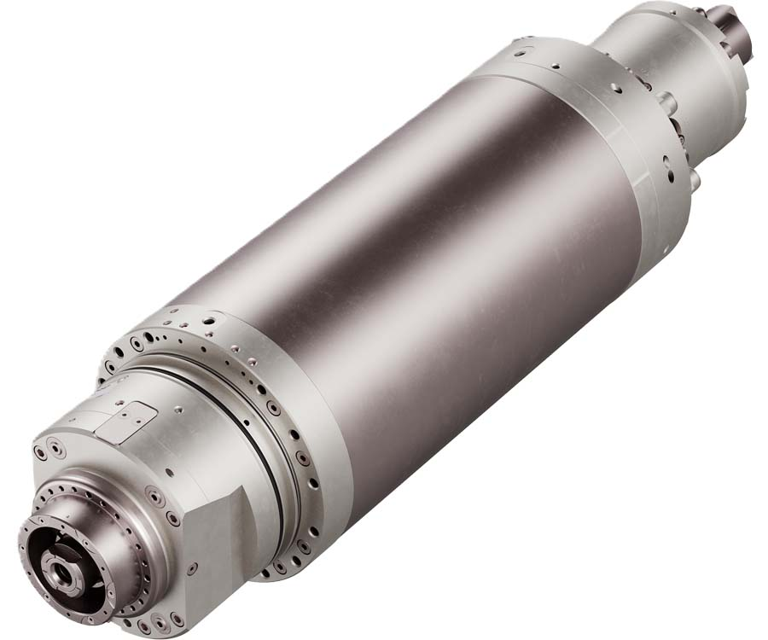
Caption 2: ES60 electric spindles stand out through their well-engineered design

Image/s: | H6161  HES6000 | Characters: | 1870
File name: | 202606078_pm_hsd_es60_en | Date: | 06-16-2026
Tags: | electric spindles, synchronous motor technology with internal permanent magnets, IPM, horizontal machining centres, automotive, metalworking
About HSD
For over 30 years, HSD Mechatronics has been developing, manufacturing and distributing electric spindles, two-axis milling heads and technologically advanced components for machining metal, composite alloys and wood. The company has an 8000 square metre plant working according to the just-in-time principle. HSD is headquartered in Italy and has five subsidiaries in the most important markets worldwide.
Contact:  HSD Deutschland GmbH  Simon Lohmiller  An der Leibi 10  89278 Nersingen  Germany  Office phone: +49 7308 9606 15  Mobile: +49 151 1191 5905  Email: simon.lohmiller@biesse.com  Internet: www.hsdmechatronics.com |  | gii die Presse-Agentur GmbH  Christburger Str. 41  10405 Berlin  Germany  Phone: +49 30 538 965 - 0  Email: info@gii.de  Internet: www.gii.de

