Press Release

Coloring book for future motor engineers

Menzel Elektromotoren has published the world’s first coloring book about industrial motor manufacturing. Illustrations based on photographs from the shopfloor invite children to discover how large electric motors are made and develop an early interest in engineering and technology.

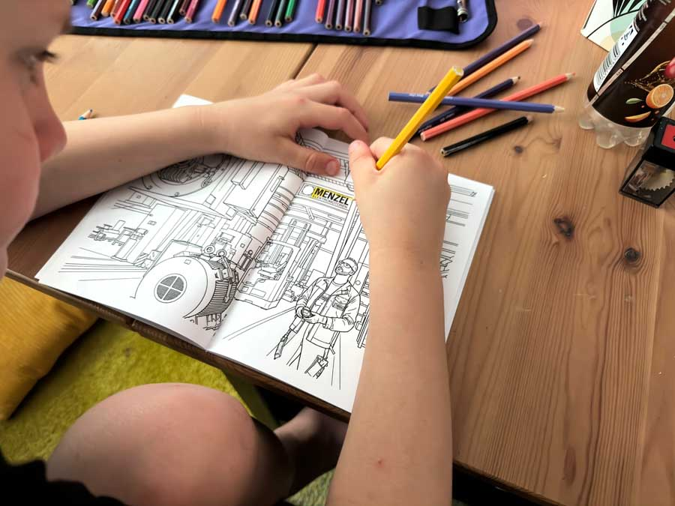
Caption: Based on photographs from Menzel's shopfloor, the coloring book offers a vivid glimpse into the world of large electric motor manufacturing

Menzel Elektromotoren makes its case for a career in electric motor engineering even to the youngest generation. The Berlin-based company takes an original approach and is the first industrial manufacturer to publish a coloring book about its work. Children of preschool and elementary-school age can explore how large industrial motors are built.
“The coloring book is meant to bring children joy and spark curiosity about technology along the way,” says Anja Leipold, head of marketing at Menzel. “We already partner with schools in our region to raise awareness of motor technology and attract young people to apprenticeship programs. Our industry is vital to every branch of manufacturing and the economy. It’s never too early to get the next generation interested in what we do. Who better than a motor manufacturer to show what goes into building, testing, servicing and repairing electric motors?”
The coloring book portrays a varied line of work at the intersection of skilled trades, electrical and mechanical engineering and industrial production. The illustrations are based on photographs from the shopfloor and depict the manufacture of large electric motors in precise detail.
Menzel takes talent development seriously. The family-run business, now in the third generation and approaching its centennial in 2027, trains young people as electrical machine and drive systems technicians every year. Employees tend to stay for the long term, and family members frequently follow – possibly the strongest endorsement any employer can earn.

For more images and background, visit https://www.menzel-motors.com/article/first-coloring-book-on-electric-motor-manufacturing/.

Image/s: | menzel-coloring-book | Characters: | 1546
File name: | 20260707-Menzel-PM-EN-coloring-book | Date: | 07-07-2026
Tags: | coloring book, motor engineers, industrial motor manufacturing, electric motor engineering | gii ID: | 26174
About Menzel Elektromotoren
Menzel Elektromotoren GmbH has been manufacturing and distributing electric motors since 1927. The German family-run company based in Hennigsdorf near Berlin specializes in the delivery of large electric motors, including special models, within the shortest time possible. The product range comprises high and low voltage motors, DC motors, transformers, and frequency inverters. Services include motor production up to and beyond 25 MW and short-term adaptation of stock motors to application-specific requirements. In order to ensure short delivery times, Menzel maintains a large inventory with over 20,000 motors up to 15 MW. Qualified engineering, experienced staff, and state-of-the-art production and testing facilities help the manufacturer provide excellent reliability. Menzel operates subsidiaries in Sweden, the UK, France and Italy and cooperates with numerous partners worldwide.
Contact:  Menzel Elektromotoren GmbH  Anja Leipold  Corporate Communications  Am Alten Walzwerk 2  16761 Hennigsdorf  Germany  Phone: +49 30 349 922-0  Email: info@menzel-motors.com  Internet: www.menzel-motors.com |  | gii die Presse-Agentur GmbH  Christburger Str. 41  10405 Berlin  Germany  Phone: +49 30 538 965-0  Email: info@gii.de  Internet: www.gii.de

