Press Release

Fast-track production of high-voltage motor

A Swedish operator urgently needed a replacement for a faulty 2,300 kW mixer motor. Menzel Elektromotoren modified a high-voltage stock motor in just six working days to fit the application – with customized shaft dimensions, a base frame and reinforced roller bearings.

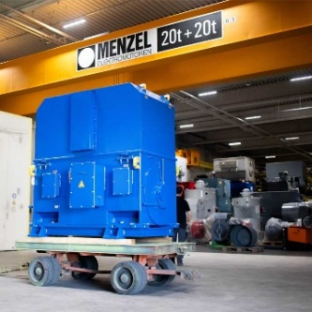
Caption: Menzel built an application-specific 2,300 kW high-voltage motor as a drop-in replacement in six working days

Menzel Elektromotoren has customized a high-voltage motor in just six working days. A Swedish customer urgently needed a replacement for a damaged mixer motor.

The application defined the specifications: 2,300 kW output at 6,600 V, a speed of 1,485 rpm and a rated torque of 14,791 Nm. Menzel selected a suitable three-phase squirrel-cage motor from stock and modified it as a drop-in replacement, requiring no changes to the customer's equipment. The motor manufacturer built a foot adapter and re-machined the shaft diameter to match the customer’s mounting interface and installed heavy-duty roller bearings designed to handle the high loads typical of agitator applications.

The motor for foot mounting (mounting type IM 1001 / IM B3) features IP55 protection and an air-to-water heat exchanger (cooling type IC 81W). It combines high robustness with high efficiency.

Designing its motor series for modularity, Menzel can flexibly configure motors with different cooling and protection ratings as well as mounting options. The company also carries out custom adaptations including special shaft dimensions or electrical reconfigurations at short notice, if required. This way, the German manufacturer minimizes downtime and gets plants back up and running fast.

More information: https://www.menzel-motors.com/modification/

Image/s: | mixer-motor-6600v-ic81w-h13068 | Characters: | 1262
File name: | 20260908-Menzel-PM-EN-mixer-motor | Date: | 09-08-2026
Tags: | high-voltage motor, mixer motor, three-phase squirrel-cage motor, customized, drop-in replacement | gii ID: | 26275
About Menzel Elektromotoren
Menzel Elektromotoren GmbH has been manufacturing and distributing electric motors since 1927. The German family-run company based in Hennigsdorf near Berlin specializes in the delivery of large electric motors, including special models, within the shortest time possible. The product range comprises high and low voltage motors, DC motors, transformers, and frequency inverters. Services include motor production up to and beyond 25 MW and short-term adaptation of stock motors to application-specific requirements. In order to ensure short delivery times, Menzel maintains a large inventory with over 20,000 motors up to 15 MW. Qualified engineering, experienced staff, and state-of-the-art production and testing facilities help the manufacturer provide excellent reliability. Menzel operates subsidiaries in Sweden, the UK, France and Italy and cooperates with numerous partners worldwide.
Contact:  Menzel Elektromotoren GmbH  Anja Leipold  Corporate Communications  Am Alten Walzwerk 2  16761 Hennigsdorf  Germany  Phone: +49 30 349 922-0  Email: info@menzel-motors.com  Internet: www.menzel-motors.com |  | gii die Presse-Agentur GmbH  Christburger Str. 41  10405 Berlin  Germany  Phone: +49 30 538 965-0  Email: info@gii.de  Internet: www.gii.de

