Press Release

5,000 V pump motors for high-temperature environments

Menzel Elektromotoren has built three 400-kW high-voltage motors for centrifugal pumps in a steel mill. The cost-effective standard motors are adapted to the application and rated for ambient temperatures up to 60 °C.

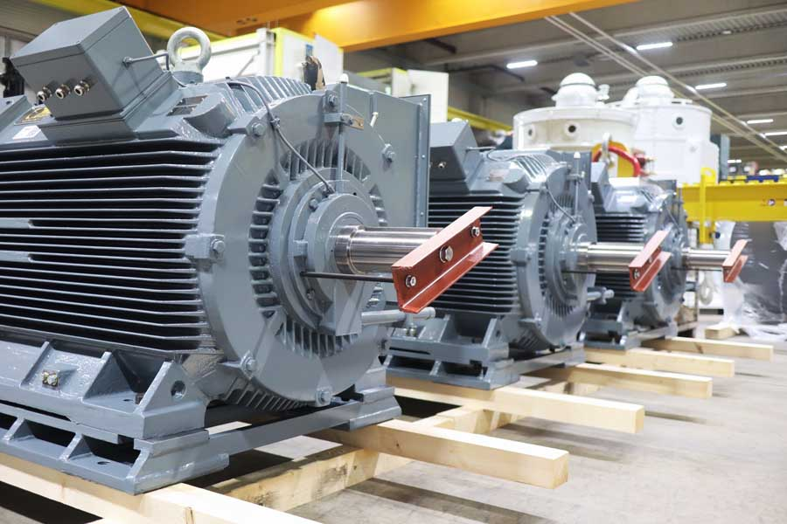
Caption: Menzel adapts standard high-voltage motors for high thermal resistance and custom shaft height, delivering a cost-effective application-specific solution

German manufacturer Menzel Elektromotoren has supplied three large motors to drive centrifugal pumps in the pump house of a steel mill. The motor windings are insulated to Class H (180 °C), giving ample thermal headroom for ambient temperatures that can briefly reach 60 °C. Cylindrical roller bearings in NU configuration compensate for axial displacement caused by heating and expansion of the motor shaft, ensuring reliable, long-lasting operation without efficiency losses.

The customer required drop-in replacements for older three-phase squirrel-cage motors. Menzel selected compact MEBKGR-type motors for foot-mounting (mounting type IM 1001/IM B3) and built a customized base frame to adapt the shaft height. Rated at 5,000 V and 400 kW, the motors deliver a rated torque of 2,563.8 Nm. They feature IP55 protection and cooling method IC 411 (rib-cooled housing with an external fan).

The MEBKGR series addresses the growing demand for economical high-voltage motors. Key features include a strong price–performance ratio, high efficiency, low operating and maintenance costs, high load capacity, and low vibration levels. Menzel won the contract with a competitive total price, short delivery time, high flexibility and expert customer support.

More information about squirrel-cage motors with versatile configuration options: https://www.menzel-motors.com/squirrel-cage-motor/ic411-ic416/

Image/s: | pump-motors-5000v-ic411-h12783 | Characters: | 1251
File name: | 20260929-Menzel-PM-EN-pump-motors-steelworks | Date: | 09-29-2026
Tags: | pump motors, high-voltage motors, three-phase squirrel-cage motors, centrifugal pumps, steel mill, customized, drop-in replacements | gii ID: | 26274
About Menzel Elektromotoren
Menzel Elektromotoren GmbH has been manufacturing and distributing electric motors since 1927. The German family-run company based in Hennigsdorf near Berlin specializes in the delivery of large electric motors, including special models, within the shortest time possible. The product range comprises high and low voltage motors, DC motors, transformers, and frequency inverters. Services include motor production up to and beyond 25 MW and short-term adaptation of stock motors to application-specific requirements. In order to ensure short delivery times, Menzel maintains a large inventory with over 20,000 motors up to 15 MW. Qualified engineering, experienced staff, and state-of-the-art production and testing facilities help the manufacturer provide excellent reliability. Menzel operates subsidiaries in Sweden, the UK, France and Italy and cooperates with numerous partners worldwide.
Contact:  Menzel Elektromotoren GmbH  Anja Leipold  Corporate Communications  Am Alten Walzwerk 2  16761 Hennigsdorf  Germany  Phone: +49 30 349 922-0  Email: info@menzel-motors.com  Internet: www.menzel-motors.com |  | gii die Presse-Agentur GmbH  Christburger Str. 41  10405 Berlin  Germany  Phone: +49 30 538 965-0  Email: info@gii.de  Internet: www.gii.de

