Press Release

VISION 2026:
Camera enclosures for every vision task

At VISION 2026, autoVimation presents its enclosures for machine vision applications at the Exaktera booth (Hall 10, Booth C50). Rugged aluminum enclosures and stainless-steel hygienic enclosures for cameras and lasers feature in demo models for the food and beverage industry and washdown processes.

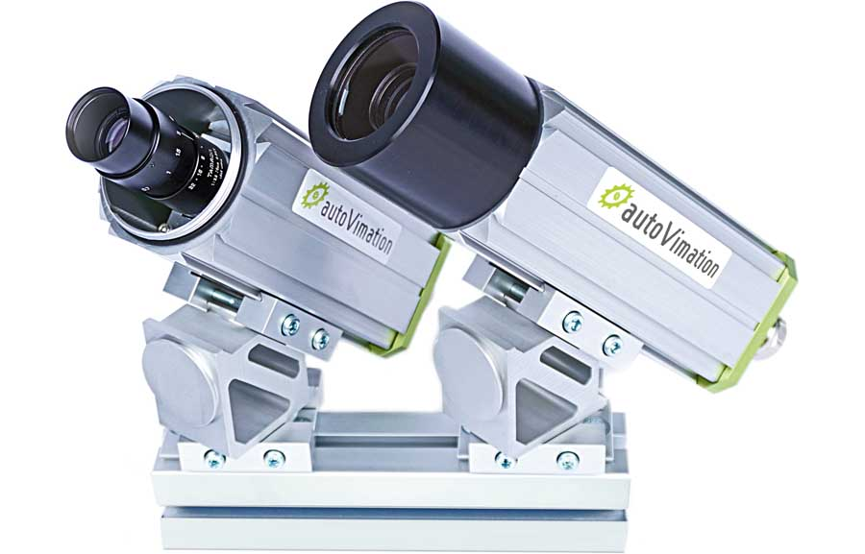
Caption: Lizard enclosures fit long lenses and allow tool-less access to the lens settings.

At the 2026 VISION trade fair, autoVimation (Hall 10, Booth C50) will present its camera enclosures together with fellow specialized brands from Exaktera. autoVimation has recently moved to Suhl, where it benefits from shared infrastructure with sister brands LUMIMAX and VisioCablePro.

autoVimation enclosures protect cameras and lasers from dirt and moisture while providing effective passive cooling. Active heating and cooling options are also available for more extreme temperature applications. Different enclosure sizes and modular extensions accommodate all common industrial camera models and a wide range of lenses. Window materials are available for all inspection tasks from visible light to hyperspectral imaging and infrared vision as well as for laser light sources.

Live models at the VISION booth demonstrate optical inspection in diverse industrial settings. A food-and-beverage demo features Chameleon and Lizard enclosures. These rugged aluminum enclosures provide at least IP66 protection. The Chameleon series fits right-angled cameras and vision sensors. Lizard enclosures have a removable tube for tool-less access to the lens settings. Lenses with different lengths, including wide-angle lenses, can be mounted directly behind the front window for shading-free image capture.

A hygienic demo includes stainless-steel Dolphin and Piranha enclosures in strict, EHEDG-compliant hygienic design. Rated IP69K, they withstand heavy-duty cleaning cycles. Their smooth, crevice-free surfaces offer no foothold for bacteria, keeping critical food and pharmaceutical processes free from contamination.

Exaktera and autoVimation at the VISION tradeshow
Stuttgart, Germany, 6 – 8 October 2026
Hall 10, Booth C50

Image/s: | lizard_camera_enclosures_mounted | Characters: | 1613
File name: | 20260930-autoVimation-PM-EN-Vision-tradeshow-preview | Date: | 09-30-2026
Tags: | VISION 2026, trade fair, camera enclosures, hygienic enclosures, machine vision, optical inspection, food and beverage, washdown, EHEDG-compliant hygienic design | gii ID: | 26298
About autoVimation
Founded in 2008, autoVimation develops and distributes protective camera enclosures and modular mounting systems for the durable, cost-efficient and time-saving installation of machine vision components. The product range covers solutions for harsh industrial environments, indoor, outdoor and underwater applications, hygienically demanding applications as well as temperature-controlled enclosures for all climate zones. The Hygienic Building Kit enables EHEDG-compliant vision installations in food and pharmaceutical production processes.
autoVimation is part of Exaktera.
Contact:  iiM GmbH  autoVimation  Michael Alteg  Neuer Friedberg 5  98527 Suhl  Germany  Phone: +49 3681 455 19-0  Email: sales@autovimation.com  Internet: www.autovimation.com |  | gii die Presse-Agentur GmbH  Christburger Str. 12  10405 Berlin  Germany  Phone: +49 30 538 965-0  Email: info@gii.de  Internet: www.gii.de

