Press Release

LOSYCO at LogiMAT 2026:
Production logistics for all automation levels

LOSYCO will showcase innovative rail-based intra-logistics and production logistics at the LogiMAT trade fair in Stuttgart, Germany, March 24 to 26, 2026, at booth #7-F09. The manufacturer designs and implements complete transport and handling solutions from a single source and will be presenting new developments extending its LOXrail system. LOXrail tracks, which are available in two sizes, are designed for payloads up to 60 tons and more. The system enables economic and energy-saving transport on customer-specific trolleys in a wide range of production processes, from the manufacture of tools and agricultural machinery to wind turbine building and modular house pre-fabrication. Even loads weighing several tons can be transported manually and alternatively powered via batteries.

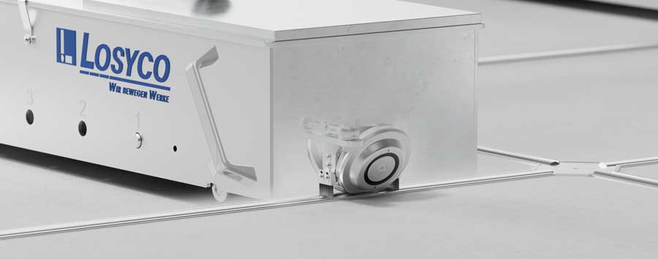
Caption 1: The flush-with-the-floor LOXrail system with crossings and AllRounder wheelsets enables flexible lane changes at full load

Image source: LOSYCO GmbH

LOSYCO will furthermore present a new fully automated transport solution as next innovation stage for rail-based production logistics: the LOXrail smartCURVE system combines the load-bearing capacity of intra-logistics rails with the advanced levels of automation of current AGV technology, creating a cutting-edge smart-factory heavy-duty transport solution. The autonomous transport system, which LOSYCO has successfully deployed in an automotive production plant, consists of self-propelled transport trolleys, latency-free, fail-safe Wi-Fi communication, sensor-based position detection and inductive charging technology. The trolleys navigate the manufacturing site with sensors, transport material or assemblies between work stations, find their exact positions and independently charge their batteries.

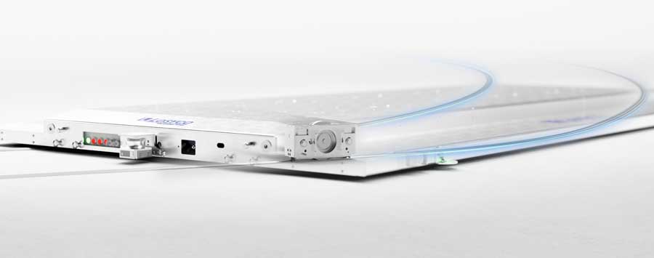
Caption 2: LOXrail smartCURVE is the first autonomous corner-going intra-logistics rail system for payloads of several tons

Image source: LOSYCO GmbH

In addition, the German systems provider LOSYCO will exhibit floor-level crossing systems, AllRounder steering platforms as well as material feeding and warehouse logistics solutions. The team is looking forward to engaging contacts and professional exchange at the trade fair.

Image/s: | allrounder-kreuzung_2000.jpg  smart-curve-wagen_2000.jpg | Characters: | 1876
File name: | 260223-1_pm_logimat_en | Date: | 02-24-2026
Tags: | LogiMAT, production logistics, rail-based intra-logistics, autonomous transport, automotive production
About Losyco
LOSYCO designs, builds, and installs intra-logistics systems for the manufacturing industry. The company based in Bielefeld, Germany, was founded by experienced engineers in 2016. LOSYCO’s core product is the LOXrail® floor rail system for easy transport and precise positioning of loads weighing several tons. LOXrail transport platforms can be operated manually or with auxiliary drives. LOSYCO also supplies handling equipment such as chain and roller conveyors, material management and storage systems, as well as sound-proof cabins and machine covers. LOSYCO supports customers wishing to transform their production processes to lean manufacturing and continuous flow production. LOSYCO is a member of the DRECKSHAGE Family.
Contact:  LOSYCO GmbH  Tim Schneider  Walter-Werning-Str. 7  33699 Bielefeld  Germany  Tel.: +49 . 521 . 945 643-0  Email: info@losyco.com  Internet: www.losyco.com |  | gii die Presse-Agentur GmbH  Christburger Str. 41  10405 Berlin  Germany  Tel.: +49 . 30 . 538 965-0  Email: info@gii.de  Internet: www.gii.de

