Press Release

Digital LVDT Displacement Sensor: Fewer Variants, Greater Flexibility

INELTA Sensorsysteme has played a key role in advancing the digitization of proven LVDT technology and has successfully established it, particularly in hydraulic applications. Applying this concept to additional designs and areas of use opens up new possibilities for industrial displacement measurement. In the future, users will benefit from greater flexibility, reduced procurement effort, and simplified inventory management.

Digital Linear Variable Differential Transformers (LVDTs) can be configured via software. To achieve this, INELTA Sensorsysteme stores multiple customer-specific measuring ranges within a single sensor type. Users can parameterize the sensor on-site to the measuring range required for a given application. In addition, the characteristic curve can be shifted to compensate for installation tolerances. This eliminates the need for system recalibration when replacing a sensor. Signal inversion is also possible.

Thanks to its scalable preconfiguration, a single displacement sensor replaces multiple variants and combines different specifications in a single housing. This enables INELTA Sensorsysteme to make the advantages of digital LVDT displacement sensors available for additional application areas and industries. Significant cost-saving potential exists, particularly in automation technology, but also in other industrial sectors where different measurement ranges and a minimal number of variants are required.

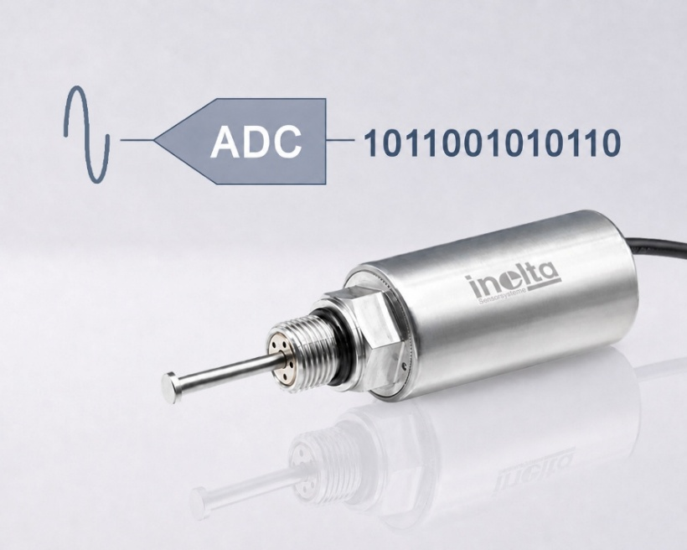
Caption: The digital LVDT displacement sensor from INELTA Sensorsysteme combines multiple measurement ranges in a single device and can be flexibly configured via software to suit the specific application.

(Image Source: INELTA Sensorsysteme)

Image/s: | Digitaler-LVDT_2000.jpg | Characters: | 1,449
File name: | 26179-Inelta_PIL-PM2-digital-lvdt.docx | Date: | 07-07-2026
Tags: | INELTA Sensorsysteme, LVDT, displacement sensor, digitization, automation, displacement measurement, INELTA sensor systems, digital sensor, preconfiguration, parameterization, automation technology, sensor technology
About INELTA Sensorsysteme
INELTA Sensorsysteme GmbH & Co. KG, based in Taufkirchen near Munich, has been developing, manufacturing, and marketing standard and custom sensor solutions for industrial applications since 2000. Together with its sister companies PIL Sensoren GmbH (Erlensee near Frankfurt am Main), a pioneer in ultrasonic sensor technology, and VYPRO s.r.o. (Trenčín, Slovakia), the company offers a broad product range for measuring displacement, position, force, pressure, and tilt. The product range includes displacement sensors, force sensors, tilt sensors, signal conditioners, pressure switches, motor potentiometers, capacitive sensors, and ultrasonic sensors. Services in the field of cable and connector assembly round out the portfolio.
The group of companies primarily serves customers in the industrial automation, mechanical engineering, hydraulics, medical technology, aerospace, and process industries. Industry- and customer-specific sensor solutions are a particular focus, which is continuously expanded through interdisciplinary expertise.
Contact:
INELTA Sensorsysteme GmbH & Co. KG
Bettina Redepenning
Ludwig-Bölkow-Allee 22
82024 Taufkirchen
Germany
Phone: +49 89 45 22 45 0
Email: bettina.redepenning@inelta.de
Email: mailbox@inelta.de

Internet: News & Product Updates | INELTA Sensorsysteme

