Press Release

Ten years of rail-based production logistics
LOSYCO marks its first decade

German production logistics specialist LOSYCO celebrates its tenth anniversary. Founded in April 2016 by experienced engineers, the expert for rail-based heavy-duty intra-logistics has grown into a global systems provider of integrated solutions for production and warehouse logistics as well as heavy-load material feeding.
Based on its flush-mounted LOXrail system, LOSYCO designs, manufactures and installs custom intra-logistics systems with application-specific transport trolleys for the tooling and agricultural machinery industries, wind turbine production, prefabricated building construction and many other sectors worldwide. The technology enables workers in flow production lines to move multi-ton payloads manually without auxiliary power. Alternatively, battery-powered and inductively fed drive concepts are available.
The most recent addition to the product range, the LOXrail smartCURVE system navigates curves and corners and combines the load capacity of conventional rails with the automation level of modern automated guided vehicle (AGV) technology for heavy-load transport at Industry 4.0 levels. LOSYCO has also developed high-precision systems with various automated feeding options for robot cells, laser cutting machines and other applications. In warehouse logistics, the robust LOXrail systems have proven their value as an economical, low-wear and barrier-free transport solution.
Since company founder Derek P. Clark stepped down from management in 2020, LOSYCO has been led by industrial engineer Manuel Granz. He states, “We are proud of our success story and the many projects we have completed worldwide in 10 years. We have grown continuously since our founding and have steadily opened up new business areas through innovative system extensions. We will continue to offer our customers forward-looking conveyor concepts tailored precisely to their applications.”

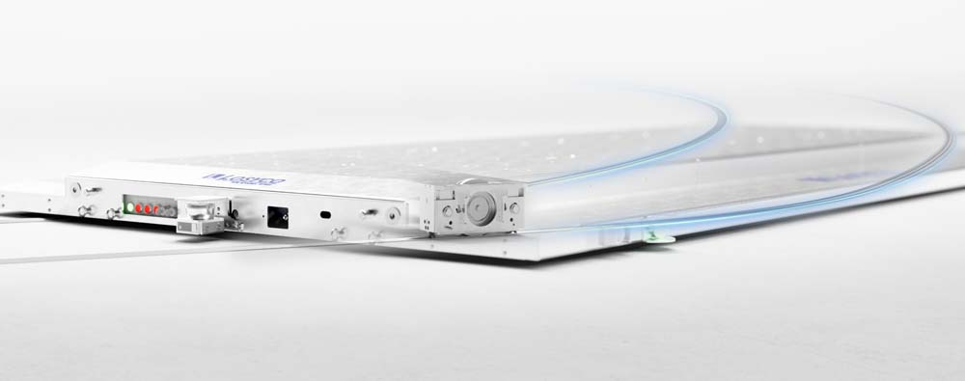
Caption 1: Rail-based innovation: the fully automated SmartCURVE system with autonomous transport trolleys, inductive power supply and zero-latency Wi-Fi communication
(Image: LOSYCO GmbH)


Caption 2: Manuel Granz, LOSYCO’s managing director since 2020

(Image: LOSYCO GmbH)

Image/s: | smart-curve-wagen_2000.jpg  m_granz22_2000.jpg | Characters: | 1896
File name: | 26254-LOSYCO-PM-EN-10-yr-anniversary | Date: | 08-05-2026
Tags: | company anniversary, production logistics, intra-logistics, warehouse logistics as, material feeding, flow production lines
About Losyco
LOSYCO designs, builds, and installs intra-logistics systems for the manufacturing industry. The company based in Bielefeld, Germany, was founded by experienced engineers in 2016. LOSYCO’s core product is the LOXrail® floor rail system for easy transport and precise positioning of loads weighing several tons. LOXrail transport platforms can be operated manually or with auxiliary drives. LOSYCO also supplies handling equipment such as chain and roller conveyors, material management and storage systems, as well as sound-proof cabins and machine covers. LOSYCO supports customers wishing to transform their production processes to lean manufacturing and continuous flow production. LOSYCO is a member of the DRECKSHAGE Family.
Contact:  LOSYCO GmbH  Tim Schneider  Walter-Werning-Str. 7  33699 Bielefeld  Germany  Tel.: +49 . 521 . 945 643-0  Email: info@losyco.com  Internet: www.losyco.com |  | gii die Presse-Agentur GmbH  Christburger Str. 41  10405 Berlin  Germany  Tel.: +49 . 30 . 538 965-0  Email: info@gii.de  Internet: www.gii.de

