Press Release

New RAMO E emergency stop buttons with Plug&Play connection

RAFI is expanding its easy-to-install RAMO product family with new emergency stop buttons. The newly introduced models in the RAMO E series include the RAMO 22 E and RAMO 30 E emergency stop buttons with pull release. RAFI now offers emergency stop actuators up to IPx9K degree of protection on the front side, which are particularly suitable for high-pressure and steam-jet-cleaned applications. A new RAMO E PLUS 1 emergency stop variant is also being added to the portfolio. This emergency stop button has three contacts so that, for example, in addition to two redundant contacts for safety applications, a signaling contact for position detection can also be assigned. The range extension is completed by RAMO E buttons with rotary release. In addition to the tried-and-tested 4- and 5-pole versions, both actuators are now also available as illuminated versions with an 8-pole, A-coded M12 connection. The RAMO E series is designed for 50,000 actuation cycles and meets all applicable ISO and IEC standards. With maximum mounting depths of 30.2 mm (RAMO 22) or 36.4 mm (RAMO 30), the emergency stop buttons, which are designed for mounting hole diameters of 22.3 mm or 30.3 mm, can be installed in a space-saving manner even where installation space is limited. Like the entire RAMO series, the emergency stop buttons are equipped with easy-to-install M12 plug terminals that reduce wiring work to a minimum. Plug&Play cabling, which can be carried out in freely selectable lengths with any cable from a wide range of manufacturers, can also be carried out by untrained personnel and ensures rapid commissioning. The RAMO-typical single-part, closed housing can be mounted directly onto aluminum profile rails, walls, tables or workbenches with the RAMO EDGE mounting bracket without using a housing. This makes RAMO operating components a flexible, highly economical stand-alone solution for decentralized industrial applications. Thanks to the low-profile design in front of and behind the front panel and the 135° angled plug, tight horizontal and vertical row mounting can be implemented.

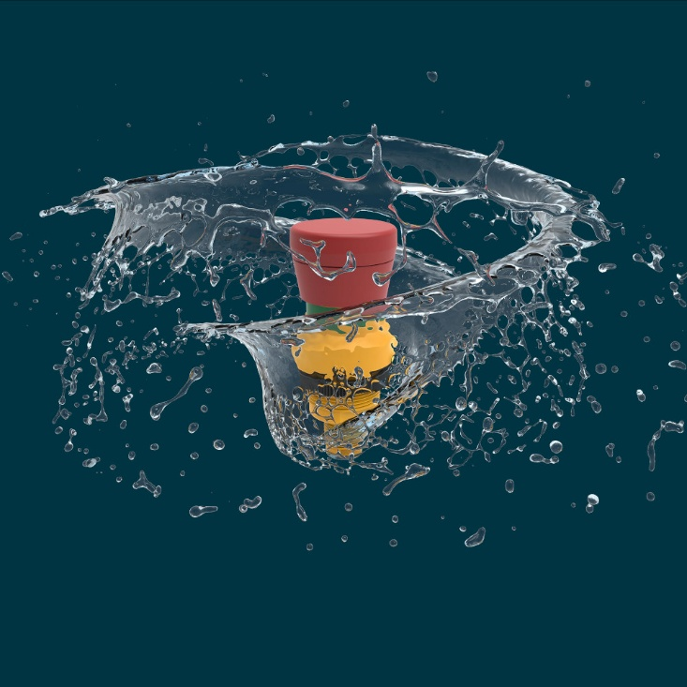

Caption: With RAMO E, RAFI also offers emergency stop buttons with up to IPx9K degree of protection on the front side for high-pressure and steam-jet-cleaned areas of application.

(Image source: RAFI)

Image/s: | RAFI_RAMO_E_2000.jpg | Characters: | 2,096
File name: | 26271-RAFI-PM1-ramo-e_en.docx | Date: | 09-01-2026
Tags: | RAMO E, RAMO 22 E, RAMO 30 E, RAMO E PLUS 1, RAMO EDGE, emergency stop buttons, high-pressure applications, steam-jet-cleaned applications, M12 connection, ISO standards, IEC standards
About the RAFI Group
Founded in 1900, RAFI today develops and produces electromechanical components and systems for human-machine interaction. The range of products includes switches and key switches, touchscreens, control systems, and electronic assemblies. RAFI products are employed in many industries, including automation, medical technology, machine and plant engineering, road and railway vehicles, household appliances, and telecommunication. The RAFI Group operates internationally with over 2,000 employees at sites in Germany, Europe, China, and the USA. The headquarters of the RAFI Group are located in Berg near Ravensburg.

Contact:  RAFI GmbH & Co. KG  Fred Nemitz  Head of Corporate Marketing  Ravensburger Straße 128-134  88276 Berg  Germany  Phone: +49 160 92048569  Email: fred.nemitz@rafi-group.com  Web: www.rafi-group.com |  | gii die Presse-Agentur GmbH  Christburger Str. 41  10405 Berlin, Germany  Phone: +49 30 53 89 65-0  Email: info@gii.de  Web: www.gii.de

