Press Release

RAFI at electronica 2026
HMI expertise: From automation to cybersecurity

From November 10 to 13, RAFI will showcase innovative system solutions for automation and robotics, energy systems, smart infrastructure, and cybersecurity at electronica in Munich. At the trade show, the global HMI specialist will present new keypads with16 and 20 key switches, as well as keypads with integrated encoders, in Hall A3, Booth 361. Also making its debut is the smart encoder, an adaptive rotary encoder with programmable haptic feedback that can be individually configured for click behavior, torque, end stops, and active resetting.

A key focus of the exhibition program is new technology platforms for autonomous machines. Machine manufacturers will find tested, customizable modular kits ranging from individual technology components and scalable autonomy kits for retrofitting mobile machines to the development and production of complete autonomous systems.

As its second area of expertise, RAFI presents highly functional HMI solutions for robotics and industrial automation. A prime example is the highly ergonomic multitouch panel for injection molding machines that will be presented at the booth. Equipped with a 21.5-inch capacitive display and an innovative pushbutton console, the control system features a dual-swivel mechanism for optimal positioning at the workstation. Another area of focus is on custom, rugged operating and control systems for outdoor use in smart infrastructure, such as charging stations or energy management systems.

In the increasingly important field of cybersecurity, RAFI supports its customers in developing secure system architectures that comply with the upcoming EU requirements of the Cyber Resilience Act (CRA). RAFI’s expertise includes integrating secure boot and authentication mechanisms, protecting sensitive data through modern encryption technologies, safeguarding interfaces, and planning and implementing sustainable lifecycle strategies.
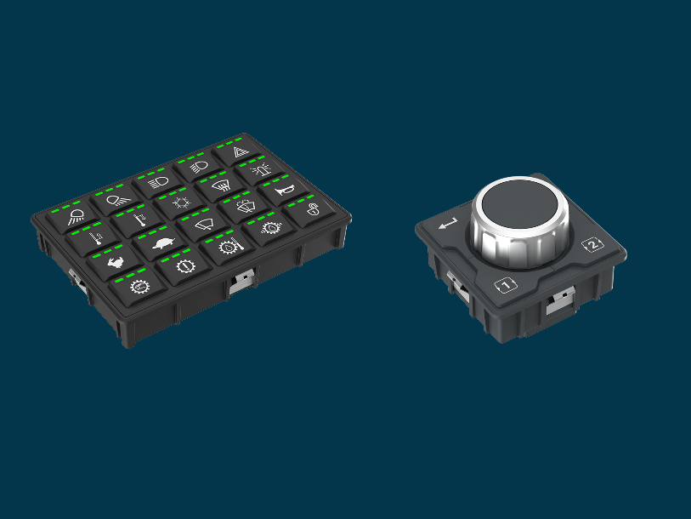

Caption 1: At electronica, RAFI is introducing new keypads with 16 and 20 key switches, as well as rotary push encoders, for precise data entry, menu navigation, and function control.

Source: RAFI

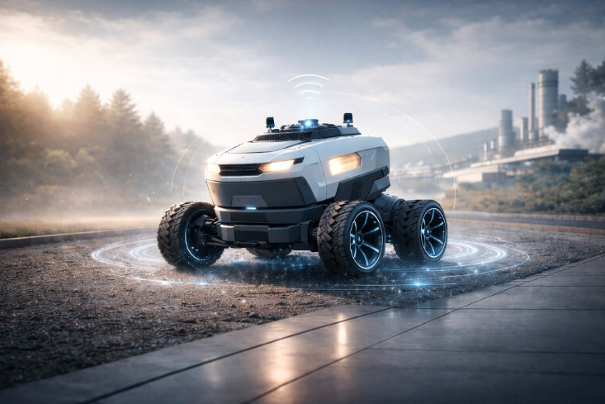

Caption 2: As a single-source provider, RAFI can handle every stage of the process, from development to industrial-scale series production, in the “Autonomy” division.

Image source: RAFI (AI-generated)

Image/s: | keypad_encoder_2000.jpg  RAFI_Autonomy_Kit_2000.jpg | Characters: | 1,911
File name: | 26315-RAFI-PM1-electron-26_en.docx | Date: | 10-13-2026
Tags: | RAFI, electronica 2026, HMI specialist, automation, robotics, smart infrastructure, cybersecurity, Munich, autonomy kit, multitouch panel, capacitive display, cybersecurity, Cyber Resilience Act, smart encoder

About the RAFI Group

Founded in 1900, RAFI today develops and produces electromechanical components and systems for human-machine interaction. The range of products includes switches and key switches, touchscreens, control systems, and electronic assemblies. RAFI products are used in automation, medical technology, mechanical and plant engineering, road and rail vehicles, household appliances, and telecommunications. The RAFI Group operates internationally, with over 2,000 employees at sites in Germany, Europe, China, and the USA. The headquarters of the RAFI Group are located in Berg near Ravensburg.

Contact:  RAFI GmbH & Co. KG  Fred Nemitz  Corporate Communications  Ravensburger Straße 128–134  88276 Berg, Germany  Phone: 0160 92048569  Email: fred.nemitz@rafi-group.com  Web: www.rafi-group.com |  | gii die Presse-Agentur GmbH  Christburger Str. 41  10405 Berlin  Phone: 030 53 89 65-0  Email: info@gii.de  Web: www.gii.de

