Press Release

Conta-Clip launches KDS-Rail cable management system
Successful InnoTrans premiere

The InnoTrans trade fair celebrated its 30th anniversary with record-breaking attendance and a host of innovations. More than 3,000 exhibitors from nearly 60 countries presented their highlights at the Berlin Expo Center from September 22 to 25, 2026. Conta-Clip celebrated the successful premiere of its new cable entry systems for rail applications and now prepares for the next InnoTrans edition.

The leading trade fair for transport technology drew strong crowds from the start, and the Conta-Clip booth was a hub of activity. The German connection technology specialists had a large team on the show floor, briefing visitors on every detail of the new modular KDS-Rail program. The cable management system delivers the flexibility users expect, carries an IP66 rating and allows for tool-less installation from either the inside or the outside. It enables well-structured cable routing in control cabinets, machines and enclosures and is easily adapted to changing requirements at any time without removing the frame.

Safety and fire protection
Passenger safety is rightly the top priority in modern rail transport, and speed is another key factor for success. Conta-Clip’s cable entry systems for rail applications address both. KDS-DE-Rail and KDS-DEG-Rail comply with EN 61373 and carry HL3 approval. Many visitors at the manufacturer’s booth put the products to the test and saw the benefits of the cable management systems for themselves. All components, including cables and sealing elements, can be quickly and easily installed and replaced, just like customers have come to expect from the company’s full portfolio and, in particular, from its rail-certified terminal block range.

A resounding debut
Jörg Nowastowski-Stock, Managing Director Sales and Marketing, and Marketing Director Christian Quade look back on InnoTrans with great satisfaction: “Presenting our cable entry systems at the leading rail transport trade show for the first time was a complete success. We are very pleased with the response to our new KDS-Rail system and are already looking forward to the next InnoTrans edition in two years, where we will present further innovative products.”

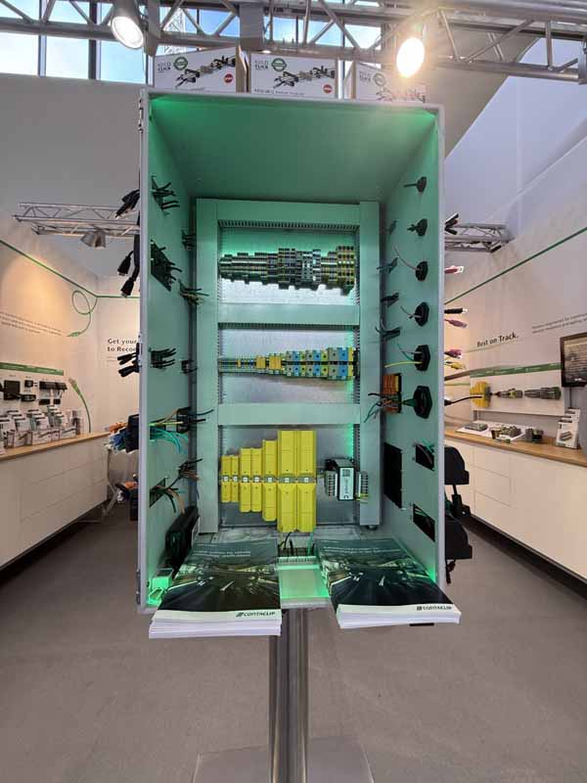
Caption: Conta-Clip’s terminal blocks and cable entries for rail technology

Image/s: | conta-clip-rail-program | Characters: | 2170
File name: | Conta-Clip-KDS-InnoTrans-review-PM-EN-2026-09-29 | Date: | 09-29-2026
Tags: | rail-certified, cable management, cable entry, terminal block, fire protection, rail technology, InnoTrans | gii ID: | 26313
About CONTA-CLIP
Conta-Clip is one of Europe’s leading manufacturers of electrical and electronic connection elements and cable management solutions. Based in Hoevelhof, Germany, the mid-sized company has been producing electric and electronic connection systems for the process and automation industries since 1978. Conta-Clip supplies all industry sectors, focusing on machine and plant engineering, instrumentation and control, construction, building automation, HVAC, control panel manufacturing, transformer manufacturing, conveyor technology, the railroad industry, shipbuilding and environmental technology.
Product divisions include Conta-Connect for electric connection technology, Conta-Cable for cable management systems, Conta-Electronics for electronics and Conta-Con for PCB edge connectors. Additionally, Conta-Clip provides services such as customizing housings and mounting rails, labeling and supplying user-specific electronic components.
Contact:  CONTA-CLIP  Verbindungstechnik GmbH  Christian Quade  Otto-Hahn-Str. 7  33161 Hoevelhof  Germany  Phone +49 5257 9833-172  Email christian.quade@conta-clip.de  Internet www.conta-clip.com |  | gii die Presse-Agentur GmbH  Christburger Str. 41  10405 Berlin  Germany  Phone +49 30 538 965-0  Email info@gii.de  Internet www.gii.de

