Cable management solutions for rail vehicles
Safe and speedy rail-certified cable entries

Passenger safety comes first in modern rail transport, and cable entry systems play a key role. They keep electric installations organized and fully functional behind the walls and panels of every railcar. Conta-Clip has enhanced and adapted its proven KDS cable entry program for the demanding requirements of rail applications, and certified it for this safety-critical environment.

Cable entry systems must pass the strictest industry-specific standards and certifications. The new sealing elements KDS-DE-RAIL and KDS-DEG-RAIL form the core of Conta-Clip’s rail-certified cable entries. Available in two sizes, these elements are made from a specialized TPE approved for railway use to DIN EN 45545-2 (HL3). They provide reliable safety and fire protection in rail vehicles. The German manufacturer offers them with KDS-SR and KDSI-SR frames from its KDS cable entry program.

Complete package for maximum safety
The new KDS-RAIL systems are HL3-certified and can be used across all train classes and railway applications without restriction. Conta-Clip also offers certified fire protection sets, providing customers with a straightforward and reliable solution for all available frame sizes. These ready-to-install packages eliminate the need to source individual components. The tailored complementary sets contain a precisely fitted intumescent fire protection mat, heat-resistant fastening screws, and all necessary mounting hardware. The KDS-RAIL sets achieve fire resistance class E30 per European standard DIN EN 45545-3.

Flexible cable management
Conta-Clip’s extensive product range covers every assembly and pre-wiring requirement, whether cables are routed from the inside out, from the outside in, or through a split frame. The KDS cable management system stands out for its flexibility, tool-free installation, and IP66 protection rating. It enables smart cable routing in control cabinets, machinery, and enclosures, and adapts to changing requirements at any time without removing the frame.

Conta-Clip at InnoTrans 2026: Hall 12, Stand 77

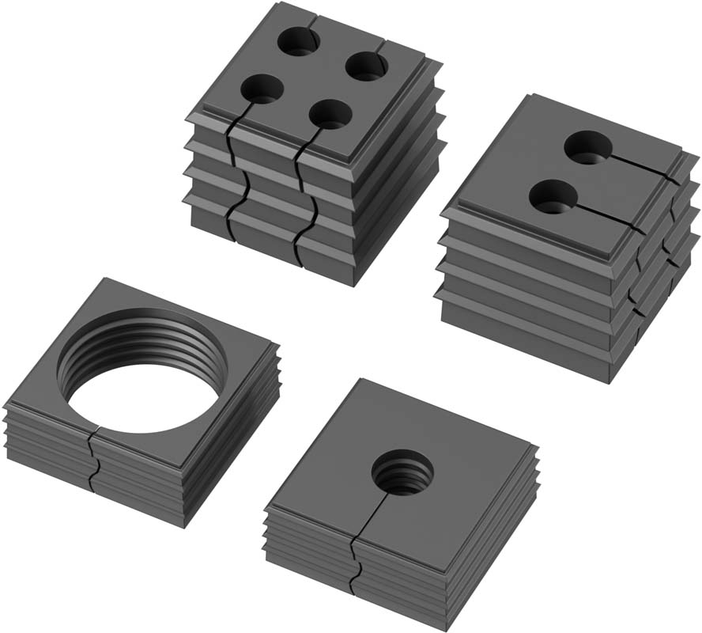
Caption 1: The new rail-certified sealing elements are the core of Conta-Clip’s cable entry systems

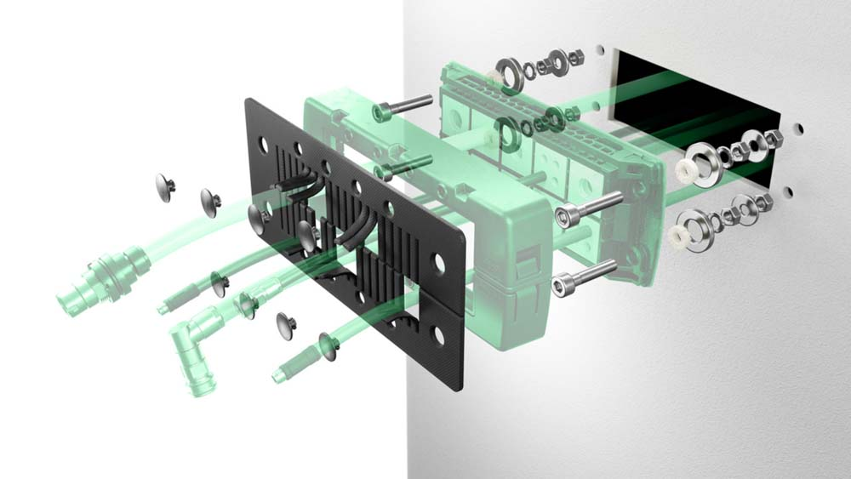
Caption 2: A safe choice: the new KDS-RAIL fire protection set

Image/s: | KDS-DEG-DE-RAIL  SET-Explosion | Characters: | 2005
File name: | Conta-Clip-KDS-Rail-PM-EN-2026-09-15 | Date: | 09-15-2026
Tags: | cable management, cable entries, cable entry, electric installations, rail applications, rail-certified, HL3-certified, DIN EN 45545, safety, fire protection, InnoTrans | gii ID: | 26256
About CONTA-CLIP
CONTA-CLIP is one of Europe’s leading manufacturers of electrical and electronic connection elements and cable management solutions. Based in Hövelhof, Germany, the medium-sized, family-run company has been producing electric and electronic connection systems for the process and automation industries since 1978. CONTA-CLIP supplies all industry sectors, focusing on railroad industries, shipbuilding, building automation, conveyor technology, machine and plant engineering and construction, instrumentation and control technology, control panel manufacturing, transformer manufacturing, and environmental technology. The company consists of many specialized branches: CONTA-CONNECT for electric connection technology, CONTA-CABLE for cable management systems, CONTA-ELECTRONICS for electronics and CONTA-CON for PCB edge connectors. Additionally, CONTA-CLIP provides services such as customizing housings and mounting rails, labeling and supplying user-specific electronic components.
Contact:  CONTA-CLIP  Verbindungstechnik GmbH  Christian Quade  Otto-Hahn-Str. 7  33161 Hövelhof  Germany  Phone: +49 5257 9833-172  Email: christian.quade@conta-clip.de  Internet: www.conta-clip.com |  | gii die Presse-Agentur GmbH  Christburger Str. 41  10405 Berlin  Germany  Phone: +49 30 538 965-0  Email: info@gii.de  Internet: www.gii.de

