Press Release

IFAT tradeshow:
UV disinfection and purification of water and air

Excelitas Technologies will launch a new out-of-arc lamp series for efficient and resource-saving water and air disinfection at IFAT Munich, at booth A3-521. The Noblelight® NNILight series boasts superior power density, with the 1500 W variant NNI¹⁵⁰⁰Light emitting an unrivaled UV output. As a result, significantly fewer lamps are required, leading to minimized maintenance and repair costs and total cost of ownership. Excelitas also adds 800 W and 1000 W Noblelight NNILight variants to its portfolio of low- and medium-pressure lamps and application-specific air disinfection systems.

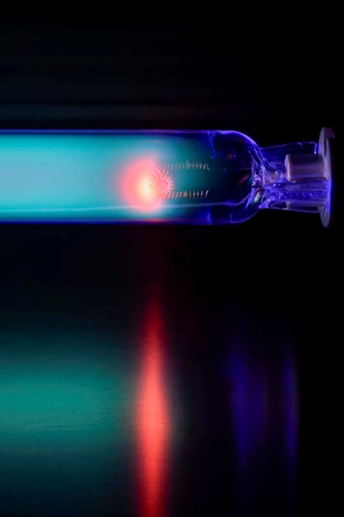
Caption: Excelitas will present the Noblelight 1500 W UVC out-of-arc lamp for efficient, cost-effective and resource-saving water disinfection at IFAT Munich

The water disinfection systems are used in a wide range of applications, such as wastewater, drinking water and process water treatment and agriculture. In addition, Excelitas Noblelight solutions are used in industrial ventilation systems to keep the air clean, minimize pollutants and eliminate odors. The experts at the booth will be happy to advise visitors on their individual applications and the optimal implementation of UV treatment in their systems.

More information: https://www.heraeus.com/en/hng/products_and_solutions/uv_lamps_and_systems/uv_lamps/nni_light/nni_light_series.html

Excelitas at the IFAT tradeshow
Munich, Germany, 13 – 17 May 2024
Hall A3, Booth 521

Image/s: | nni1500light | Characters: | 1085
File name: | ENpm_20240429_ifat_preview_noblelight | Date: | 04-29-2024
Tags: | 2 - LIG - Noblelight; PR-24-18 | gii ID: | 202404029
About Excelitas Technologies
Excelitas Technologies® is a leading industrial technology manufacturer focused on delivering innovative, market-driven photonic solutions to meet the illumination, optical, optronic, sensing, detection and imaging needs of our OEM and end-user customers. Serving a vast array of applications across biomedical, scientific, semiconductor, industrial manufacturing, safety, security, consumer products, defense and aerospace sectors, Excelitas stands committed to enabling its customers’ success in their many various end-markets. More than 7,500 professionals work across North America, Europe and Asia to serve customers worldwide. Connect with Excelitas on Facebook, LinkedIn, Instagram and Twitter.
Contact:  Excelitas Technologies Corp.  Wiebke Rustler  Marketing Manager  Reinhard-Heraeus-Ring 7  63801 Kleinostheim  Germany  Phone: +49-6181-35-7353  Email: wiebke.rustler@heraeus.com  Internet: www.noblelight.com |  | gii die Presse-Agentur GmbH  Christburger Str. 41  10405 Berlin  Germany  Phone: +49-30-538965-0  Email: info@gii.de  Internet: www.gii.de

