Press Release

Infrared systems solve challenges in plastics processing

Deburring glove compartments, laminating interior trim, or welding ventilation pipes—these are just some of the tasks involving plastics processing in modern cars. Heat processes are often required in challenging corners, small spaces or along edges.
Infrared contour emitters are shaped precisely along these contours, which offers decisive advantages. Heat is applied precisely to the burr or fold, minimizing energy consumption and optimizing the production step.
“This automates a complex process with reproducible results,” says application specialist Michael Jauch. “We have customers who have now performed more than half a million deburring cycles with the same set of emitters!”
Excelitas will be presenting Noblelight solutions for plastics processing at the K trade fair in Düsseldorf in October, hall 11 stand D01. Infrared emitters that are precisely tailored to the product and process in terms of shape, voltage, and power, as well as UV technology for curing.

Clean and efficient plastic welding
Complex pipe systems, transport boxes, and storage containers for windshield washer fluid or brake fluid—many plastic products are assembled from several individual parts during the manufacturing process. The type of plastic, shape, wall thickness, and color have a significant influence on the process. It is worth taking a close look at these process parameters before installing a new joining system. Infrared emitters from Excelitas transfer heat without contact and can be used in programmed time cycles.
In most cases, an infrared emitter module moves between two plastic parts and heats the surfaces of both parts. When the specified temperature is reached, the infrared module moves out, the ends of the parts are pressed firmly together and thus welded to each other.
Infrared welding systems offer many advantages over contact plate systems. The welding process is usually faster and also much cleaner, as no plastic sticks to the heating tools.

Faster deburring, reduced scrap
Plastic handles, covers, and panels are often manufactured using injection molding. The formation of sharp burrs, for example at the mold parting line, cannot always be prevented. Removing burrs before further processing or coating can be a real challenge, especially with complexly shaped parts.
Manual deburring with gas flames or special tools does not deliver uniformly reproducible results. Infrared radiation heats plastic parts contact-free and precisely on the surface in a matter of seconds. Shaped emitters direct infrared radiation exactly where it is needed. This is made possible by reflectors that are applied as a coating directly to the shaped emitters. The light emission gap is selected so that the energy arrives precisely at a burr. This enables in-line production of plastic parts and significantly reduces the reject rate in the production of molded parts.

Targeted heating for laminating
Door panels, headliners, and other interior parts of a car are of higher quality when the decorative trim is bonded to the back of the workpiece. This lamination is usually done in a wrapping tool, where the adhesive on the decorative trim is activated by heat. Infrared contour emitters heat the wrapping area precisely, ensuring a very efficient heating process.

Infrared heat for efficient energy use
Infrared heating technology works by transferring electromagnetic waves, which then generate heat in the product. This requires neither direct contact with the material nor a transfer medium such as gas or air. Infrared emitters transfer energy into a plastic product and generate heat exactly where it is needed. This helps to solve many requirements.
Infrared systems with contour emitters can be optimally networked with robots or handling systems. The ability to switch infrared emitters on or off in a matter of seconds means that energy is used efficiently, time is saved, and ultimately production costs are reduced.

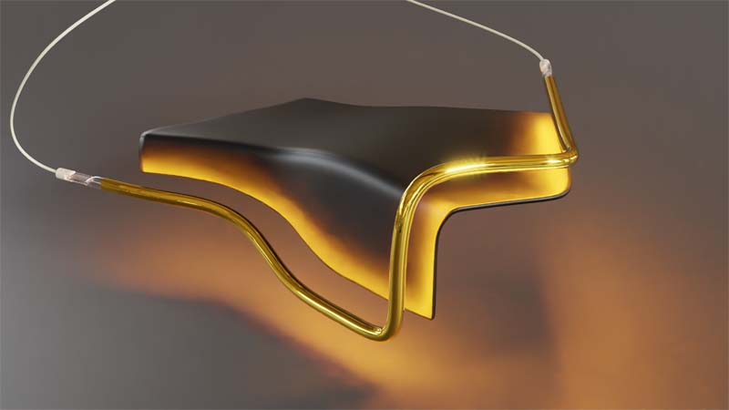
Caption: Infrared contour emitters heat the folding area precisely, ensuring highly efficient energy use.
- Copyright Excelitas Noblelight

Image/s: | excelitas_eir_kaschieren | Characters: | 3923
File name: | ENpm_20250819_messe_k_gezielte_waerme | Date: | 08-19-2025
Tags: | Messe K, Kunststoffverarbeitung, Infrarot, Kontur-Strahler
About Excelitas
Excelitas is a leading provider of advanced, life-enriching technologies that make a difference, serving global market leaders in the life sciences, advanced industrial, next-generation semiconductor and avionics end markets. Headquartered in Pittsburgh, PA, USA, Excelitas is an essential partner in the design, development and manufacture of advanced technologies, offering leading-edge innovation in sensing, detection, imaging, optics and specialty illumination for customers worldwide.
Excelitas is at the forefront of addressing many of the relevant megatrends impacting the world today, including precision medicine, industrial automation, artificial intelligence, and connected devices (IoT).
Stay connected with Excelitas on Facebook, LinkedIn, Instagram, and X, or visit our website at www.excelitas.com for more information.
Kontakt:
Excelitas
Marie-Luise Bopp
Senior Marketing Manager
Reinhard-Heraeus-Ring 7
63801 Kleinostheim
Germany
Tel.: +49-6027-121-7959
Email: marie-luise.bopp@excelitas.com
Website: www.excelitas.com

