HSD at AMB 2026: Motorised spindles, milling heads, smart connectivity

The metalworking world meets at the AMB tradeshow in Stuttgart, Germany, from 15 to 19 September 2026. HSD’s mechatronics specialists present their latest and most innovative system solutions at one of the industry’s leading trade fairs.

Since 1982, the who's who of the metalworking industry has been gathering in Stuttgart, Germany, for the AMB tradeshow every other autumn, and HSD always takes part. The Italian manufacturer showcases a cross-section of its solutions, positioning itself as a system supplier for boring heads, motorised spindles and 2-axis milling heads. Tradeshow visitors are invited to explore various technologies that offer concrete advantages for everyday production and meet daily operational demands. Trained technical staff and sales specialists are on hand to advise and support users.

Showcases include both established and new milling heads and electric spindles, including selected models from the ES5, ES10 and ES60 product lines as well as the HST series. Visitors can examine the robust, precise and thermally stable tools up close. HSD now also offers the HST810 milling head in an extra-large version. HSD designed the HST810XL specifically for demanding machining of steel and light alloys. The cast-iron head delivers almost double the torque of the standard version and features greater structural rigidity. This effectively dampens vibrations and improves stability and precision in heavy-duty machining operations. The XL version is geared at the aerospace industry.

Further highlights include the robust and fast HST610 2-axis milling head for gigacasting applications and the compact, precise and versatile ES510 motorised spindle, purpose-built for demanding applications. Also on show are the ES1000 and ES6000 motorised spindles, which HSD developed to address specific customer requirements. Both product lines reflect the state of the art and adapt to the diverse needs of users as well as the ever-increasing pace of the market. New ES10-line high-tech spindles stand out with smart options for challenging milling processes. The horizontal ES6000 is tailored specifically to the automotive sector. Its design and sensor technology deliver even greater performance and reliability.

Anticipating digital and Industry 4.0 trends, the spindle specialist presents a connecting device that links HSD motorised spindles to the myHSD IoT platform via a range of sensors. This in-house development promotes innovative manufacturing and makes workflows more efficient and effective. The device boosts productivity and quality by detecting faults early and minimising downtime. HSD developed the platform specifically for cost reduction and real-time data analysis. It improves overall processes and helps optimise maintenance through timely alerts and targeted problem-solving measures. HSD applies these concepts in its own production facilities.

Ferdinand Dannenmann, Head of HSD DACH (Germany, Austria, Switzerland), and his team are looking forward to productive meetings in Stuttgart: “AMB is one of the most important trade fairs in Central Europe and gives us the opportunity to engage with our customers in person. HSD is available to all machine tool manufacturers as a reliable partner in spindle and milling head technology. In short, by working with us, manufacturers gain a proven system supplier with extensive experience in key mechatronic systems.”

HSD at AMB: Hall 6, Booth 6D82

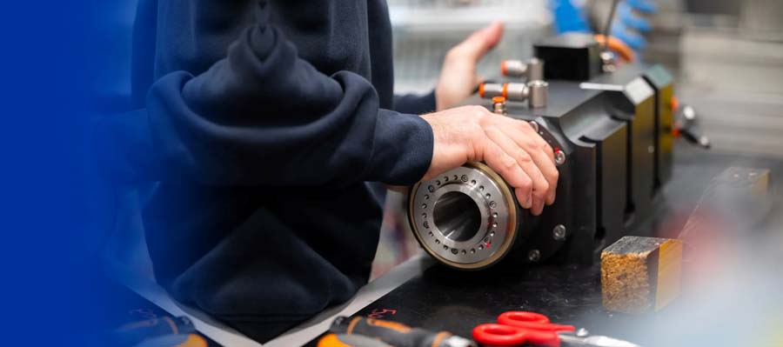
Caption 1: AMB visitors can experience selected electric spindles hands on

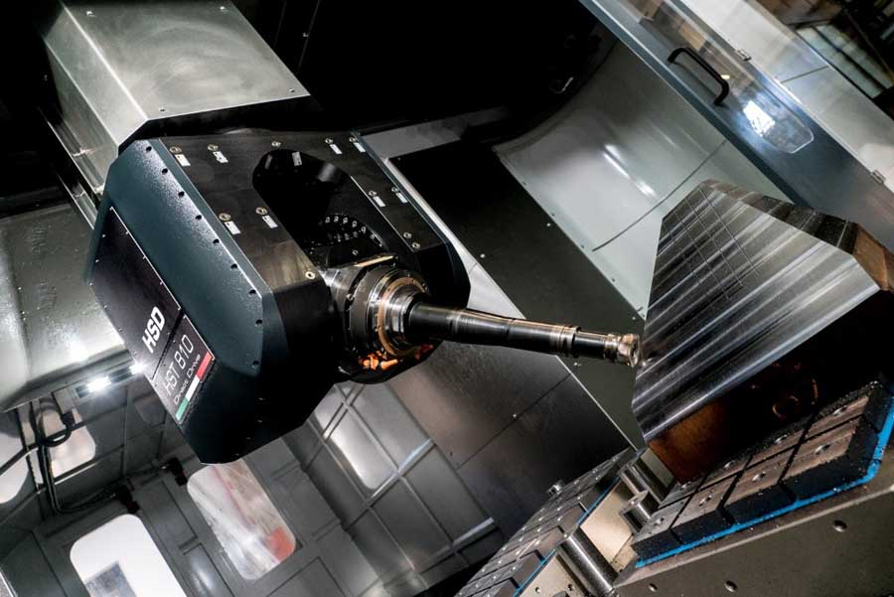
Caption 2: HSD Mechatronics’ innovative milling heads are robust, precise and thermally stable

Image/s: | ES-Baureihe  HSD_HST810 | Characters: | 3402
File name: | HSD-AMB-tradeshow-PM-EN-2026-08-05 | Date: | 08-04-2026
Tags: | HSD, AMB tradeshow, motorised spindles, milling heads, boring heads, metalworking, aerospace, automotive, gigacasting | gii ID: | 26184
About HSD
For over 30 years, HSD Mechatronics has been developing, manufacturing and distributing electric spindles, two-axis milling heads and technologically advanced components for machining metal, composite alloys and wood. The company has an 8000 square metre plant working according to the just-in-time principle. HSD is headquartered in Italy and has five subsidiaries in the most important markets worldwide.
Contact:  HSD Deutschland GmbH  Simon Lohmiller  An der Leibi 10  89278 Nersingen  Germany  Office phone: +49 7308 9606 15  Mobile: +49 151 1191 5905  Email: simon.lohmiller@biesse.com  Internet: www.hsdmechatronics.com |  | gii die Presse-Agentur GmbH  Christburger Str. 41  10405 Berlin  Germany  Phone: +49 30 538 965 - 0  Email: info@gii.de  Internet: www.gii.de

