Dynamic milling heads for metalworking

HSD Mechatronics announces its newly developed HST-Line of premium range 1- and 2-axis milling heads for demanding metal machining. Engineered to deliver maximum positioning speed, precision and robustness, these milling heads are the manufacturer’s most powerful product series and are used primarily in metalworking.

HST-Line milling heads are available in a variety of scalable sizes, including the models HST610MS, HST610DS, HST810MS, HST810DS and HST910DS. All milling heads feature high dynamics, precision and direct-drive axes. They are paired with HSD’s own direct-drive motors (IPM synchronous motors) for outstanding reliability and performance. The heads are suited to demanding machining operations including milling, turning, drilling and thread cutting, particularly on cast iron and steel. Typical target machines include gantry milling machines and other CNC systems.

As a key feature, the HST heads can integrate electric spindles running at up to 24,000 rpm with permanent grease lubrication. This capability unique to HSD enables high performance in the most demanding applications. The direct-drive configuration delivers excellent dynamics without additional components such as cabinet chokes. This translates into clear economic advantages. Fewer components in the control cabinet, a smaller footprint and reduced cooling requirements all contribute to lower overall costs. HST-Line milling heads offer an excellent price–performance ratio and are commonly more cost-effective than equivalent in-house developments.

In modern gigacasting plants for the automotive industry, HST-Line heads symmetrically machine complete car body parts from die castings in a single operation. They boost efficiency by reducing cycle times while maintaining high quality and accuracy. Aerospace manufacturers, too, benefit from the combination of speed, precision and durability. Thus, the series reinforces HSD Mechatronics’ position as a leading provider of mechatronic solutions for high-performance industrial manufacturing.

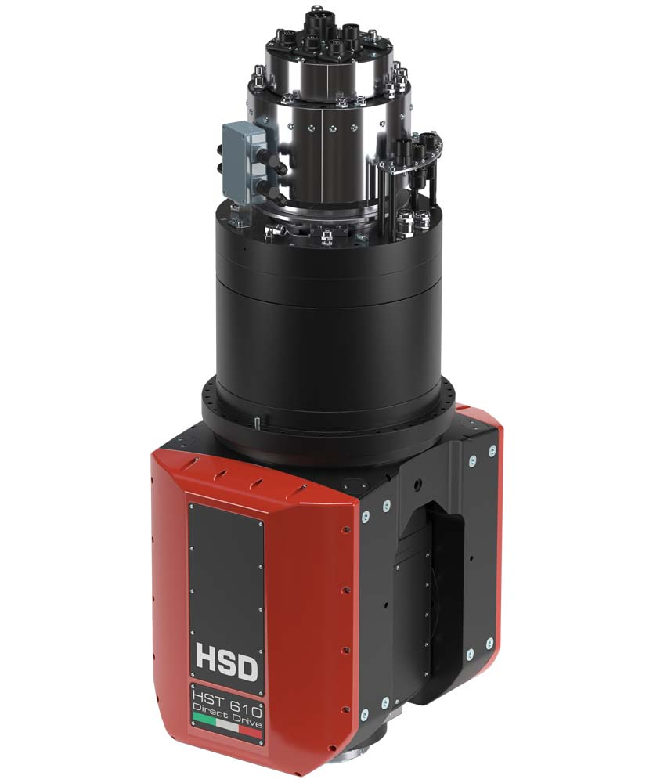
Caption: HST-Line milling heads (HST610 pictured) are defined by high dynamics, precision and direct-drive axes

Image/s: | HST610 | Characters: | 2030
File name: | HSD-HST-Line-milling-heads-PM-EN-2026-07-22 | Date: | 07-21-2026
Tags: | HSD Mechatronics, milling heads, metal machining, metalworking, gantry milling machines, CNC systems, gigacasting, automotive | gii ID: | 26183
About HSD
For over 30 years, HSD Mechatronics has been developing, manufacturing and distributing electric spindles, two-axis milling heads and technologically advanced components for machining metal, composite alloys and wood. The company has an 8000 square metre plant working according to the just-in-time principle. HSD is headquartered in Italy and has five subsidiaries in the most important markets worldwide.
Contact:  HSD Deutschland GmbH  Simon Lohmiller  An der Leibi 10  89278 Nersingen  Germany  Office phone: +49 7308 9606 15  Mobile: +49 151 1191 5905  Email: simon.lohmiller@biesse.com  Internet: www.hsdmechatronics.com |  | gii die Presse-Agentur GmbH  Christburger Str. 41  10405 Berlin  Germany  Phone: +49 30 538 965 - 0  Email: info@gii.de  Internet: www.gii.de

