Press Release

From Upper Swabia to the world: RAFI turns 125

Berg, January 16, 2025 – Whether intuitive human-machine interaction systems or tailored electronics solutions: From its German headquarters and plants in Hungary, Italy, Poland, China, and the USA, RAFI supplies a diverse range of industrial sectors. Throughout its corporate history, the company has continuously set new benchmarks. RAFI was founded on November 15, 1900, in the same year as the Nobel Foundation. Originally named “Institut für Elektrotechnik, Optik & Mechanik”, the company immediately launched its innovation trajectory.

“In its 125 years of company history, RAFI has grown into an international high-tech enterprise. We have our founders Ernst Bucher and Raimund Finsterhölzl to thank for this, but also all the individuals from various generations since the beginning who have contributed in Berg and at our other locations,” says Dr. Lothar Seybold, CEO of the RAFI Group. “Our joint work has led to ongoing innovations that not only propelled our company forward but also made a significant impact on the industry as a whole.”
Pioneering development of control systems
RAFI is responsible for major innovations including the development and manufacture of the first ever pushbuttons and switches for machine controls in the 1950s, series switches and control systems for industrial applications and household appliances in the 1960s, and the RAFI keyboard in 1970. This keyboard ushered in the PC age a full six years before the advent of the Apple I computer. In 1977 RAFI launched the RS76 keyboard program that made it the market leader for terminal and office applications, manufactured e.g. under license for Siemens. During the following decade up to 1990, RAFI achieved further pioneering milestones. These included the development and production of flat data entry systems and tactile switches which are still in use in industry today under the name RACON. They ensure individual control, input and operation of machine applications.

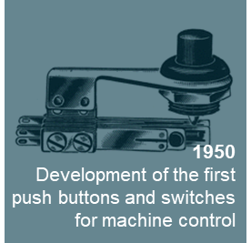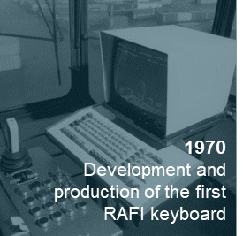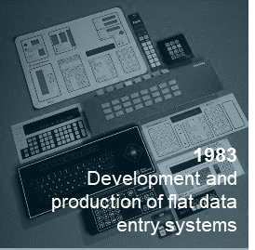
Source: RAFI Group
Innovations driven by zeitgeist and megatrends
Early in the new millennium, in 2004, RAFI developed a touch control system for WMF coffee machines. In 2012, RAFI launched its own touch sensor production for all types of capacitive control systems in order to meet the need for adequate standards in industry in the smartphone age. In the middle of the 2010s, RAFI broke new records in another segment which plays a key role globally: the production of routers and WLAN devices for internet communication. This area remains an established part of the RAFI product portfolio today.

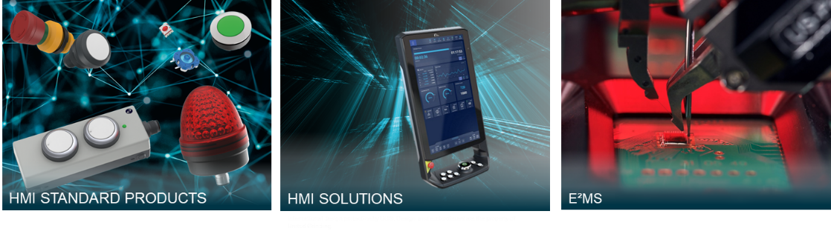
Source: all RAFI Group, except center image: international design protection by UGG. The design and representation are the property of United Grinding.

“The markets we move in are fast-paced and fiercely competitive. Technological advancement requires continuous innovation and rethinking. That demands intensive industry knowledge and tailor-made solutions plus integrated development, design and manufacturing capabilities,” explains Lothar Seybold. He adds: “We draw on many years of experience and cross-industry expertise, for example in medical technology, vehicle, machine, and system engineering, robotics and automation, as well as building and control technology. All this enables us to think and act in multiple dimensions.”

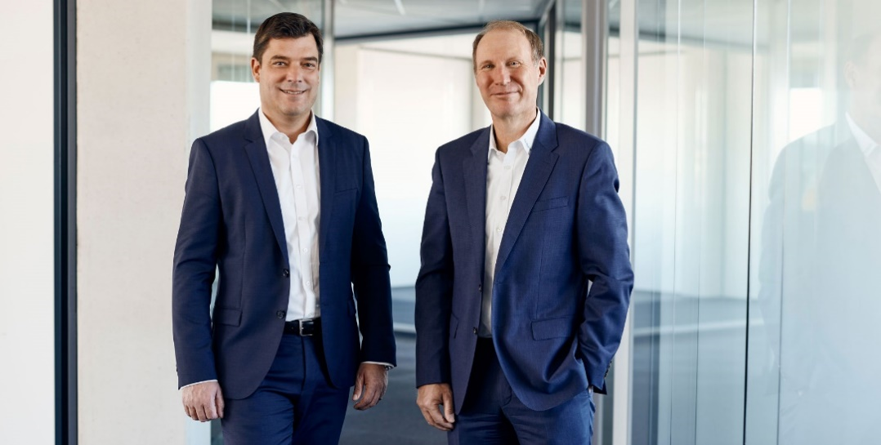
The two company leaders who, together with almost 2,300 employees, ensure RAFI’s global position as an innovation driver in human machine interfaces (HMI) and electronic engineering and manufacturing services (E²MS): CFO Lothar Arnold and CEO Dr. Lothar Seybold (from left). Source: RAFI Group

Focus on corporate culture and sustainability
Seybold points out the company’s longstanding relationships with industry leaders and also emphasizes the in-house development and manufacturing of both components and software elements. Flat hierarchies and direct communication channels ensure fast and efficient processes. Lothar Arnold, CFO of the RAFI Group, explains that sustainability is also firmly anchored in the organization and management system and forms an integral part of the international corporate culture. “In 2023, the rating agency EcoVadis awarded us its silver medal for our sustainability efforts, and in 2024 we topped that with a gold medal. This award motivates us to continuously improve and constantly review and optimize our organization, processes, and products.”

In 2024 RAFI signed up to the UN Global Compact. Based on ten universal principles and the 17 Sustainable Development Goals (SDGs), the initiative pursues “the vision of a more inclusive and sustainable economy for the benefit of all people, communities, and markets, both now and in the future.”

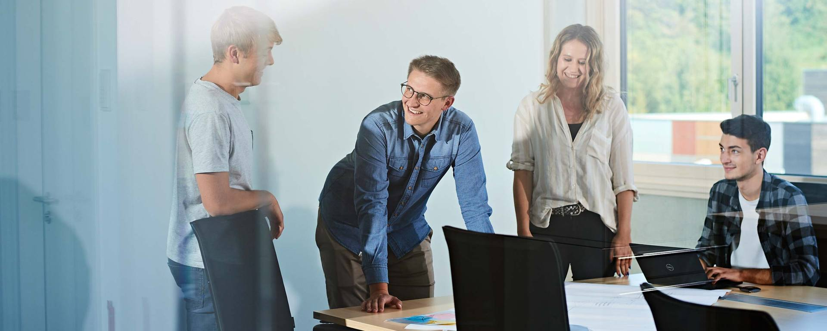
Interdisciplinary exchange, open communication, and cross-industry know-how transfer are key characteristics of the working culture at RAFI. Source: RAFI Group
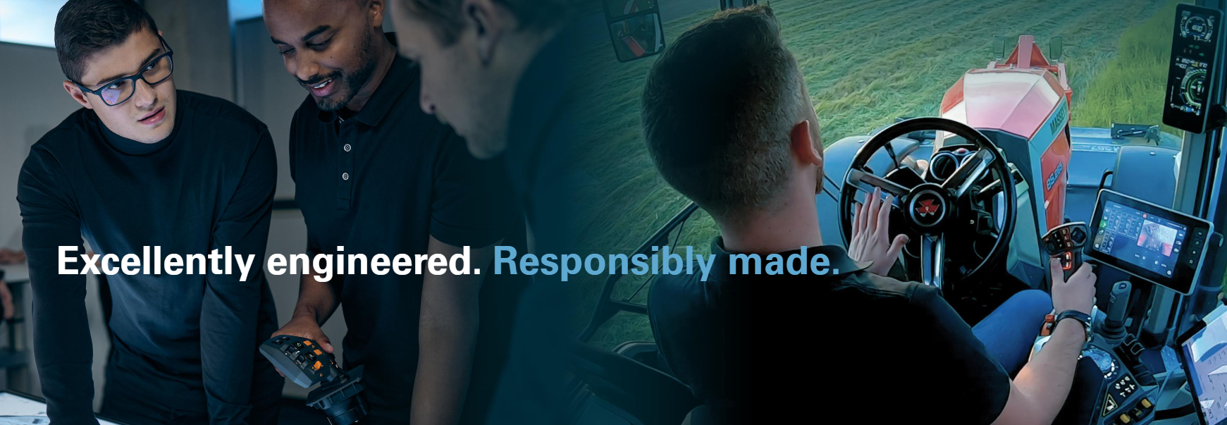
With the slogan “Excellently engineered. Responsibly made.”, RAFI sums up its corporate philosophy and the wide range of industries that use its applications. Source: RAFI Group

Development of platform technologies and expansion of locations
RAFI is dedicated to continuing its role as a source of ideas and inspiration for its customers into the future. The portfolio will develop, adjusting not only to the latest market requirements, but also creating new platform technologies that provide added value. “We develop basic technologies, hardware assemblies, and both IoT and embedded software. Our products are tailored to each customer project in their particular industry and can be applied worldwide. The customer benefits from risk minimization, development cost savings, and shorter development periods,” says Lothar Seybold, summing up the big picture. This pooling of expertise, competence, and knowledge is ideal for tapping into both traditional and new markets.

Naturally, the resulting growth demands an expansion of the company’s resources. One example is the new RAFI plant in Bad Waldsee, which will start operations in early 2025. The investment also demonstrates the company’s commitment to the region. “Covering a floorspace of 10,000 m², the facility will include new production shops for synthetic materials and automatic machines, metal processing, tool and die making, tool and die development, and the new training and apprentice center, RAFI Academy”, says Lothar Arnold. A major priority for RAFI with this new building was an energy efficient infrastructure in compliance with the EFFH 40 standard. The primary energy source will be a geothermal probe system with 34 probes installed at a depth of 131 m. Additional energy will be provided by a PV system with a performance of 760 kWp.

RAFI also remains committed to its international growth strategy and plans to further expand capacities above all in Asia and the USA. In 2023, RAFI acquired Xymox Technologies, which draws on more than 40 years of experience in the development and production of capacitive input sensors and membrane switches. Further initiatives may follow.
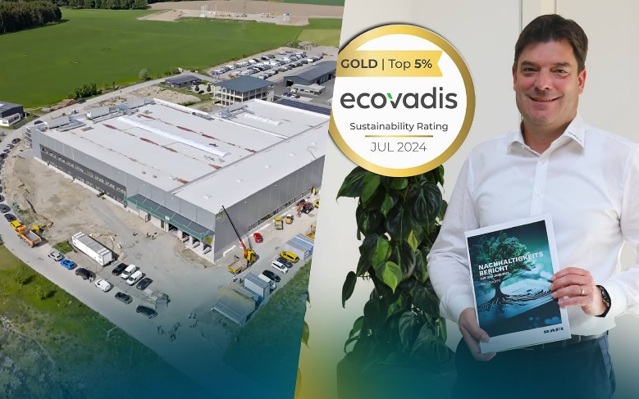
The plant in Bad Waldsee adds another state-of-the-art facility for the manufacture of hi-tech products in the RAFI portfolio. Here again, sustainability will play a key role in all processes. Source: RAFI Group

Training, voluntary work and roots in the community
Apart from expanding its product portfolio and developing company locations, RAFI also maintains a focus on supporting young career-starters. This involves offering opportunities for dual study programs, internships, and training. Last fall, 11 trainees, two retrainees, and 13 dual-study students embarked on trade, commercial, or technical qualification programs. Currently, RAFI employs a total of 72 trainees and students.

There is a long tradition of company sports activities at RAFI. Last year, the company sports groups celebrated their 50th anniversary. The variety of sporting activities is huge: from fitness training to gymnastics, bowling, bouldering, cycling, swimming, tennis, and archery.

“RAFI Heroes – Spotlight on Voluntary Work” offers employees the chance to nominate their favorite charity projects for company support. In the past two years, RAFI chose a selection of especially impressive projects from a large number of inspiring entries. “As a part of society, we feel a duty to contribute to improving our community. Voluntary workers often dedicate much of their spare time to taking on social responsibility. That’s why it is and will always be important to us to also support carefully chosen local organizations and initiatives,” says Lothar Arnold. Additionally, RAFI supports regional soccer and ice hockey clubs.

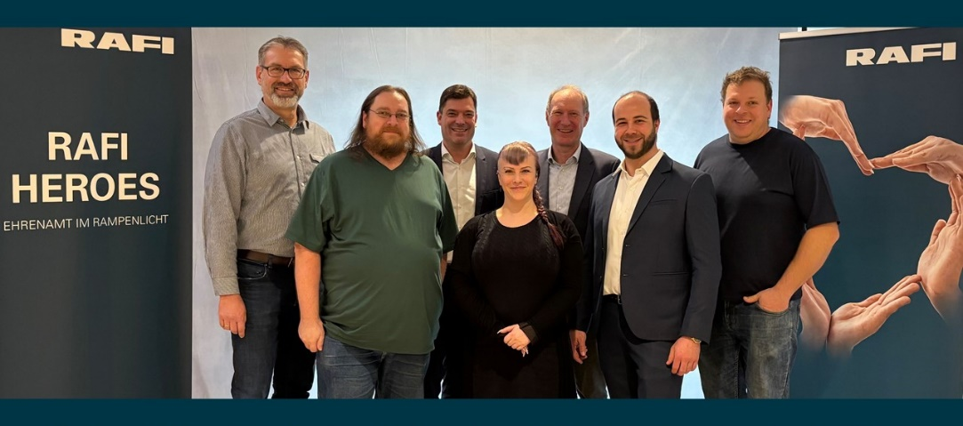
In December 2024, Managing Directors Lothar Arnold and Dr. Lothar Seybold (back row) congratulated the RAFI HEROES Thomas Kohler, Andreas Michel, Lisa Klan, Dominik Schmid, and Michael Prestel (left to right). The company supported voluntary work in these institutions: Helfer vor Ort in Horgenzell, Stadttauben Memmingen, Tischtennisverein (TTV) Wolpertswende-Mochenwangen, Kitzrettung Zogenweiler, and Narrenzunft Henkerhaus Baienfurt.
Source: RAFI Group

Download the high-resolution image files at
https://www.gii.de/download/rafi_125.zip

Image/s: | milestones1_1000.jpg  meilensteine2_2000.jpg  RAFI_Geschaeftsfuehrung.jpg  RAFI_Auszubildende.jpg  RAFI_Branchen_Landtechnik.jpg  RAFI_Bad_Waldsee_Ecovadis.jpg  RAFI_HEROES_2024.jpg | Characters: | 7600
File name: | PM_125_years_RAFI_Group_en.docx | Date: | 01-16-2025
Tags:
About the RAFI Group
Founded in 1900, RAFI today develops and produces electromechanical components and systems for human-machine interaction. The range of products includes key switches, switches, touchscreens, control systems, and electronic assemblies. RAFI products are employed in many industries including automation, medical technology, machine and plant engineering, road and railway vehicles, household appliances, and telecommunication. The RAFI Group operates internationally at sites in Germany, Europe, China, and the USA. Its headquarters are in Berg, Germany.
Contact:  RAFI GmbH & Co. KG  Fred Nemitz  Ravensburger Str. 128 – 134  88276 Berg  Germany  Phone: +49 160 9204 8569  Email: fred.nemitz@rafi-group.com  Internet: www.rafi-group.com |  | Distribution:  gii die Presse-Agentur GmbH  Christburger Str. 41  10405 Berlin  Germany  Phone: +49 30 538 965-0  Email: info@gii.de  Internet: www.gii.de

