Press Release

The future needs roots:
RAFI celebrates its 125th anniversary with customers, suppliers, and friends

Berg, July 15, 2025 – Together with 200 guests from around the world, the RAFI Group – originally founded as the “Institut für Elektrotechnik, Optik & Mechanik” on November 15, 1900 – celebrated its anniversary at Inselhalle Lindau. As part of the Future Impact Symposium held under the slogan “Zeitgeist. Megatrends. Courage.” on July 10, the event offered a look at the company’s past. On October 11, interactive workshop sessions focused on contemporary topics such as AI applications, de-globalization, and innovation management.

Ernst Bucher established an electrical engineering business in Ravensburg under the name “Institut für Elektrotechnik Optik & Mechanik,” thus laying the cornerstone for RAFI. His successor, Raimund Finsterhölzl, registered RAFI as a trademark with the Imperial Patent Office in 1908. A lot has happened since then. Initially focusing on the development and production of switches and nurse call systems, the company from Upper Swabia has continuously evolved and reinvented itself over the past 125 years – not just in terms of its product line but also in its range of applications.

“Today, our involvement across such a wide spectrum of sectors sets us apart. We continually pursue innovations, keeping our customers at the cutting edge and pushing beyond current boundaries. Thinking ahead to tomorrow is embedded in our DNA. The primary reason for this is that people trust us and value our experience, especially since we are constantly surprising the market with new things,” says Dr. Lothar Seybold, CEO of the RAFI Group, during his welcome address on the first day of the Future Impact Symposium. “Our employees at our locations in Berg, Bad Waldsee, Überlingen, Shanghai, Milwaukee, Zielona Góra, Mezötúr, and Cambiago, along with our representative offices in France and Scandinavia, understand the value of quality, technological expertise, pragmatism, and courage, all of which drive our success.”

The markets in which RAFI operates are dynamic, fiercely competitive, and driven by technology. To keep pace as a supplier, you need to possess comprehensive expertise in development, design, and manufacturing, along with in-depth industry knowledge that enables multidimensional thought and action. The requirements in the medical technology, electromobility, and agricultural and construction machinery sectors differ from those in mechanical and plant engineering, as well as robotics and automation.

Impressions from the RAFI Group anniversary event

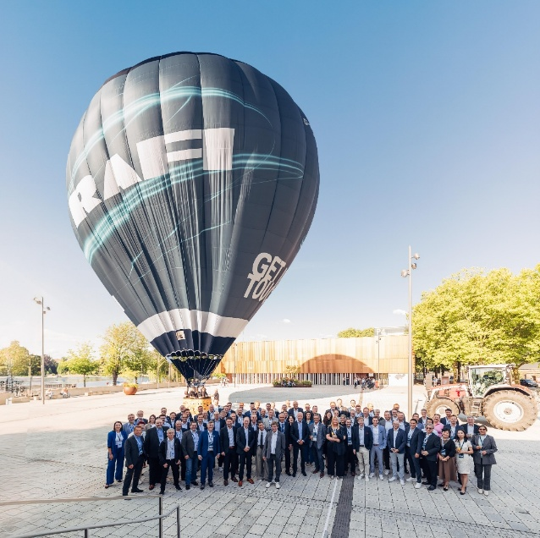
Caption 1: The RAFI hot air balloon also made a brief stopover in front of Inselhalle Lindau during the RAFI anniversary event.
Image source: Eric Wetzel Design

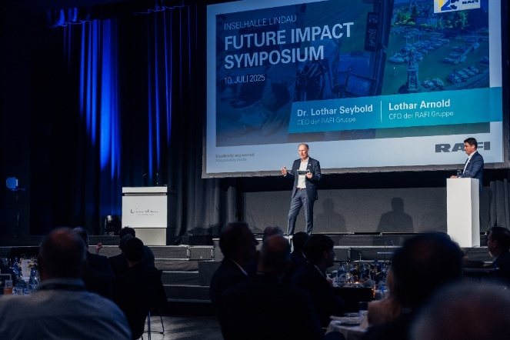
Caption 2 The RAFI Board of Directors at the official welcome.
Image source: Eric Wetzel Design

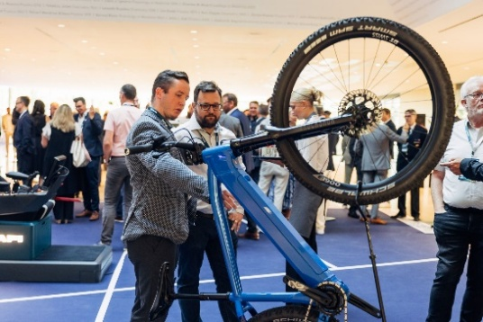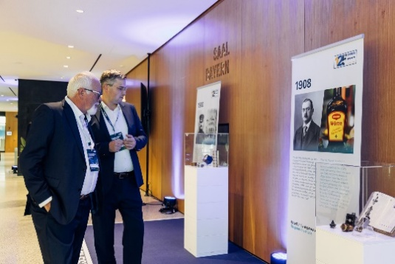
Images 3, 4: The “Historical Milestones” traced the legacy of an innovative past, while the “Future Impact Space” showcased current and future RAFI applications across industries such as robotics, agricultural and medical technology, and mechanical engineering.
Image source: Eric Wetzel Design

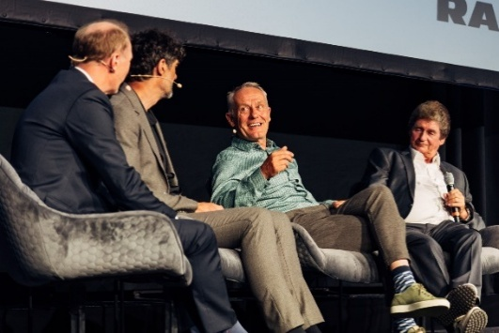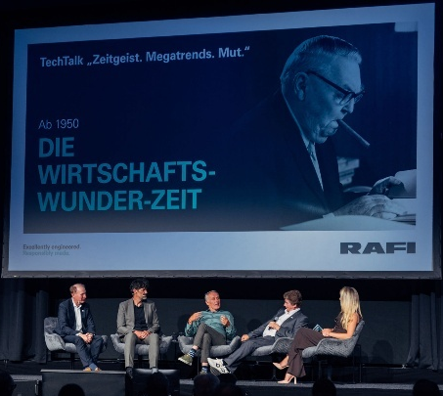

Images 5, 6: Dr. Ines Marbach moderated the TechTalk “Zeitgeist. Megatrends. Courage.” and elicited fascinating anecdotes from a variety of eras from the panelists Dr. Lothar Seybold, Prof. Heiner Linke, Christian Streich, and Albert Wasmeier.
Image source: Eric Wetzel Design

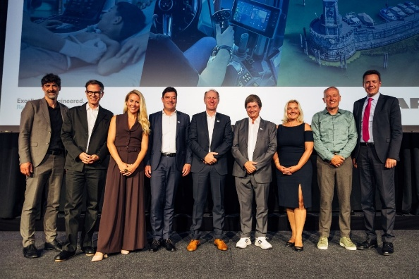

Image 7: RAFI and 125 years of contemporary history – while also looking ahead to the future (from left to right): Prof. Heiner Linke, Mathias Haas, Dr. Ines Marbach, Lothar Arnold, Dr. Lothar Seybold, Albert Wasmeier, Manuela Hugger, Christian Streich, and Harald Sievers.
Image source: Eric Wetzel Design

What would Alfred Nobel have thought about all this?

It was not without reason that RAFI moved its anniversary celebration from the Berg site near Ravensburg to Inselhalle Lindau: the Nobel Foundation, which has been awarding the Nobel Prize since 1901, was also established in the year RAFI was founded. Even though the Nobel Prizes are famously awarded in Oslo and Stockholm, the Nobel laureates meet each year on Lake Constance, specifically at Inselhalle Lindau, with this year marking the 74th such gathering. Nearly 600 guests attended the Lindau Nobel Laureate Meeting from June 29 to July 4. This time the scientific focus was on the field of chemistry.

Fittingly, the TechTalk “Zeitgeist. Megatrends. Courage.” began on the evening of July 10 with the following thematic introduction: Everything has changed – over the last 125 years. The industrial age. Consumer society. Science. Business. Nature. Technology. Mobility. Energy. Sport. Worldwide. Even the development of our workplaces compared to 10, 30, or 50 years ago. What might Alfred Nobel have thought about all of this?

The industrial age, consumer society, and RAFI over 125 years

The discussion featured panelists from a wide range of disciplines who engaged with these and other questions in an insightful and humorous manner: Christian Streich, former German soccer player and coach; Prof. Heiner Linke, Vice-President of the Board of Trustees of the Nobel Laureate Meetings and Professor of Nanophysics at Lund University; Albert Wasmeier, former CEO of RAFI; and Dr. Lothar Seybold, CEO of the RAFI Group.

Moderated by Dr. Ines Marbach, the event explored the innovative spirit at the dawn of the last century that laid the foundations for modern life, the economic boom following World War II, the rise of the computer age in the 1970s, and the emergence of new markets and opportunities after German reunification.

At the conclusion of the discussion, the digital transformation of the value chain provided the ideal lead-in for Mathias Haas, who, as a futurist who engages in “trend watching in the here & now,” gathers global insights in real time and advises companies on their future direction. RAFI’s significance in this context and era was illustrated through vivid anecdotes and key moments from the company’s history.

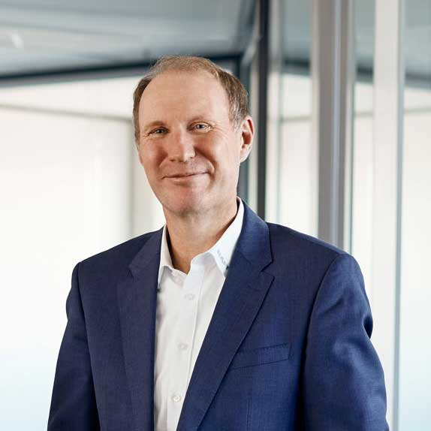

Image 8: Dr. Lothar Seybold, CEO of the RAFI Group: “With 125 years of experience, our diverse industry product portfolio, and our strategic direction, we have an ideal basis for the future. We are fully prepared to develop new products, implement innovative ideas, and consistently provide the best solutions for our customers.”
Image source: RAFI

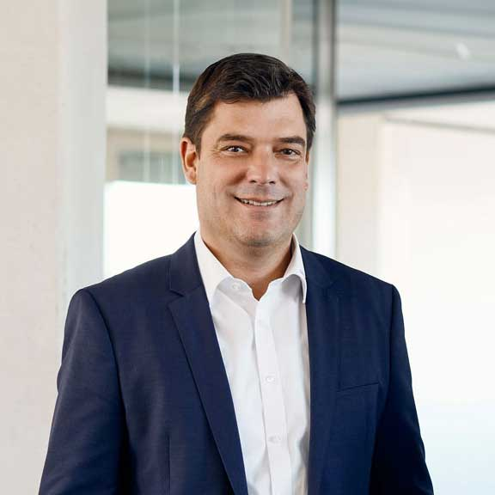

Image 9: Lothar Arnold, CFO of the RAFI Group: “We are keeping pace with global competition and strategically expanding our resources while prioritizing our corporate culture and our commitment to sustainability. Our new factory in Bad Waldsee exemplifies this and demonstrates a clear commitment to Upper Swabia as a business location.”
Image source: RAFI

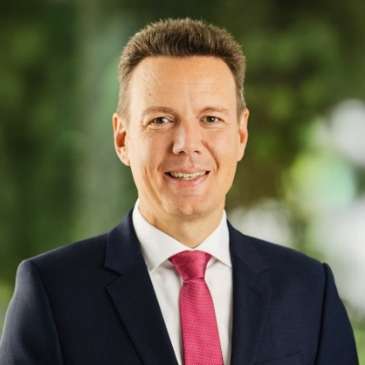

Image 10: Harald Sievers, District Administrator of Ravensburg: “RAFI has been an indispensable part of our district for 125 years. As an attractive employer and driver of innovation, you make a valuable contribution to shaping our region and demonstrate a strong commitment to the Ravensburg district as a business location. Your anniversary is therefore a reason for the entire district to celebrate!”
Image source: District of Ravensburg

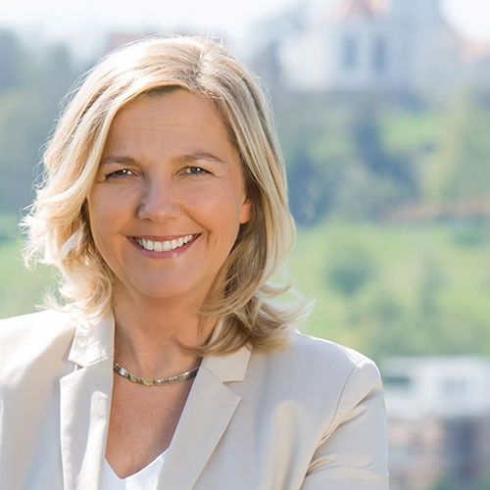

Image 11: Manuela Hugger, Mayor of Berg: “125 years of RAFI represent a significant chapter in the industrial history of Upper Swabia.” And above all, RAFI is a true asset – for the region, for the people, and for us as the municipality of Berg.”
Image source: The municipality of Berg

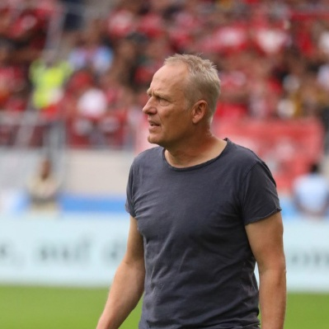

Image 12: Christian Streich, former German soccer player and coach: “During my coaching career, I trained with players representing more than 50 different countries. That experience inspired and shaped me. It wasn’t winning that was important, but our mindset.”
Image source: zVg

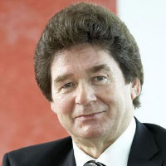

Image 13: Albert Wasmeier, former CEO of RAFI: “On my very first business trip in 1974, I faced a tricky assignment – reducing the switch height from 65 mm to 30 mm. In the end, we managed to get the height down to 10 mm – astonishing the customer by exceeding their requirements. Such an innovation represented a quantum leap for RAFI at the time.”
Image source: RAFI

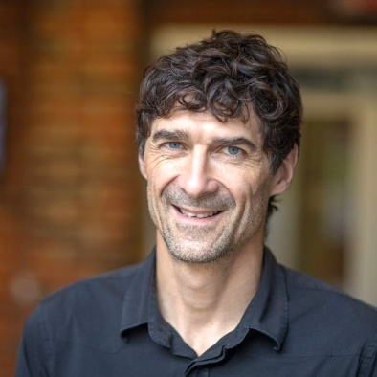

Image 14: Prof. Heiner Linke, Vice-President of the Board of Trustees of the Nobel Laureate Meetings and Professor of Nanophysics at Lund University: “The 2024 Nobel Prize in Chemistry for protein structure prediction could serve as a shining example for how to successfully work with artificial intelligence: high-quality training data, transparency, and verifiability should always be prioritized as fundamental principles.”
Image source: Knut and Alice Wallenberg Foundation

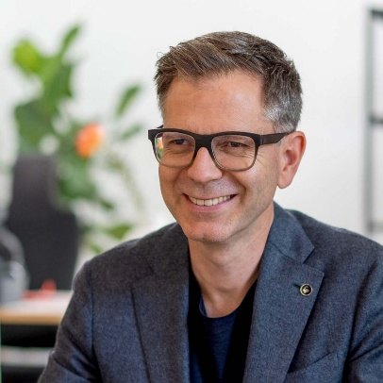

Image 15: Mathias Haas, futurist and trend watcher: “The new possibilities are rapidly expanding – relying on yesterday’s manual would be disastrous. We must fundamentally question our actions – both regularly and systematically!”
Image source: DER TRENDBEOBACHTER

For editors: Download all high-resolution images at
https://www.gii.de/download/rafi_images_anniversary_event_2025-07.zip

Image/s: | RAFI_125_Jahre_Highlights_Website_001.jpg  RAFI_125_Jahre_Highlights_Website_002.jpg | Characters: | 4,798
File name: | PM_RAFI_Anniversary_Event_2025_en.docx | Date: | 07-15-2025
Tags: | RAFI, 125 Years, anniversary event, Lindau, Inselhalle

About the RAFI Group
Founded in 1900, RAFI today develops and produces electromechanical components and systems for human-machine interaction. The range of products includes switches and key switches, touchscreens, control systems, and electronic assemblies. RAFI products are used in many industries, including automation, medical technology, machine and plant engineering, road and railway vehicles, household appliances, and telecommunication. The RAFI Group operates internationally at sites in Germany, Europe, China, and the USA. Its headquarters are in Berg near Ravensburg.

Contact: RAFI GmbH & Co KG, Ravensburger Straße 128-134, 88276 Berg, Fred Nemitz, Corporate Communications, fred.nemitz@rafi-group.com, www.rafi-group.com

