Press Release

RAMO control components in floor cleaners

During the typical working day of a floor cleaner, the control technology must be able to withstand a good deal of wear and tear and, in addition to mechanical stress, must also withstand many a rustic actuation. That’s why Dr. Gansow Gmatic AG uses robust, easy-to-install switches from the RAFI RAMO 22 series as the control units in its high-quality Gmatic and Rotan scrubber dryers. The actuators, sized for an installation opening with a diameter of 22.3 mm, are very easy to install and connect. As standalone solutions in the completely enclosed mono-housing, they achieve a high degree of protection up to max. IP69 without the need for further seals. Thanks to direct wiring via M12 terminals, no time-consuming individual wiring is required. Correct connection is possible without specialist knowledge of electrical engineering. Service and maintenance work is also reduced, because the connections can be easily disconnected and reconnected as required. Switching states and settings are indicated clearly by signal lamps, illuminated switches and twist grip labels. The energy-efficient LED technology is robust and lasts for the lifetime of the machine.

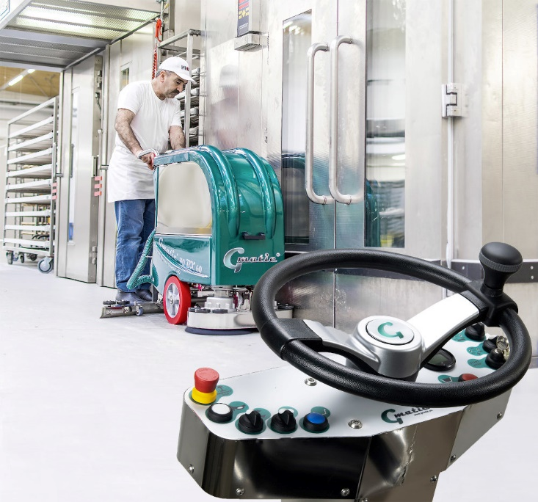

Caption: User-friendly control panel with clearly arranged key switches and switches from the RAMO 22 control component family

Image/s: | gansow_rotan_collage | Characters: | 1.166
File name: | 202111040_pm_ramo-gansow_en.docx | Date: | 12-01-2021

About the RAFI group
Founded in 1900, RAFI today develops and produces electromechanical components and systems for human–machine interaction. The range of products includes key switches, switches, touchscreens, control systems and electronic assemblies. RAFI products are employed in many industries including automation, medical technology, machine and plant engineering, road and railway vehicles, household appliances and telecommunication. The RAFI group operates internationally with more than 2,000 employees at sites in Germany, Europe, China, and the USA. Since 2020, it owns the US investment company Oaktree. Its headquarters are in Berg, Germany.

Contact:  RAFI GmbH & Co. KG  Artur Krug  Ravensburger Str. 128–134  88276 Berg, Germany  Phone: +49 751 89-1307  Email: artur.krug@rafi-group.com  Internet: www.rafi-group.com |  | gii die Presse-Agentur GmbH  Immanuelkirchstr. 12  10405 Berlin, Germany  Phone: +49 30 53 89 65-0  Email: info@gii.de  Internet: www.gii.de

