Press Release

Hannover Messe:
Waterproof and water-jacket-cooled motors

At the 2020 Hannover Messe, Menzel Elektromotoren will focus on motors with IP67 ingress protection. Menzel's subsidiary Franz Wölfer Elektromaschinenfabrik will showcase its newly developed water-jacket-cooled motor. Menzel specializes in short-term production of large-scale industrial motors. The Berlin-based manufacturer is now increasing its stock of IP67 components in order to also enable shorter delivery times for this type of motor. IP67 motors resist ingress of water even if temporarily submerged. Enquiries for this protection class usually concern flood-prone pumping stations and maritime applications. The manufacturer offers optional IPX7 TÜV tests. The three-phase asynchronous motors are available with squirrel cage rotors or slipring rotors with outputs from 37 kW to 1,500 kW, with voltages from 380 V to 13,800 V, up to and including size 500. Menzel fits waterproof encapsulated motor housings and clamping boxes and ensures assembly with minimum tolerances. When the water has receded after a flooding, the motors are ready to be switched on again immediately.

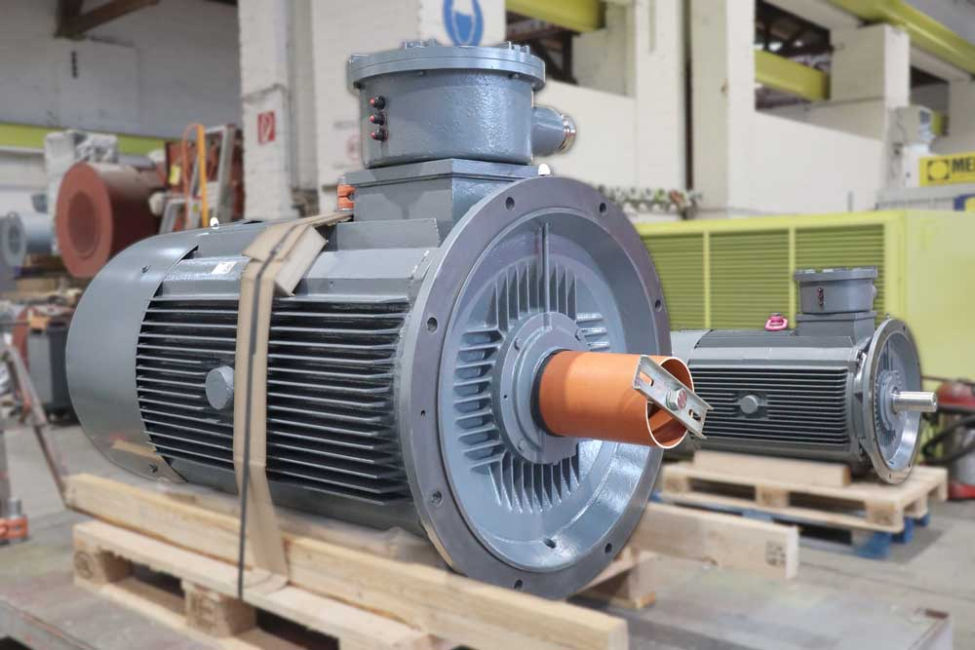
Caption: Menzel stocks up on components to enable faster delivery of IP67 motors – the picture shows two motors for a pump station in Egypt

Menzel subsidiary Wölfer will present the prototype of a new totally enclosed water-jacket-cooled motor series for frequency inverter operation, which was successfully tested with a rated power of 230 kW in operating mode S1 - continuous operation. The market launch of this new motor generation with water jacket cooling will take place later this year. 4-pole and 6-pole versions from size 180 to 450 are planned. These IP56 motors are more compact, lighter, and more dynamic than TEFC motors. In addition to Wölfer's established core markets offshore floating cranes and winch drives, target applications also include mining, steelworks, and naval propulsion drives.
Delegates and trade fair visitors are invited to discuss their need for drive solutions with asynchronous motors up to 20 MW and DC motors up to 2000 kW with the team at the booth. Menzel is committed to always maintaining the same high level of quality even in fulfilling unusual customer requests.

Menzel at Hannover Messe, 20 – 24 April 2020
Hall 5, Stand C36

Read on
…about IP67 ingress protection and Menzel IP67 motors: https://www.menzel-motors.com/specialized-motors/ip67-motor/
…about Wölfer electric motors: https://www.woelfer-motoren.com/

Image/s: | ip67_motors_pump_station_eg | Characters: | 2054
File name: | 202002010_pm_hannover_messe_en | Date: | 02-05-2020
About Menzel Elektromotoren
Based in Berlin, Menzel Elektromotoren GmbH has been manufacturing and distributing electric motors for more than 90 years. The medium-sized company specializes in the delivery of large electric motors, including special models, within the shortest possible time. The product range comprises high and low voltage motors, DC motors, transformers, and frequency inverters. Services include motor production and short-term adaptation of stocked motors to application-specific requirements. In order to ensure fast deliveries to the customer at all times, the company maintains a very extensive inventory including more than 20,000 motors with a maximum performance of up to 15,000 kW. Qualified engineering, experienced staff, and state-of-the-art production and testing facilities help Menzel provide excellent reliability. Menzel operates subsidiaries in the UK, France, Italy, Spain, and Sweden, and cooperates with numerous partners worldwide.

Contact:  Menzel Elektromotoren GmbH  Mathis Menzel  Neues Ufer 19-25  10553 Berlin  Germany  Phone: +49 . 30 . 349 922-0  Email: info@menzel-motors.com  Internet: www.menzel-motors.com | gii die Presse-Agentur GmbH  Immanuelkirchstr. 12  10405 Berlin  Germany  Phone: +49 . 30 . 538 965-0  Email: info@gii.de  Internet: www.gii.de

